


Developing A Temporal Poverty Monitoring Framework In Malaysia Using Explainable Machine Learning

By
MUHAMMAD AFIF FARIHIN BIN MOHAMMAD
TP076690
APD3F2509CS(DA)

A project submitted in partial fulfilment of the requirements for the degree of
B.Sc. (Hons) Computer Science with specialism in Data Analytics at Asia Pacific University of Technology and Innovation
Supervised by Assoc. Prof. Dr. Nirase Fathima Abubacker
2nd Marker: Dr. Murugananthan Velayutham
2026

DECLARATION OF THESIS CONFIDENTIALITY
Author's full name: Muhammad Afif Farihin Bin Mohammad
IC No./Passport No.: TP076690
Thesis/Project title: Developing A Temporal Poverty Monitoring Framework In Malaysia Using Explainable Machine Learning
I declare that this thesis is classified as:
CONFIDENTIAL
RESTRICTED
OPEN ACCESS

I acknowledged that Asia Pacific University of Technology & Innovation (APU) reserves the right as follows:
- The thesis is the property of Asia Pacific University of Technology & Innovation (APU).
- The Library of Asia Pacific University of Technology & Innovation (APU) has the right to make copies for the purpose of research only.
- The Library has the right to make copies of the thesis for academic exchange.

Author's Signature: | 
Date: | 19 May 2026
Supervisor's Name: | Assoc. Prof. Dr. Nirase Fathima Abubacker
Date: | 19 May 2026
Signature: | 

First Name:
Muhammad Afif Farihin
Middle Name (only if applicable):
Last Name:
Bin Mohammad
Title of the Final Year Project / Dissertation / Thesis:
Developing A Temporal Poverty Monitoring Framework in Malaysia Using Explainable Machine Learning
Abstract:
This study develops a reproducible, explainable machine learning framework for monitoring state-level poverty in Malaysia using satellite-derived geospatial proxies. The submitted workflow retains official DOSM raw poverty labels, validates cleaned DOSM labels against a 158-observation model-ready state-year panel, and uses derived nighttime lights, vegetation, population, and topography features across 16 states and 10 survey years. Random Forest, XGBoost, year-only, Ridge and ElasticNet baselines are compared under leave-one-state-out validation. The selected full-feature Random Forest absolute-poverty monitor achieves LOSO MAE = 2.52 percentage points, R² = 0.218 and Spearman = 0.787; rf_sensor_safe is reported separately as the lower-error robustness benchmark, and XGBoost as the strongest ranking comparator. Satellite/geospatial features improve selected absolute-poverty MAE by 0.44 pp over year-only, while relative poverty is better explained by year-only dynamics. The workflow delivers reproducible notebooks, QA outputs, SHAP explanations and a Dash dashboard, with sensor-discontinuity and 2012 VIIRS source-year limitations disclosed.
A few keywords associated with the work:
Poverty Mapping, Machine Learning, Remote Sensing, Explainable AI, Malaysia, SHAP
General Subject:
Computer Science in Data Analytics
Date of Submission:
20 May 2026

Acknowledgement
The author would like to convey his deepest gratitude to his supervisor, Assoc. Prof. Dr. Nirase Fathima Abubacker, whose unwavering support, constructive guidance, and thoughtful feedback have been instrumental throughout the development of this project. Dr. Nirase's dedication, availability, and insightful suggestions consistently shaped the direction of this work and enabled the author to overcome numerous challenges. This project would not have reached completion without her encouragement and expertise.
The author also extends his sincere appreciation to Ms. Nur Amira Abdul Majid, the project manager for all Final Year Projects. Her clear briefings, well-structured guidelines, and complete reference materials have been invaluable in navigating each chapter of this investigation report. Her work in keeping students informed and on track has greatly helped the successful completion of this report.
The author also acknowledges the support of family members, whose sustained encouragement and practical assistance contributed to maintaining continuity and focus throughout the investigation period. This support enabled consistent progress on data acquisition, preprocessing, and documentation activities required for timely completion of the investigation report.

Abstract
This study develops a reproducible, explainable machine learning framework for monitoring state-level poverty in Malaysia using satellite-derived geospatial proxies. The submitted workflow retains official DOSM raw poverty labels, validates cleaned DOSM labels against a 158-observation model-ready state-year panel, and uses derived nighttime lights, vegetation, population, and topography features across 16 states and 10 survey years. Random Forest, XGBoost, year-only, Ridge and ElasticNet baselines are compared under leave-one-state-out validation. The selected full-feature Random Forest absolute-poverty monitor achieves LOSO MAE = 2.52 percentage points, R² = 0.218 and Spearman = 0.787; rf_sensor_safe is reported separately as the lower-error robustness benchmark, and XGBoost as the strongest ranking comparator. Satellite/geospatial features improve selected absolute-poverty MAE by 0.44 pp over year-only, while relative poverty is better explained by year-only dynamics. The workflow delivers reproducible notebooks, QA outputs, SHAP explanations and a Dash dashboard, with sensor-discontinuity and 2012 VIIRS source-year limitations disclosed.
Keywords: Poverty Mapping, Machine Learning, Remote Sensing, Explainable AI, Malaysia, SHAP
SDG Alignment: SDG-1 (No Poverty), SDG-10 (Reduced Inequalities)

Table of Contents
DECLARATION OF THESIS CONFIDENTIALITY 1
Acknowledgement 3
Abstract 4
List of Figures 10
List of Tables 12
Chapter 1: Introduction 13
1.1 Introduction 13
1.2 Problem Background 13
1.3 Project Aim 13
1.4 Objectives 14
1.5 Scope 14
1.6 Potential Benefits 14
1.6.1 Tangible Benefits 14
1.6.2 Intangible Benefits 15
1.7 Overview of the FYP Documentation 15
1.8 Project Plan 16
Chapter 2: Literature Review 18
2.1 Introduction 18
2.2 Domain Research 18
2.2.1 Poverty Measurement and Monitoring Challenges 18
2.2.2 Remote Sensing for Socioeconomic Mapping 19
2.2.3 Night-Time Lights as Poverty Proxies 20
2.2.4 Vegetation Indices and Agricultural Productivity 22
2.2.5 Multi-Source Geospatial Data Integration 23
2.2.6 Panel Data and Temporal Analysis 24
2.2.7 Explainable Artificial Intelligence for Policy-Facing Models 25
2.3 Similar Works 27
2.3.1 Global Poverty Mapping Studies 27
2.3.2 Southeast Asia and Regional Applications 31
2.3.3 Systematic Comparison of Reviewed Works 32
2.3.4 Research Gap Analysis and Project Positioning 33
2.4 Technical Research 34
2.4.1 Google Earth Engine Platform 34
2.4.2 Development Environment and Tools 35
2.4.3 Python Libraries and Frameworks 35
2.5 Summary 35
Chapter 3: Methodology 37
3.1 Introduction 37
3.2 Methodology 37
3.2.1 Introduction to CRISP-DM 37
3.2.2 Methodology Choice and Justification 38
3.2.3 Detailed Phase Descriptions 39
3.3 Project-Specific Methodology Pipeline 44
3.4 Modelling Methodology 45
3.4.1 Algorithm Selection and Rationale 45
3.4.2 Evaluation Protocols 45
3.4.3 Feature Policy Comparison 46
3.4.4 Baseline Comparison Strategy 46
3.4.5 Explainability Framework 47
3.4.6 Metrics 47
3.5 Summary 47
Chapter 4: Design and Implementation 49
4.1 Introduction 49
4.2 Data Collection 50
4.2.1 Poverty Labels 50
4.2.2 Administrative Boundaries 50
4.2.3 Nighttime Lights (NTL) 51
4.2.4 Vegetation Indices 52
4.2.5 Population and Topography 53
4.3 Data Preprocessing 54
4.3.1 Phase I: Label Preprocessing 54
4.3.2 Phase II: Feature Engineering and Sensor Transition Handling 54
4.3.3 Phase III: Panel Assembly, VIF Diagnostics, and Export 55
4.4 Data Understanding / Exploratory Data Analysis 56
4.4.1 Dataset Summary and Coverage 56
4.4.2 Temporal and Spatial Signal Analysis 57
4.4.3 Missing Data and Data Quality 58
4.4.4 Feature Correlation and Leakage Prevention 60
4.5 Model Building 62
4.5.1 Feature Policies and Target Variables 62
4.5.2 Evaluation Protocols 63
4.5.3 Baseline Models 64
4.5.4 Learnable Models 64
4.5.5 State-Level Model Evidence Chain 66
4.5.6 Explainability and Feature Importance 67
4.6 Implementation Details 67
4.6.1 Feature List and Definitions 67
4.6.2 Model Hyperparameter Justification 68
4.6.3 Leakage Prevention Checklist 69
4.7 Summary 70
Chapter 5: Results and Discussions 71
5.1 Introduction 71
5.2 Model Evaluations and Discussions 71
5.2.1 Leave-One-State-Out Cross-Validation Results 71
5.2.2 Cross-Target Comparison 72
5.2.3 ML Models vs Baselines Discussion 73
5.2.4 Model Use Boundary 74
5.2.5 Comparison Against Similar Works 74
5.2.6 SHAP-Based Explainability and Feature Importance 75
5.2.7 Policy Implications of Feature Rankings 77
5.3 Model Deployment 78
5.3.1 Dashboard Architecture and Design 78
5.3.2 Key Features and Demonstration 82
5.4 Summary 82
Chapter 6: Conclusion 83
6.1 Critical Evaluation 83
6.1.1 Objective 1: Construct a Harmonized State-Year Panel Across 10 DOSM Survey Years (2002-2022) 83
6.1.2 Objective 2: Evaluate Predictive Performance Under Leakage-Aware Protocols 83
6.1.3 Objective 3: Implement SHAP-Based Explainability Analysis 84
6.1.4 Objective 4: Deploy Interactive Dash Dashboard Supplement 84
6.2 Limitation 84
6.2.1 Data-Level Limitations 85
6.2.2 Methodological Limitations 85
6.2.3 Model-Level Limitations 85
6.2.4 Interpretation Limitations 85
6.3 Recommendation 85
6.3.1 Short-Term (1-2 Years) 86
6.3.2 Medium-Term (2-5 Years) 86
6.3.3 Long-Term (5+ Years) 86
References 88
Appendices 94
Appendix A: Project Proposal Form (PPF) 94
Appendix B: Ethics Form (Fast Track) 95
Appendix C: Meeting Log Sheets 97
Appendix D: FYP Poster 100
Appendix E: Gantt Chart 101
Appendix F: Sample Code Implementation 102
Appendix G: Turnitin Similarity Report 104

List of Figures
Figure 1 CRISP-DM Methodology Lifecycle 38
Figure 2 End-to-End Temporal Poverty Monitoring Pipeline 44
Figure 3 Nighttime Light Intensity vs Absolute Poverty Rate (Malaysian States, 2019 & 2022) 51
Figure 4 Distribution of State-Level Poverty Rates Across Survey Years 56
Figure 5 Temporal Stability of Proxy-Poverty Correlations: Spatial Signal (left) vs Temporal Signal (right) 58
Figure 6 Feature Correlation Matrix - State-Year Panel (n=158) 60
Figure 7 State-Level RF LOSO MAE by Held-Out State - Absolute Poverty 73
Figure 8 SHAP Feature Importance - Malaysia State-Level Random Forest, Poverty Absolute (n=157 evaluated state-years) 75
Figure 9 SHAP Feature Importance - Malaysia State-Level XGBoost, Poverty Relative (XGBoost comparator, n=158 state-years; descriptive post-selection only) 76
Figure 10 Dash Dashboard Overview Page 79
Figure 11 Dash Dashboard State Review Page 80
Figure 12 Dash Dashboard Reliability Check Page 81
Figure 13 Project Proposal Form 94
Figure 14 Ethics Form (Page 1) 95
Figure 15 Ethics Form (Page 2) 95
Figure 16 Ethics Form (Page 3) 96
Figure 17 Ethics Form (Page 4) 96
Figure 18 Meeting Log 1 97
Figure 19 Meeting Log 2 97
Figure 20 Meeting Log 3 98
Figure 21 Meeting Log 4 98
Figure 22 Meeting Log 5 99
Figure 23 Meeting Log 6 99
Figure 24 FYP Poster 100
Figure 25 Semester 1 Gantt Chart 101
Figure 26 Semester 2 Gantt Chart 101
Figure 27 Notebook evidence for raw DOSM lineage and state-year panel validation. (notebooks/00_dosm_raw_to_labels.ipynb; notebooks/01_malaysia_data_preparation.ipynb) 102
Figure 28 Executed notebook screenshot evidence for state-level LOSO benchmark, RF selection, and baseline metadata. (notebooks/03_model_training_evaluation.ipynb) 102
Figure 29 Executed notebook screenshot evidence for DMSP-VIIRS sensor discontinuity rank-shift QA. (notebooks/03_model_training_evaluation.ipynb) 103
Figure 30 Executed notebook screenshot evidence for dashboard artifact contract validation. (notebooks/04_dashboard_artifacts.ipynb) 103
Figure 31 Turnitin Similarity Report Page 1 104
Figure 32 Turnitin Similarity Report Page 2 105

List of Tables
Table 1 Semester 1 Project Plan 16
Table 2 Semester 2 Project Plan 17
Table 3 Comparison of Satellite-Based Poverty Mapping Studies 33
Table 4 Summary Statistics of Continuous Variables (State-Year Panel, n=158) 57
Table 5 Complete Feature Definitions and Data Sources 68
Table 6 Leakage Prevention Checklist 70
Table 7 State-Level LOSO Cross-Validation Results (Malaysia state-level benchmarks, n=157 absolute and n=158 relative state-year observations) 71
Table 8 Top Features from RF SHAP (poverty_absolute, State-Level, n=157 evaluated state-year observations) 76

Chapter 1: Introduction

Introduction
This chapter introduces the Final Year Project on satellite-based poverty mapping in Malaysia using explainable machine learning. It explains the study context, project aim, objectives, scope, expected benefits, and the structure of the report.

Problem Background
Malaysia has reduced poverty substantially over time. According to DOSM, the overall poverty rate dropped from 49.3 percent in 1970 to 6.2 percent in 2022 (Department of Statistics Malaysia [DOSM], 2022). Even so, two practical issues make regular monitoring difficult. First, the Household Income and Expenditure Survey (HIES) is conducted about every three years, so official poverty trends have multi-year visibility gaps. Second, the transition from DMSP-OLS to VIIRS-DNB nighttime-light sensors around 2012-2013 creates a radiometric discontinuity that complicates long-term satellite proxies. These issues motivate a machine learning framework that uses yearly satellite-derived features to estimate state-level poverty patterns between survey releases while staying calibrated to official DOSM labels and evaluated with leakage-aware validation. Poverty also varies strongly by geography: in 2022, absolute poverty in Sabah was 19.7 percent, compared with 1.5 percent in Selangor (DOSM, 2022).

Project Aim
The aim of this project is to develop a reproducible and explainable machine learning framework that uses multi-temporal remote-sensing data to estimate and monitor state-level poverty across Malaysia. The framework treats the documented DMSP-OLS to VIIRS-DNB cross-sensor limitation as a disclosed methodological constraint and produces interpretable estimates for policy review and decision making.

Objectives
This study has four objectives. First, it constructs a multi-sensor state-year panel for Malaysia across 10 official DOSM survey years from 2002 to 2022, using satellite-derived features and official DOSM poverty statistics. Second, it evaluates baselines, Random Forest, XGBoost, Ridge, and ElasticNet under leakage-aware state-level validation to select the primary algorithm. Third, it applies SHAP-based explainability to inspect satellite-observable factors associated with state-level poverty estimates. Fourth, it deploys a Dash dashboard supplement that visualizes state-level poverty monitoring outputs, benchmark results, and model explanations for stakeholders.

Scope
The spatial scope covers Malaysia's 16 administrative states and federal territories at Admin-1 level. The temporal scope covers 10 official survey years: 2002, 2004, 2007, 2009, 2012, 2014, 2016, 2019, 2020, and 2022. The data sources come from public repositories: the DOSM Open Data Portal for poverty labels and the Google Earth Engine public catalogue for satellite imagery, including DMSP-OLS via BNU/FGS/CCNL/v1, VIIRS-DNB via NOAA/VIIRS/DNB/ANNUAL_V22, MODIS via MOD13Q1/MCD12Q1, WorldPop, and CGIAR SRTM. The modelling comparison includes Random Forest, XGBoost, year-only, Ridge, and ElasticNet benchmarks. Deep learning is not used because the state-level sample is small. The deployment scope is a local Dash stakeholder dashboard supplement.

Potential Benefits

Tangible Benefits
(1) A reproducible pipeline for satellite-based state poverty estimation, with raw DOSM poverty-label lineage retained and validated in the submitted package.
(2) A 21-year feature-horizon, 10-survey-year model-ready panel that combines cleaned DOSM poverty labels with derived multi-source satellite features.
(3) A state-level model comparison showing how Random Forest, XGBoost, and simple baselines perform under leakage-aware LOSO validation.
(4) A Dash stakeholder dashboard supplement that presents state poverty trends, benchmark comparisons, RF SHAP explanations for the selected state model, and XGBoost SHAP comparator evidence.

Intangible Benefits
(1) Transparency: RF SHAP-based explanations let readers inspect the selected absolute-poverty model, while XGBoost SHAP is retained as comparator evidence. All SHAP outputs remain descriptive rather than causal.
(2) SDG alignment: the framework supports monitoring progress toward SDG Goal 1 (No Poverty) and SDG Goal 10 (Reduced Inequalities) between official survey releases.
(3) Methodological precedent: leakage-aware evaluation protocols and explicit baseline comparisons set a documented benchmark for satellite-based poverty monitoring research in Malaysia.

Overview of the FYP Documentation
This report consists of six chapters. Chapter 1 introduces the project background, aim, objectives, and scope. Chapter 2 reviews poverty measurement, remote-sensing proxies, explainable AI methods, and similar works. Chapter 3 describes the CRISP-DM framework and modelling methodology. Chapter 4 explains the design and implementation, including data collection, preprocessing, data understanding, and model building. Chapter 5 presents the results, model evaluation, explainability analysis, and deployment. Chapter 6 concludes with a critical evaluation, limitations, and recommendations for future work.

Project Plan
Name of Tasks | Duration | Start Date | End Date | Status
Project Proposal Form | 6 Days | 21 October 2025 | 28 October 2025 | Completed
Acknowledgement | 1 Day | 29 October 2025 | 29 October 2025 | Completed
Abstract | 1 Day | 29 October 2025 | 29 October 2025 | Completed
Fast Track Ethics Form Preparation | 2 Days | 20 November 2025 | 21 November 2025 | Completed
Chapter 1 | 5 Days | 24 November 2025 | 28 November 2025 | Completed
Introduction | 1 Day | 24 November 2025 | 24 November 2025 | Completed
Problem Background | 1 Day | 24 November 2025 | 24 November 2025 | Completed
Project Aim | 1 Day | 24 November 2025 | 24 November 2025 | Completed
Objectives | 1 Day | 24 November 2025 | 24 November 2025 | Completed
Scope | 2 Day | 25 November 2025 | 26 November 2025 | Completed
Potential Benefit | 1 Day | 27 November 2025 | 27 November 2025 | Completed
Overview of the IR | 1 Day | 28 November 2025 | 28 November 2025 | Completed
Project Plan | 1 Day | 28 November 2025 | 28 November 2025 | Completed
Chapter 2 | 7 Days | 1 December 2025 | 9 December 2025 | Completed
Introduction | 1 Day | 1 December 2025 | 1 December 2025 | Completed
Domain Research | 4 Days | 1 December 2025 | 4 December 2025 | Completed
Similar Systems/Works | 2 Day | 4 December 2025 | 5 December 2025 | Completed
Technical Research | 2 Day | 8 December 2025 | 9 December 2025 | Completed
Summary | 1 Day | 9 December 2025 | 9 December 2025 | Completed
Chapter 3 | 3 Days | 11 December 2025 | 15 December 2025 | Completed
Introduction | 1 Day | 11 December 2025 | 11 December 2025 | Completed
Methodology | 1 Day | 11 December 2025 | 11 December 2025 | Completed
Data Collection | 1 Day | 12 December 2025 | 12 December 2025 | Completed
Initial Data Pre-processing and Data Understanding | 2 Day | 12 December 2025 | 15 December 2025 | Completed
Summary | 1 Day | 15 December 2025 | 15 December 2025 | Completed
Chapter 4 | 1 Day | 16 December 2025 | 16 December 2025 | Completed
Achievement of Investigation Phase | 1 Day | 16 December 2025 | 16 December 2025 | Completed
Research and Investigation Outcomes | 1 Day | 16 December 2025 | 16 December 2025 | Completed
Gaps and Future Improvements | 1 Day | 16 December 2025 | 16 December 2025 | Completed
Gantt Chart | 1 Day | 16 December 2025 | 16 December 2025 | Completed
Table 1 Semester 1 Project Plan

Name of Tasks | Duration | Start Date | End Date | Status
Declaration of Thesis Confidentiality | 1 Day | 26 April 2026 | 26 April 2026 | Completed
Library Form | 1 Day | 26 April 2026 | 26 April 2026 | Completed
Acknowledgement | 1 Day | 26 April 2026 | 26 April 2026 | Completed
Abstract | 1 Day | 26 April 2026 | 26 April 2026 | Completed
Chapter 1: Introduction | 1 Day | 11 March 2026 | 11 March 2026 | Completed
Introduction | 1 Day | 11 March 2026 | 11 March 2026 | Completed
Problem Background | 1 Day | 11 March 2026 | 11 March 2026 | Completed
Project Aim | 1 Day | 11 March 2026 | 11 March 2026 | Completed
Objectives | 1 Day | 11 March 2026 | 11 March 2026 | Completed
Scope | 1 Day | 11 March 2026 | 11 March 2026 | Completed
Potential Benefit | 1 Day | 11 March 2026 | 11 March 2026 | Completed
Overview of the FYP Documentation | 1 Day | 11 March 2026 | 11 March 2026 | Completed
Project Plan | 1 Day | 11 March 2026 | 11 March 2026 | Completed
Chapter 2: Literature Review | 14 Days | 12 March 2026 | 26 March 2026 | Completed
Introduction | 1 Day | 12 March 2026 | 12 March 2026 | Completed
Domain Research | 4 Days | 12 March 2026 | 16 March 2026 | Completed
Similar Works | 4 Days | 16 March 2026 | 20 March 2026 | Completed
Technical Research | 4 Days | 20 March 2026 | 24 March 2026 | Completed
Summary | 2 Days | 24 March 2026 | 26 March 2026 | Completed
Chapter 3: Methodology | 4 Days | 27 March 2026 | 30 March 2026 | Completed
Introduction | 1 Day | 27 March 2026 | 27 March 2026 | Completed
Methodology | 4 Days | 27 March 2026 | 30 March 2026 | Completed
Summary | 1 Day | 30 March 2026 | 30 March 2026 | Completed
Chapter 4: Design and Implementation | 15 Days | 31 March 2026 | 15 April 2026 | Completed
Introduction | 1 Day | 31 March 2026 | 31 March 2026 | Completed
Data Collection | 1 Day | 31 March 2026 | 31 March 2026 | Completed
Data Pre-processing | 5 Days | 31 March 2026 | 4 April 2026 | Completed
Data Understanding | 3 Days | 4 April 2026 | 6 April 2026 | Completed
Model Building | 7 Days | 7 April 2026 | 14 April 2026 | Completed
Summary | 2 Days | 14 April 2026 | 15 April 2026 | Completed
Chapter 5: Results and Discussions | 6 Days | 15 April 2026 | 20 April 2026 | Completed
Introduction | 1 Day | 15 April 2026 | 15 April 2026 | Completed
Model Evaluations and Discussions | 4 Days | 16 April 2026 | 19 April 2026 | Completed
Model Deployment | 2 Days | 19 April 2026 | 20 April 2026 | Completed
Summary | 1 Day | 20 April 2026 | 20 April 2026 | Completed
Chapter 6: Conclusion | 5 Days | 21 April 2026 | 25 April 2026 | Completed
Important Evaluation | 2 Days | 21 April 2026 | 22 April 2026 | Completed
Limitation | 2 Days | 22 April 2026 | 23 April 2026 | Completed
Recommendation | 2 Days | 24 April 2026 | 25 April 2026 | Completed
Table 2 Semester 2 Project Plan

Chapter 2: Literature Review

Introduction
This chapter reviews literature on satellite-based poverty mapping using explainable machine learning. It is organized around four areas: poverty measurement, longitudinal remote-sensing challenges, the environmental proxy features used in this study, and the growing role of Explainable Artificial Intelligence (XAI) in policy-facing machine learning.
Section 2.3 reviews similar systems and related work. It traces how poverty mapping has moved from static cross-sectional studies to dynamic time-series analysis, and it compares methods, accuracy ranges, and limitations across global and regional studies.
Section 2.4 covers the technical research. It justifies the use of Google Earth Engine (GEE) as the computational platform and the Python ecosystem for harmonising heterogeneous satellite archives.

Domain Research

Poverty Measurement and Monitoring Challenges
Poverty is not only about income. It also involves limited access to education, healthcare, clean water, and other essential services (Alkire & Santos, 2014). Traditional poverty measurement relies on household surveys that collect income and expenditure data and compare household conditions against poverty lines. In Malaysia, the Department of Statistics Malaysia (DOSM) conducts the Household Income and Expenditure Survey (HIES) to measure and report poverty. DOSM reports three poverty categories: absolute poverty, hardcore poverty, and relative poverty.
Survey-based poverty measurement is useful, but it has practical limits for longitudinal monitoring. Household surveys require trained enumerators, fieldwork, and representative samples (Glewwe & Grosh, 2000). They are also not frequent enough to capture every economic shock as it happens. In Malaysia, official survey cycles can leave long gaps between poverty releases. Because of sample design constraints, reliable statistics are usually available only at national or state level, so smaller pockets of deprivation can remain hidden within states.
These limitations have led researchers to use Remote Sensing (RS) as a supporting data source for poverty mapping. RS provides spatially referenced observations at daily or monthly frequencies, which can support more regular monitoring (Watmough et al., 2019). Long-term satellite monitoring still has its own problem: the satellite record is not seamless. For multi-decade studies such as 2001-2022, researchers must handle the transition from legacy DMSP-OLS data to modern VIIRS-DNB data. These systems differ in spatial resolution, dynamic range, and radiometric calibration (Li et al., 2020). For this reason, the project treats sensor transition as a methodological limitation and uses validation procedures to avoid overstating the strength of the satellite signal.

Remote Sensing for Socioeconomic Mapping
A growing number of researchers have recently identified the potential of remotely sensed variables for use as reliable socio-economic indicators. Traditionally remote sensing has been used to monitor environmental conditions and classify land cover. Researchers have now recognized that many satellite derived variables show very strong correlations to human activities and therefore can be used as proxies for various socio-economic indicators. These include wealth, income and poverty (Watmough et al. 2019).
Satellite-based poverty mapping relies on the principle that poverty leaves an observable footprint in space and time. Spatially areas with similar economic characteristics tend to present themselves differently in terms of physical attributes. Areas with high incomes normally appear brighter because they produce a greater amount of night-time lighting. They will normally have well-managed vegetation and more people per unit area. Lower-income communities often appear darker and/or have less vegetative cover. Many lower-income areas have difficult terrain such as steep slopes and high elevations that make it difficult to build roads and other infrastructure (Engstrom et al. 2017). Temporally, changes in these physical representations, like an increase in illuminated space or deforestation for construction purposes, usually occur before, simultaneously with or after changes in economic status.
Using these visible physical indicators, researchers train machine-learning models to predict poverty levels in future years when no additional data is available. Some earlier research examined static images of poverty, but since then there has been a trend toward analyzing temporal trends of poverty through longitudinal studies. This new emphasis on temporal analysis creates the problem of data continuity, as a study examining poverty over a long period must combine data from multiple satellite platforms into one dataset (Li et al. 2020).
Poverty mapping has been tested successfully in several geographically diverse locations. Many researchers (Jean et al. 2016; Yeh et al. 2020) have used Convolutional Neural Networks (CNN) to analyze day time images at high resolution to identify poverty. Others (Zhao et al. 2019) have argued that the best method for identifying poverty uses Ensemble Methods (such as Random Forest), on environmental data organized in tables. Hall et al. (2023), who analyzed 215 papers written between 2014 and 2023, concluded that models that use easily understandable features were generally able to either match or exceed performance compared to CNN-based models, with the added advantage of being transparent enough for policymakers to adopt.
The combination of three types of physically identifiable variables -- Night-Time Light (economic activity), Vegetation Index (productivity), and Topography (accessibility) -- can support both prediction and interpretation in poverty-mapping work when the variables are matched carefully to the target geography (Zhao et al., 2019; Zheng et al., 2024).
Remote-sensing applications for mapping poverty support two UN Sustainable Development Goals (SDGs): Goal No. 1 (No Poverty) and Goal No. 10 (Reduce Inequality Within Countries). It enables more frequent monitoring than traditional survey cycles of 2 to 5 years. Furthermore, at the subnational level, remote sensing provides evidence of inequality that is often masked at the national level.

Night-Time Lights as Poverty Proxies
Night-time light (NTL) satellite images have become the most widely applied satellite image for estimating economic activity and wealth. The fundamental idea behind NTL is easy to understand. Places where electricity exists, where development is happening, and where people work will likely produce more artificial light at night. There are many studies that show a high correlation between NTL intensities and Gross Domestic Product (GDP), average household incomes and consumption expenditures at country-wide and sub-country levels (Henderson et al., 2012).
There are two main satellite systems available to researchers interested in using NTL imagery to measure socio-economic conditions, but each system is very different:
DMSP-OLS (1992-2013): the legacy Defense Meteorological Satellite Program sensor produced annual composite images at about 1 kilometre resolution. The data are useful for long-term economic proxy analysis, but they have saturation, blooming, and calibration problems. Bright city centres can reach the digital-number ceiling, light can spill into adjacent pixels, and the lack of onboard calibration limits year-to-year comparability (Li & Zhou, 2017).
VIIRS-DNB (2012-present): the newer Visible Infrared Imaging Radiometer Suite Day/Night Band has produced radiometrically calibrated data since 2012, with improved spatial resolution of about 500 metres and no fixed digital-number ceiling (Miller et al., 2013). However, VIIRS-DNB radiance values are not directly comparable with the DMSP-OLS digital-number scale.
Sensor transition problem: long-term poverty monitoring must deal with the shift from DMSP nighttime-light data to VIIRS nighttime-light data. This project acknowledges that transition and treats cross-sensor comparability as a limitation rather than claiming a perfectly harmonised satellite record.
Comparing luminosity to luminosity per capita: Researchers continue to debate whether total luminosity or luminosity per capita is the best way to represent nighttime lights as a proxy for socio-economic status. Some researchers support the use of luminosity per capita because it represents an individual's potential access to goods and services better; other researchers believe that total luminosity is the best representation of an area's ability to accumulate individuals through urbanization (Chen & Nordhaus, 2011). Results based on empirical evidence vary depending on location; for example, Zheng et al. (2024) determined that raw nighttime light features outperformed all other variables for predicting rural poverty rates in rural China. Therefore, this project explores both forms of luminosity to determine what is the most appropriate proxy for Malaysia.
In addition to recent studies demonstrating the continued utility of nighttime lights for poverty estimation in contemporary contexts, McCallum et al. (2022) demonstrated that nighttime lights retain strong predictive capabilities even in areas of the world that appear completely uninhabited by night -- around 19 percent of the globe's population lives in such settlements -- by combining VIIRS with the World Settlement Footprint to locate and classify illuminated dark pixels and achieve 93 percent correct classifications of wealth in low-income communities. Zheng et al. (2024) confirmed these findings at the county-level in China, reporting an R² = 0.928 for a model that used random forest regression techniques trained on nighttime light derived features and geospatial features, producing one of the highest reported accuracy benchmarks for using nighttime light features to estimate poverty globally to date. Overall, together these studies demonstrate that nighttime light continues to be one of the strongest primary features for predicting poverty in a wide range of locations worldwide, although its limitations - including sensor saturation, urban blooming, and cross-sensor discontinuity - necessitate additional feature types as supplementary.
This research combines corrected DMSP data (CCNL) with VIIRS-calibrated data to create a 21-year feature horizon from 2002-2022, covering 10 official Department of Statistics Malaysia (DOSM) poverty survey years. The discontinuity between DMSP and VIIRS around 2012-2013 is acknowledged as a methodological limitation.

Vegetation Indices and Agricultural Productivity
Nighttime-light data can be complemented with multispectral satellite data to derive vegetation indices, which can help describe rural and agricultural conditions. Vegetation density and health are identified through the difference between visible and infrared light reflected by plant chlorophyll (Tucker, 1979).
Although the normalized difference vegetation index (NDVI) is the most commonly used index, there are significant constraints on its application in tropical countries such as Malaysia. It saturates at very high biomass levels (i.e., in dense rainforest or mature plantation conditions) making it insensitive after vegetation reaches a particular level of density (Huete et al., 2002).
Therefore, the enhanced vegetation index (EVI) has been chosen over NDVI for this research due to its better performance in tropical environments. EVI contains a blue band correction to mitigate both atmospheric scattering issues (frequently found in humid tropical areas) and soil background interference. Therefore, EVI is much more responsive to differences in canopy structure than NDVI when dealing with high biomass regions; enabling greater discrimination among different forms of rural land use.
Therefore, EVI is used in preference to NDVI as the theoretical best tropical vegetation indicator for this study. However, since NDVI is a well established proxy for vegetation in the poverty mapping literature and is also compared to EVI, it will be included in the model. Whether either vegetation index provides relevant predictive information about poverty will then be determined empirically by the RF/XGBoost benchmark workflow and fold internal feature selection.
Dual Functions of Vegetation in Poverty Mapping:
- Agricultural Productivity: Seasonal vegetation health and hence yield levels/rural incomes are correlated in rural agrarian states (such as Kedah-the "rice bowl" of Malaysia) (Vrieling et al., 2013).
- Urbanization Proxies: As part of the variance inflation factor (VIF) analysis, unmanaged high EVI values frequently represent underdeveloped interior regions (low accessibility); whereas consistent low EVI values indicate built up urban centers (high wealth).
This research uses the MODIS MOD13Q1 product to obtain yearly EVI statistics. When combined with the nighttime brightness signal, the model can effectively triangulate poverty and discriminate among lit urban wealth, productive agricultural rural areas and unlit undeveloped wilderness.

Multi-Source Geospatial Data Integration
Multi-source approaches to recent poverty mapping studies have been developed using different geospatial datasets to represent different aspects of poverty (Zhao et al., 2019; Zheng et al., 2024). The rationale behind this approach is that poverty is not captured by one observable dimension. For example, a rural village could be classified as "dark" because of low nightlights, but it may still be agriculturally productive; an urban settlement may be bright but deprived. No single satellite proxy captures all of these spatial relationships (Alkire & Santos, 2014).
Data sources that have been used to construct frameworks that combine multiple data types include:
- Nighttime lights as indicators for electrification, infrastructure, and non-agricultural economic activity (Henderson et al., 2012).
- Vegetation indices (EVI/NDVI) as indicators for agricultural production and environmental health (Tucker, 1979; Huete et al., 2002).
- Population density as indicators for settlement patterns and demographic pressure (Tatem, 2017).
- Topography (slope and elevation) as indicators for development costs and agricultural potential (Okwi et al., 2007).
The Double-Edged Sword - Integration vs. Multicollinearity:
Studies have shown repeatedly that multi-source models can outperform single-source models when the added covariates are relevant to the poverty target. Zhao et al. (2019), for example, reported stronger Bangladesh poverty estimates when VIIRS, Google satellite imagery, land-cover, and road features were used together rather than relying on nighttime lights alone. The cost of combining many variables is multicollinearity: population density, urbanisation, night lights, and vegetation are often correlated. This is one reason ensemble models such as Random Forest and XGBoost are common in this literature, since they do not require independent input variables and can capture non-linear relationships among topography, population, infrastructure, and poverty.
Chi et al. (2022) studied the problem globally using a Random Forest Model with Global Satellite, Mobile Phone Data, Topographic and Connectivity Data to create Micro-Estimates of Poverty at a Resolution of 2.4 km Across 135 Low-Middle Income Countries. Chi's research demonstrated how multi-source ensemble methods could be applied globally while still being computationally feasible although differences in model performance across regions indicate the need for regional specific calibrations, which is directly related to this Malaysia focused research project.
Marty and Duhaut (2024) further advanced the gains made by integrating multiple data types at a global level through their research where they used satellite data in conjunction with Facebook Marketing API Reach Statistics and Open Street Map Infrastructure Density across 63,854 Survey Clusters in 59 Countries. Marty and Duhaut indicated that when using only open satellite data (VIIRS, Landsat) along with OSM infrastructure density achieved predictive power similar to that produced by proprietary Facebook Data alone; therefore further validating the ability to develop completely open-data poverty mapping pipelines, a principle followed in this research project.
This research project uses the multi-source method above by integrating the four feature sets - Night-Time Lights, Vegetation (EVI), Population, and Topography - developed from Google Earth Engine data so as to provide a balance between the economic and environmental indicators.

Panel Data and Temporal Analysis
Most poverty mapping studies have focused on cross-sectional predictions (i.e., predicting poverty at one time) while recent research has demonstrated increased interest in using panel data methods that use temporal variability to allow for dynamic monitoring of poverty. Panel data consists of multiple observations made at the same spatial unit(s) across different points in time. The primary advantage of panel data compared to static snapshots include: Temporal Dynamics: Panel data can capture changes in poverty levels over time. In theory, models may be able to identify patterns/trends/impacts due to economic shocks and/or policies.
Identification: Temporal variation in the panel data allows researchers to control for additional confounds (e.g., determine if a particular state is experiencing high levels of poverty due to permanent geographic features [e.g., steep mountains] versus temporary events [e.g., a bad harvest]).
Effective Sample Size: Panel data effectively increases the number of observations available for machine learning algorithms, particularly when ground truth is limited/sparse (Dang & Lanjouw, 2023).
While the benefits of transitioning from static to longitudinal poverty mapping exist, several challenges accompany this type of approach. Specifically:
Sensor Discontinuity: The switch from DMSP to VIIRS in 2013 creates a break in the time series for the dataset, necessitating significant efforts to harmonize the two datasets (Li et al., 2020).
Signal-to-Noise Ratio: Satellite data are well-suited to measure structural spatial disparities ("Forest" vs. "City"), however the annual changes in the light intensity are typically small and noisier than other types of data, thus complicating attempts to separate true economic development from sensor noise (Yeh et al., 2020).
Project approach: unlike prior studies that used only selected snapshot years, this study combines a certified Malaysia state-year panel with leakage-aware LOSO validation and baseline benchmarking. The final product is a state-level monitoring system, not an attempt to produce district-level poverty estimates without official district-level labels.

Explainable Artificial Intelligence for Policy-Facing Models
The reason behind selecting "Explainable Machine Learning" as the project title comes from research into the growing body of literature on Explainable AI (XAI). As machine learning models continue to be used in increasingly policy-sensitive areas like poverty monitoring, healthcare resource allocation, and urban planning there will be increasing need for these models to have some form of transparency. To make a decision on how to allocate resources and provide justifications for those decisions, a model that correctly identifies people living in poverty and cannot identify why a certain region was identified as poor has little-to-no value to policymakers (Molnar, 2022).
Literature relevant to the XAI approach being used here includes three approaches to explaining how a model works:
Feature Importance and Permutation Importance: The foundational work on random forests by Breiman (2001) introduced permutation-based feature importance. Feature importance is measured through the increase in prediction error when the values of a feature are randomly reordered. Therefore, the above referenced technique provides a global rank order of which satellite-derived characteristics (i.e., Night-Time Light Intensity, Enhanced Vegetation Index (EVI), Population Density) are responsible for contributing to the model's predictions. For poverty mapping, this directly addresses the policy issue: "What drives poverty in this region? Isolation, lack of infrastructure, or low levels of agricultural productivity?"
SHAP (SHapley Additive exPlanations): Lundberg & Lee (2017) provided a unifying framework for multiple existing interpretation methods through their SHAP method. Their SHAP method uses game theoretic Shapley Values to calculate the contribution of each feature towards predicting each individual case. Lundberg et al. (2019) expanded upon this method through developing TreeSHAP, which is an efficient version of SHAP applicable for tree-based models such as Random Forest and XGBoost. In this study, we use SHAP twice: once for the selected Random Forest model of absolute-poverty and secondly for the XGBoost comparator. Thus, the selection of our model(s) remains justified based on the benchmark metrics we use at the state level and not based on SHAP outputs. SHAP produces both global importance graphs and local explanations; however, it is not causal evidence and therefore does not serve as a substitute for LOSO validation.
Partial Dependence Plots (PDPs): Molnar (2020) systematically documents Partial Dependence Plots (PDPs) which display the marginal effect of a single variable on the predicted outcome of a model after having averaged out the effects of all other variables. PDPs allow us to visually illustrate nonlinear relationships. For example, night-time light intensity rapidly decreases poverty predictions until a threshold is reached, at which point increases in brightness produce decreasing rates of decrease in poverty predictions.
LIME (Local Interpretable Model-Agnostic Explanations): Ribeiro et al. (2016) propose LIME as an alternative method that generates local linear approximations of model behavior near each prediction. Although SHAP provides globally consistent and locally consistent interpretations of model behavior, LIME presents a complementary view to SHAP by providing simple and interpretable explanations for individual cases. This makes LIME particularly useful for presenting findings to non-technical stakeholders.
Why Explainability Matters: The applicability of XAI to satellite-based poverty mapping extends well beyond providing academic rigor. Newhouse (2024), in his review of small-area estimation methods employing geospatial data, finds that models using interpretable features perform equally well or better than models employing CNN-based estimators. This implies that explainability and predictive accuracy are not necessarily antagonistic forces within this domain. Hall et al. (2023) also conclude in their survey of 215 papers related to poverty mapping that interpretable models are generally preferred over less interpretable models in development-related fields due to the fact that government agencies and international organizations need clear justification for allocating resources.
In this project we implement SHAP-based explainability for the selected Random Forest absolute-poverty model. We retain the XGBoost SHAP results as comparison evidence and generate both global feature importance rankings and prediction-level explanation displays. These products enable us to interpret satellite-detectable relationships with respect to policy needs, while the state-level point-predictor selection based on RF is supported by benchmark performance. The explainability products do not demonstrate causal relations nor held-out generalization; those claims depend solely on LOSO metric validation.

Similar Works

Global Poverty Mapping Studies
Deep Learning Using Transfer Learning: The first application of deep convolutional neural networks (CNN) in combination with transfer learning for predicting poverty based on satellite imagery was performed by Jean et al. (2016). They trained a CNN on daytime Google satellite images and used nighttime light radiance as a "proxy teacher" to overcome the lack of labeled poverty data in low-income regions. This methodology has since become known as nighttime-light transfer learning. The CNN extracted higher-level visual features (e.g., road density, building structure, proximity to bodies of water and vegetation texture), which were then used as inputs to a ridge regression model predicting per-household consumption expenditure at the village level. In comparison to the use of nighttime lights alone, they demonstrated that daytime imagery contains additional relevant information. However, one major drawback is the need for cloud-free, high-resolution daytime images along with a computationally expensive CNN pre-training process; therefore, it limits deployment within resource-poor settings. Conversely, this project uses tabled satellite summary statistics as opposed to raw image data. While there are trade-offs (i.e., deeper representation by the CNN vs. greater interpretability, lower computational requirements and applicability to the smaller Malaysia state-panel), the trade-off is favorable in the context of this research.
Random Forest Regression Using Multi-Source Features: Zhao et al. (2019) developed Random Forest regression models to estimate poverty levels at sub-district level in Bangladesh using a multi-feature dataset consisting of VIIRS nighttime lights, Google daytime satellite imagery, landcover classification, road network density and the distance to district headquarters. They used 1,273 sub-district units from the 2010 Bangladesh Household Income and Expenditure Survey as reference points. From GEE accessible data sets at comparable spatial resolutions, they extracted 26 features. Nighttime light intensity via VIIRS emerged as the most important predictive variable accounting for approximately 35% of the total feature importance. Road network density ranked second. When compared to other datasets, the model produced an R-squared value of.7 in Bangladesh and.61 in Nepal without further training. Therefore, the Random Forest model demonstrated significant cross-country transferability. The authors noted that this methodology relies on existing household surveys for calibration purposes in developing countries. Additionally, the potential rural/urban bias in poverty predictions were also not addressed. This project applies similar multi-source Random Forest ideas to Malaysia's state-level panel but includes additional vegetation, topography and population variables and uses Leave-One-State-Out (LOSO) cross-validation to prevent making overly confident assertions about spatial predictions.
County-Level Poverty Evaluation with Nighttime Lights and Geospatial Data: Zheng et al. (2024) provide a recent China-based example of county-level poverty evaluation using machine learning, nighttime lights, and geospatial variables. The study is useful as evidence that nighttime-light and geospatial predictors remain relevant in contemporary poverty-mapping research, but its county-level Chinese setting, poverty definition, and validation design are not directly comparable with this Malaysia state-level DOSM panel.
Global Micro-Estimates: Chi et al. (2022) developed the first globally comprehensive poverty micro-estimates. They generated 2.4km x 2.4km wealth indices for each of the 135 lower- and middle-income countries. Their method used a combination of: (1) satellite imagery; (2) Topographic Data; (3) Density of Mobile Phone Networks; and (4) Aggregated Anonymized Facebook Connectivity Statistics. They trained their method using a Gradient Boosting Machine on national household surveys from 56 countries. In an independent assessment of 18 different countries, they found that the model accounted for 56% to 70% of the variance in household wealth (R² =.56-.70). Within these assessments, the connectivity-related features -- Mobile and Internet Infrastructure Density -- emerged as the best predictor of wealth levels. Features related to connectivity were better predictors than those derived from Nighttime Light Radiance and Population Density. They demonstrated how clusters of poverty can be mapped at a high-resolution spatial scale, especially within West Africa and parts of South and Southeast Asia. These findings supported targeted development projects. A primary limitation of this research lies in its reliance upon private Facebook connectivity data, making it difficult or impossible to replicate. Additionally, there are equity issues concerning who has access to such data. This project follows Chi et al's multiple source and gradient boosting methodology; however, instead of using proprietary Facebook data, we will use publically available satellite products through Google Earth Engine, thus keeping the entire pipeline open to replication and deployment within the Malaysian Government.
Small Area Estimation with Geospatial Data: Newhouse (2024) gave a thorough technical overview of Small Area Estimation (SAE) techniques that have been used to estimate poverty and wealth at local scales based on data collected from household surveys and various forms of geospatial auxiliary data. He reviewed applications of these SAE techniques across six countries: Madagascar, Malawi, Mozambique, Sri Lanka, Mexico, and four countries in West Africa. For SAE he discussed two types of statistical models: linear mixed effects models and machine learning models. Specifically, he compared random forests and extreme gradient boost (XGB) machine learning models to the more commonly employed linear mixed effects SAE models. One key conclusion from his review is that tree-based machine learning models (random forest and XGB) performed significantly better than linear mixed effects SAE models when the number of geospatial features included in the analysis is large and/or the household survey(s) being analyzed were collected over a large geographic area. Another major conclusion from his review is that when no data exist from a particular location (i.e., non-sampled locations), geospatial predictions provide the only means for estimating characteristics (e.g., income or poverty status) for those locations. This highlights why satellite covariates are useful auxiliary information for estimating the characteristics of non-sampled locations in this study. One key limitation mentioned in Newhouse's review is that while machine learning models may perform well under certain conditions, their predictive accuracy can also degrade quickly if one or more of the geospatial auxiliary variables included in the model do not align temporally with the survey data. Calibration errors from such misaligned auxiliary variables can propagate into estimates of poverty. As a result of these limitations in machine learning SAE, this project incorporates caution into its implementation: satellite covariates are used as auxiliary state level information, rather than as sole means of estimating state characteristics, and model fit is assessed via cross-validation over states held-out during training.
Systematic Review of ML and Satellite Poverty Prediction: Hall et al. (2023), conducted a systematic literature review of 215 peer-reviewed articles from 2014 to 2023; which provided the largest comprehensive overview of the use of machine learning and satellite images for predicting poverty available to date. The systematic review examined the trend in methodologies, data sources, and performance benchmark across multiple geographical locations and documented how the two dominant methods of Random Forest and Gradient Boosting were used for tabular satellite features, while CNNs are increasingly being adopted for processing raw satellite images. One key finding was that there has been an improvement in model performance, as indicated by R², throughout the last decade. Specifically, from the average of 0.38 for studies completed before 2017, to the average of 0.71 for studies completed in 2021-2023. These improvements have been primarily due to a shift from using only one source of Nighttime Light Data (NTL) to integrating multi-sourced feature sets and increased resolution ground-truth surveys. In addition to documenting significant methodological gaps: less than 15% of studies included spatially aware cross-validation approaches that took into account spatial autocorrelation, and less than 10% reported temporal validation results; thereby indicating consistent optimism bias in reported accuracy metrics across the literature. Finally, the authors stated that the field remains geographically limited to Sub-Saharan Africa, South Asia and Southeast Asia, where there appears to be little representation in published research. Therefore, this project will specifically focus on addressing both methodological gaps through using LOOS spatial cross-validation techniques and evaluating poverty in Malaysia. Satellite Images and Poverty Maps - Fairness and Representativeness (Aiken et al., 2023): Using the framework of systematic fairness and representational disparity in satellite-based poverty mapping, Aiken, Rolf and Blumenstock (2023), analyzed the difference in prediction accuracy in satellite-based poverty maps at the country level and by examining the urban/rural divide. Using DHS survey data as the ground truth, the study showed that satellite-based models consistently predicted lower levels of poverty in rural/remote areas than they did in urban areas; whereas mean absolute prediction error was 40-60 percent greater for rural sub-districts than for their urban counterparts. Despite having accounted for differences in total model performance; these errors remained large and persistent across all ML algorithms. These errors were explained as being due to the poor night time light and built environment signals in rural poverty; which dominate feature representations learned by nearly all satellite-based models. Regardless of what ML algorithm is used, these limitations persist. The authors then demonstrate that these predictive disparities lead to tangible policy harm: poverty maps generated from satellite predictions tend to systematically exclude the poorest and most rural populations from targeted social programs. They advocate for developing satellite models geographically stratified by location; flagging rural areas as highly uncertain predictors; and incorporating additional feature types such as vegetation and terrain elevation/slope. Incorporating EVI, NDVI, and SRTM slope features into this project are partially intended to help mitigate some of the fairness issues related to representativeness of the models developed for rural poverty and will use spatial LOOS validations to assess if performance decreases significantly for geographically peripheral states like Sabah and Sarawak.

Southeast Asia and Regional Applications
Global poverty mapping studies are very beneficial to developing methodology; however, there are many regional studies in southeast asia that will be of great interest to this project concerning global poverty in Malaysia due to their shared geographical characteristics such as tropical cloud cover and socio-economic context.
Thailand: Hutasavi and Chen (2020) used nighttime satellite imagery to estimate community-level socioeconomic status in Thailand. Their study is useful regional evidence that satellite-based welfare estimation can be applied in a Southeast Asian context, but it uses a different welfare target, spatial unit, and study design from this Malaysia state-level panel.
For this project, the Thailand study is treated as regional context rather than a direct benchmark for certified model performance. The Malaysia workflow instead keeps official DOSM state poverty labels as the ground truth, combines them with public satellite/geospatial features, and evaluates models under state-level LOSO validation.
Indonesia - spatial machine learning for poverty targeting (Gonzales Martinez & Cooray, 2025): gonzales martinez and cooray (2025) developed a novel application of spatial machine learning to enhance the precision of indonesia's Proxy Means Testing (pmt) system, which is the official mechanism to target social assistance to the poorest households. The researchers paired household survey features from the National Socioeconomic Survey (SUSENAS) with district-level satellite covariates (night time lights, NDVI, population density) and developed spatially-aware xgboost models that explicitly included spatial autocorrelation through neighborhood feature engineering. The spatial ML approach reduced errors related to excluding poor households by approximately 8% (from 28% to 20%), providing significant improvements in targeting accuracy with direct policy implications for millions of households near the poverty threshold. As a second most important feature group following own-district ntl, spatial lag features - averaging satellite and income indicators across neighbourhoods were found to be useful tools in poverty targeting applications. Limitations of the study include dependence on susenas survey coverage which excludes remote island communities located in Eastern Indonesia, along with its cross sectional design only covering 2019.
Cambodia - multidimensional poverty mapping (Khoun et al., 2025): using big-data sources such as nighttime lights, NDVI, population density, road accessibility, and OSM building density alongside the Cambodian Socio-Economic Survey (CSES), Khoun et al. (2025) used a Random Forest approach to map multidimensional poverty at sub-district level. The study reported strong agreement between predicted and observed poverty scores, but it also noted weaker accuracy in remote provinces where survey coverage and satellite observation quality were more limited. The absence of temporal analysis remained a major limitation.

Systematic Comparison of Reviewed Works
Table 3 systematically compares the reviewed poverty mapping studies. It records the methodological diversity, accuracy ranges, and limitations that inform this project's design choices.
Study | Year | Region | Method | Data Sources | Sample Size | Best R² | Temporal | XAI
Jean et al. | 2016 | Sub-Saharan Africa | CNN (Transfer Learning) | Daytime imagery + NTL | 5 countries | 0.75 | No | No
Zhao et al. | 2019 | Bangladesh | Random Forest | VIIRS, Google imagery, land cover, roads | District-level | 0.70 (BGD) / 0.61 (NPL) | No | Partial (FI)
Hutasavi & Chen | 2020 | Thailand | Random Forest | NTL, NDVI, Accessibility | Sub-district | 0.72 | No | Partial (FI)
Yeh et al. | 2020 | Africa (20k villages) | CNN | Multispectral imagery | 20,000+ | 0.70 | No | No
Browne et al. | 2021 | 11 LMICs | Random Forest | Satellite features | Multi-country | Moderate | No | Partial (FI)
Xu et al. | 2021 | Southwest China | XGBoost | NTL, DEM | Provincial | 0.68 | No | Partial (FI)
Chi et al. | 2022 | 135 LMICs | GBM | Multi-source | 56 countries GT | 0.60-0.85 | No | No
Putri et al. | 2023 | Indonesia | ML + DL comparison | NTL, NDVI, BUI, POI | East Java | 0.84 | No | No
Ramadhan et al. | 2023 | Indonesia | SVR + MLP comparison | Geospatial big data + POI | East Java sub-districts | 0.59 | No | No
Newhouse | 2024 | Global (review) | SAE + ML | Surveys + Geospatial | Multi-country | Varies | No | Partial
This Project | 2026 | Malaysia | RF + XGBoost + baselines | NTL, EVI, NDVI, Pop, Topo | 158 state-year observations | Selected RF R²=0.218; XGBoost comparator R²=0.244; rf_sensor_safe R²=0.324 | Yes (state LOSO) | RF SHAP + XGBoost comparator SHAP
Table 3 Comparison of Satellite-Based Poverty Mapping Studies

Research Gap Analysis and Project Positioning
The following section discusses how the research contributes to filling the systematic review identified gaps:
Gap 1 -- Lack of long-term studies: Almost all of the reviewed studies were cross-sectional snapshot studies that estimated poverty at one time. Although there were some studies that had a time dimension, most used machine learning techniques requiring large databases. There was a lack of a panel-data approach using interpretable ensemble techniques, which is exactly what this project will be doing with it 21-year feature horizon, state-year panel.
Gap 2 -- No Malaysian poverty mapping: Studies have been conducted on Malaysia's unique poverty-related issues (a middle income country trapped in economic underdevelopment with significant inter-state poverty disparities within the Peninsular region and East Malaysia [Sabah and Sarawak], and a major palm oil plantation sector causing complexity to vegetation proxy measures, and a federal government structure where poverty policy is transferred to each state). As such, there are no previous studies on the application of remote sensing-based ML poverty mapping specifically in Malaysia. Previous studies from other countries in Southeast Asia include Thailand, Indonesia and the Philippines. Therefore, Malaysia represents a void in evidence in this specific geographic region.
Gap 3 -- A lack of explainability: Most studies reported ranking the importance of features as a secondary output. Some studies addressed interpretability through model feature-importance rankings (Zhao et al., 2019; Zheng et al., 2024), but they did not provide SHAP explanations that support review of individual model predictions. Since the end users of poverty maps are policymakers rather than data analysts, limited explanatory capability reduces the practical value of many existing studies.
Gap 4 - Harmonizing sensors across panels: Cross sensor comparisons remain an area of unresolved methodological concern. This project views cross-sensor comparisons as a known methodological limitation, not as a completed harmonisation process.
Overall, this project addresses the identified gaps by developing a 21-year feature-horizon state-year panel for Malaysia, using 10 official DOSM survey years and 158 state-year observations, applying leakage-aware LOSO validation, comparing interpretable machine learning models, and linking the results to a stakeholder-facing dashboard.

Technical Research

Google Earth Engine Platform
Google Earth Engine (GEE) is a cloud-based geospatial analysis platform. It provides access to large satellite archives and supports scalable raster processing (Gorelick et al., 2017). In this project, GEE supports the extraction and aggregation of satellite-derived state-level features before the modelling workflow continues in Python.
The main technical benefits for this study are:
1. Server-side raster processing: GEE supports scalable state-level extraction of satellite proxy features. This study does not build a national polynomial DMSP-VIIRS calibration pipeline; instead, it treats sensor transition as a documented limitation and uses year-aware features and validation safeguards.
2. Spatial reducers: GEE spatial reduction tools convert large raster inputs into state-level statistics such as mean, sum, and median values. These outputs are then used in structured Pandas data frames for model development.
3. Dynamic Compositing: As part of the dynamic composition capabilities built-in to GEE, users have the option to mosaic together individual tiles in real-time. When dealing with years when there was extensive cloud-cover in tropical Malaysia (a very common problem in tropical regions), the system could quickly find the clearest pixel in each tile from all images taken during a single year, resulting in a clean annual composite image.
4. Python API Integration: By implementing the GEE Python API in addition to integrating Python libraries for local machine learning analysis (such as pandas and scikit-learn), the team established a direct link between server-side satellite data extraction and client-side modeling.

Development Environment and Tools
Python 3.x was used throughout this project because it has been the most popular choice in the Data Science Community and it can be easily integrated with Google Earth Engine using the earthengine-api. I chose to use Python instead of R (that provides good statistical tools but poor integration with GEE) and JavaScript (that is natively supported by GEE but does not provide as much statistical power as Python's Machine Learning Ecosystem). I ran my code locally on either Jupyter or VSCode (both run python 3.11, which is the latest version of python 3), where all of the requirements listed in setup/requirements-base.txt have been pinned. By writing this code in a notebook based workflow like described in Kluyver et al. (2016), I can ensure that the code runs on any machine and does not require access to any remote services (Google Earth Engine scripts for extracting data were provided however they need not be run or viewed to see how to use the submitted notebook to run the workflow).

Python Libraries and Frameworks
The project uses a focused set of Python libraries for geospatial processing, statistical analysis, machine learning, and model interpretation. The earthengine-api package connects the workflow to Google Earth Engine. Pandas and NumPy support panel construction, joins, and array operations. Statsmodels supports variance inflation factor (VIF) diagnostics, while SciPy supports correlation and statistical tests. Scikit-learn and XGBoost support model training and benchmarking. SHAP supports model interpretation for the selected Random Forest model and the XGBoost comparator.

Summary
This chapter provides a summary of research into satellite-based poverty mapping, including domain knowledge of satellite-based poverty mapping, Explainable AI (XAI) techniques, other poverty-mapping systems globally and regionally, and the various technical platforms available. Major results from this literature provide direct guidance to the project's methodology. These major findings include: The Poverty-Monitoring Gap: The cost, frequency (every two-three years), and spatial granularity (i.e. coarse resolution) of traditional survey-based poverty measurements create an urgent need for complimentary, high-frequency methods of measuring poverty. Sensor-Gap Problem: Long-term monitoring is made difficult due to the shift from DMSP to VIIRS night-time light sensors. In this implementation, the sensor gap problem will be identified as a known methodological limitation and addressed through the use of year coded variables and Z-Score Normalization. However, there are no formal plans to address this issue via a sensor-harmonization model. Feature Redundancy or Multi-Source vs. Multi-Collinearity: As previously mentioned, while incorporating multiple proxies (e.g. Lights, Vegetation, Population) typically increases the accuracy of predictions, they also increase the potential for feature redundancy. Researchers have found that analyzing for Variance Inflation Factors (VIF) in order to validate model stability prior to training is necessary when using multiple predictors. Choosing the Right Algorithm: Ensembling methods (e.g. Random Forest, XGBoost) tend to perform better than deep learning algorithms (e.g. CNNs) on table-based datasets with moderately-sized samples and highly correlated features. This conclusion was supported by both the review conducted by Newhouse (2024), and the 215-paper study by Hall et al. (2023). Explainability Matters: According to researchers in the XAI community, SHAP values, Feature Importance scores, and Partial Dependence plots are required for developing poverty models that can provide explanations to policymakers regarding their predictions. Models without such explanatory capabilities have little value for making government resource allocation decisions (Lundberg & Lee, 2017; Molnar, 2022). Signal-to-Noise Ratio (SNR): While predictions of "where is poor" are usually strong, temporal predictions of "when did it change?" are often noisy. A valid step which is frequently overlooked in single-year studies is validating the strength of the spatial versus temporal SNRs. Methodology Gap: There are four intersecting gaps which were revealed through this systematic review: (a) the absence of longitudinal panel studies that use interpretable machine learning, (b) the lack of Malaysia-specific poverty mappings, (c) the explainability deficit in current poverty maps, and (d) the under-exploration of sensor harmonization in panel machine learning environments. This project fills each of these gaps by building a 21-year feature-horizon state-year panel (10 poverty survey years, 158 state-year observations) for Malaysia. It uses ensemble methods that take into consideration leakage and implements full SHAP-based explainability analysis.

Chapter 3: Methodology

Introduction
This section provides an overview of the methodological approach used to implement the Poverty Mapping Project. Section 3.2 describes the justification for using the Cross-Industry Standard Process for Data Mining (CRISP-DM) methodology, which is a process-based framework for data mining projects, and demonstrates how the standard phases of this methodology can be mapped onto a two-semester timeframe. Additionally, it will provide a high-level view of the methodology pipeline developed specifically for this project, showing how each phase of the generic CRISP-DM methodology can be translated into a fully functional workflow from extracting satellite data through to explaining model performance. In Section 3.3, we describe the methodologies used for constructing panels and modeling; the methodologies include procedures for evaluating model performance, selecting models to compare against baselines, comparing those selected models against baselines, and creating frameworks to understand why these models performed well or poorly. Finally, we conclude with an overview of all the methodological design decisions made and demonstrate how they meet the objectives outlined for this project.

Methodology

Introduction to CRISP-DM
This project is implemented using the Cross-Industry Standard Process for Data Mining (CRISP-DM) lifecycle (Chapman et al., 2000). It is considered the de facto industrial process for the data science project. Although similar to other linear methodologies (i.e. Waterfall), it does have a cycle within each phase of its use. In fact, it has been shown that data preparation may reveal problems that will cause you to go back to your original understanding of the problem.

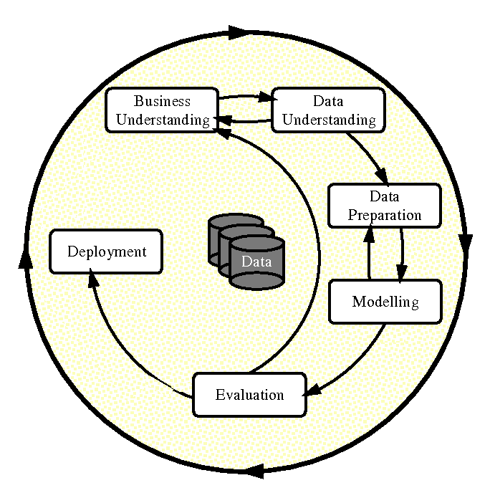
Figure 1 CRISP-DM Methodology Lifecycle
In addition, although depicted separately in Fig. 1, there are two cyclically related phases in CRISP-DM: Data Preparation and Data Understanding. The cycling revealed the risk associated with transition between sensors, and therefore, resulted in a certified, yet limited, pipeline that documented the limitations of the design instead of attempting to develop a cross-sensor solution.

Methodology Choice and Justification
There were several key reasons why CRISP-DM was selected as the methodology for this project: Structured Iteration: As mentioned above, one reason why we chose CRISP-DM was due to its ability to loop-back. This was important to us, since our early investigations had already identified the problem with the sensor transitions and our final implementation of our certified pipeline had narrowed our scope from trying to engineer an inter-calibration solution (which would have been difficult to do given the available 2012-2013 overlap data) to simply documenting the risks associated with the sensor transitions; thus, providing transparency rather than misleading others with an overly engineered solution based on unreliable data. Focus on "Data Preparation": Another reason we chose CRISP-DM was that it recognizes that approximately 50-70% of a data science project involves the preparation of the data. Based upon our experience with satellite-based poverty mapping, we agree with this estimate. We found that the primary challenge involved in creating a valid panel dataset was not necessarily developing a model, but rather in transforming large amounts of raw, unstructured, petabyte-scale imagery into a valid structured dataset. Alignment with Project Timeline: Our selection of CRISP-DM also aligned well with how our Final Year Project timeline was organized. Specifically, our investigation phase (Semester 1) corresponded to the first three phases of CRISP-DM (i.e., producing a validated panel dataset); whereas, the modeling, evaluation and deployment phases formed the basis of Semester 2. Repeatability: One additional benefit of selecting CRISP-DM as our methodology is that it allows us to document all preprocessing decisions made during the creation of our pipeline (including sensor-source provenance, year-aware normalization and rejecting polynomial DMSP-VIIRS calibration). Therefore, if anyone wants to reproduce or evaluate our pipeline at some time in the future, they will be able to do so based upon our transparent documentation. Other Methodologies Were Evaluated But Rejected: Knowledge Discovery in Databases (KDD): While KDD is very methodologically correct, it places a heavy emphasis on the "modeling" stage, whereas our project placed a greater emphasis on "business context" (SDG alignment) and "deployment" (dashboarding). Thus, we did not find KDD to be as useful for our needs as CRISP-DM. Sample, Explore, Modify, Model, Assess (SEMMA): SEMMA is another methodology developed by SAS that implies a linear process beginning with "sampling". Since we wanted to analyze the entire population (all of Malaysia) prior to aggregating the results into smaller units, we found SEMMA to be less intuitive for analyzing at a planetary scale compared to CRISP-DM. Agile/Scrum: While both Agile and Scrum methodologies allow for iteration, they are specifically developed for software development sprints. Neither Agile nor Scrum provide the data-centric phased organization that CRISP-DM offers for analytic projects. The specific segmentation of "Data Understanding" and "Data Preparation" as separate named phases in CRISP-DM directly correlates with the investigative challenges faced by this project.

Detailed Phase Descriptions
The six CRISP-DM phases have been mapped into the two semester timeframe of the FYP. Each of the phase descriptions describes which activities are carried out and what output is generated by those activities.
Phase 1: Business understanding (semester 1)
The Business understanding phase defined the context, goals and success factors of the Project based on the policy context of poverty monitoring in Malaysia.
Activities:
- problem definition: established the Sensor Gap (discontinuity dmsp-viirs) and temporal Sparsity (infrequency survey data) as the key impediments for the use of satellites to monitor poverty in Malaysia effectively.
- objective Formulation: provided specific objective of developing a State-Year panel over ten DOSM survey years during the time frame 2002-2022 instead of simply producing a snapshot map so as to enable longitudinal monitoring that is consistent with SDG-1 (no poverty).
- scope refining: reduced the analytical focus to the state-level (admin-1, 16 administrative districts) to ensure reliable statistical results because there is limited ground truth data. Identified SDG-1 as the main impact metrics for the study.
- stakeholder alignment: determined policymakers and development planners as the most relevant stakeholders consuming model outputs. Therefore, determined the need for explainable predictions and not black box accuracy.
Outputs: Project brief, objectives, scope definition, SDG alignment documentation (chap. 1).
Phase 2: data understanding (semester 1)
Data understanding consisted of systematically examining existing data resources and evaluating their characteristics, especially quality. In addition, evaluated the feasibility of creating a longitudinal panel Dataset.
Activities:
- literature review: analyzed trade-offs between dmsp (saturation) and viirs (high sensitivity); analyzed per capita vs. Total luminosity; analyzed all methods used for satellite-based poverty mapping (chap. 2).
- identifying data sources: curated certain Earth Engine collections such as corrected dmsp-ols (CCNL) and VIIRS-DNB (vnp46a1), MODIS EVI, WorldPop population density and srtm topography.
- exploratory data analysis (EDA):
  - Signal Decomposition: examined decomposition of correlation signal to demonstrate a strong spatial relationship (r = -0.584) but a weak temporal relationship (r = -0.023) to establish that model prediction strength would be largely dependent upon learning spatial relationships and not tracking short-term temporal trends.
  - VIF diagnostic tests: identified significant multicollinearity among population density features (VIF > 10) and accordingly informed algorithm selection strategy towards tree-based ensemble models that are robust to multicollinearity.
  - Temporal Stability Analysis: Night-time light remains informative; however, this study does not attempt to establish a single radiance series for 2001-2022; therefore year coded features and z-score normalization absorb inter-year scale drift.
Outputs: reports of exploratory analysis, diagnostic plots, feasibility assessments (documented in chap. 4 sec. 4.4).
Phase 3: Data Preparation (Semester 1)
The Data Preparation phase constitutes the principal technical contribution of semester 1, which involves building a harmonized and valid panel Dataset from disparate satellite and survey data sets.
Activities:
- sensor harmonization: evaluated polynomial sensor harmonisation. Evaluated that sensor transition risk represents a methodological limitation and not resolved through a fitted overlap model. Note on Semester 1 to Semester 2 calibration decision: the semester 1 evaluation established and applied quadratic dmsp-viirs calibration coefficients (β₀=0.7948, β₁=5.0549, β₂=-0.0651) and applied these calibration coefficients in semester 1 operational terms via a harmonize_final() function. More in-depth sensor analysis in semester 2 demonstrated that the 2012-2013 overlap window was too small to support a scientific defensible mapping function; consequently, z-score normalization per year was identified as a more defensible alternative to sensor transitions.
- population imputation: applied forward fill imputation strategies to WorldPop data (2021-2022) to account for delay in global demographics reporting.
- feature engineering: calculated mean values (mean), sums (Sum) for spatially aggregated statistics via GEE reducer functions; calculated Vegetation Indices (evi) to act as inverse urbanization proxies; applied Log-Transformation to officially reported poverty rates to adjust for skewed distribution.
- panel construction: combined, cleaned, and validated the final State-Year panel Dataset; therefore validated the base line for future modeling.
- quality certification: conducted a six point audit including completeness audits, temporal coherence verification, VIF analyses, and reproducibility verification.
Outputs: frozen State-Year baseline Dataset, validation list for data quality assurance, documentation regarding provenance (documented in chap. 4 secs. 4.2-4.3).
Phase 4: modeling (semester 2)
In this modeling phase, i have employed a variety of interpretable ensemble machine learning methods to be applied to the verified panel dataset. The primary objective of the modeling phase is to compare the fit of multiple model architecture configurations of the primary absolute-poverty target under two different Evaluation protocols. A second objective is to retain relative poverty as a secondary diagnostic target. Completed activities include:
- model selection: developed both random forest and XGBoost regressor based upon the literature-justified rationale that because tree-based ensemble methods are generally much less affected by multicollinearity than are traditional linear models, they are well-suited to analysis of relatively small sample size tabular datasets (i.e., n = 158).
- feature policy comparison: examined the impact of including temporal context (i.e., year and provenance) when training models by testing two different configurations -- proxy_only (using only satellite-derived features), and augmented (including satellite-derived features plus year and provenance variables) -- to determine the magnitude of improvement in predictive accuracy provided by each configuration.
- ran the entire modeling pipeline over both absolute poverty (the certified primary benchmark) and relative poverty (a comparative diagnostic).
- hard core poverty values were kept in the original source panel as a contextual description and were used as preliminary checks on the source data prior to submission but will not be used in the certification process nor incorporated into the certified output products.
- baseline benchmarking: included comparisons of all ML models developed during the project to two "naive" baselines -- global mean baseline (predicting the global mean for all observations), and year only baseline (predicting poverty from only survey-year variables, excluding input from satellite derived variables) -- to ensure that the trained models provide real predictive power beyond simply using heuristic predictions.
outputs included: trained models, predictions, metrics, feature importance rankings, saved split definitions (documented in Chapter 5).
Phase 5: Evaluation (semester 2)
The purpose of the Evaluation phase is to assess how well the models perform according to specific leakage-aware validation protocols that were created to eliminate/avoid potential spatial and temporal data leakage issues noted during the Data Understanding phase. Completed activities include:
- leave one State out (LOSO) cross validation: primary generalization test. Each of the 16 states were systematically excluded as test sets while the model was trained on the remaining 15 states. In doing so, there existed no data from the test State within the training set, therefore, the model would need to rely solely upon satellite derived variables instead of merely recalling State identity.
- as stated previously, state-level LOSO cross validation is the primary generalization test, thus excluding one State per fold for a total of 16 folds. For future work we plan to develop temporal validation for post-2022 DOSM survey data (see recommendation).
- cross target, cross policy comparison: metrics (MAE, RMSE, r^2) were calculated for each combination of target, protocol, feature policy, and model type. We then determined which configurations generalized best and failed worst.
- honest Assessment: if we observed negative r^2 values under LOSO we viewed them as evidence that generalization remained very difficult at least until unseen-State generalization improved, rather than merely being hidden or explained-away.
outputs: summary document of combined metrics, best models per target, comparative note (documented in Chapter 5).
Phase 6: deployment (semester 2)
The purpose of the deployment phase is to translate the findings from our modeling efforts into an accessible and interactive format suitable for use by decision makers/policymakers/stakeholders. Completed activities include:
- dashboard development: created an interactive technical web application built using dash that displays State-level poverty predictions along with feature importance rankings and SHAP explanations.
- explainability integration: used RF SHAP feature importance as post-selection explanatory evidence in our report. Our dashboards Overview tab provides a text-based listing of top RF SHAP features designated as "Main Factors" to allow for stakeholder monitoring review. However, we preserved DOSM's primary position.
- demonstration preparation: completed a demonstrated workflow capable of being presented for the duration of our final 20 minute presentation and 40 minute project defense, complete with valid results and navigation.
outputs: deployed dashboard application, demonstration materials, screenshots (documented in Chapter 5, Section 5.3).

Project-Specific Methodology Pipeline
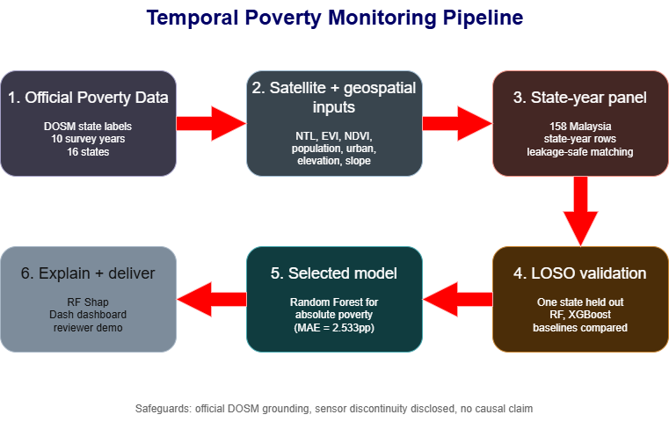
Figure 2 End-to-End Temporal Poverty Monitoring Pipeline
The project-specific pipeline retains official DOSM raw poverty labels, cleans them into project-year state poverty labels, validates those labels against the retained Malaysia model-ready panel, evaluates models with LOSO validation, explains the selected Random Forest model with SHAP, and presents the results through a supplemental Dash dashboard. The satellite and geospatial predictors are included as derived state-level features with documented provenance. The workflow treats the DMSP-to-VIIRS sensor transition as a disclosed limitation rather than a solved calibration problem.

Modelling Methodology
In this section we describe the particular modelling design choices that determine how the results of the project have been generated and validated. The justification for these choices is based on the literature review (Chapter 2) and the diagnostic findings resulting from the data understanding phase.

Algorithm Selection and Rationale
This project uses two principal tree-based algorithms. Random Forest Regressor is an ensemble method that builds many decision trees on bootstrap samples and averages their outputs (Breiman, 2001). It is retained as the selected state-level absolute-poverty monitoring model because it handles multicollinearity better than linear models, works better with small samples than deep learning, and supports the planned RF SHAP explainability workflow. XGBoost Regressor is retained as a strong gradient-boosting comparator. The rf_sensor_safe model is reported separately as the lower-error robustness benchmark, while RF SHAP explains the selected full-feature Random Forest model directly.

Evaluation Protocols
Leave one State out (LOSO) cross validation: this is the primary generalisation test. For each iteration of this experiment, one of the 16 states is removed completely as the test set while the remaining 15 states comprise the training data. By choosing this protocol, we eliminate any potential spatial leakage: i.e., the model has never viewed any example from the test State. LOSO will answer a key question about predicting poverty levels in a State without having historical data: "does the model correctly estimate poverty levels in a State where it has no prior knowledge?" We are planning a temporal sensitivity study (future work): once the next official DOSM poverty survey is published, we plan to train the model again on 2002-2022 data and validate it against the unseen post-2022 data. Since we are currently working under an active submission, we use only state-level validation via loos. Why use loos: LOSO provides direct validation of our ability to predict poverty levels in a State where we had no prior knowledge of that State's conditions. Therefore, we used LOSO as our spatial cross-validation scheme and consider LOSO to be the primary justification for selecting the best model.

Feature Policy Comparison
We evaluate Two different sets of feature policies in order to separate the predictive contribution of remote-sensing derived environmental signals from temporal context: Proxy only: contains only satellite-derived features: harmonized night-light statistics, EVI vegetation characteristics, population density, and terrain attributes (slope and elevation). This policy tests whether purely environmental signals are sufficient for estimating poverty levels. Augmented: adds year and time-based variables to the proxy features. This policy tests whether adding temporal context increases prediction accuracy. If however year becomes a major feature then we may conclude that the model is learning temporal trends instead of environmental-poverty relationships - which would have implications for what could be explained in terms of interpretation. The reason why we compare these Two feature policies is analytically important because augmented performs better than proxy only across all evaluation criteria and protocols; therefore, this indicates that adding temporal context does add predictive value but it must be framed carefully: year related features act as "predictive tools" but they do not represent "drivers of poverty", hence they should be described as an artefact of modelling rather than a causal insight.

Baseline Comparison Strategy
Certifying that ML models provide real value comes from comparing the performance of these trained models to two simple baselines: FoldMeanBaseline: this global mean baseline uses the training data mean poverty rate for every single observation in the test set. It is the easiest possible model and serves as a floor because there will be many ML models that can significantly exceed its performance. Yearonlybaseline: this year only baseline uses only the survey year as an input feature and makes no use of either satellite or geospatial features. It is the primary naive competitive benchmark. The year only model identifies the temporal trends at the national scale. Any useful satellite-enhanced ML model should exceed the year only benchmark's performance on the main target.

Explainability Framework
The project uses a multi-layered explainability framework based upon the xai literature presented in Chapter 2: Global explainability - Permutation feature importance: for each trained model, the Permutation importance of each feature is measured. This is done by measuring the change in prediction error when the values of one of the features are randomly shuffled. This gives a ranking of which satellite variables contribute most to each of the models' overall predictions. Global and local explainability - shap (TreeSHAP): SHAP values are calculated using TreeSHAP algorithm (Lundberg et al., 2019). As mentioned above, TreeSHAP is optimized for tree-based models. Additionally, shap provides both: (1) a global summary plot to show the overall importance and direction of each feature's influence; and (2) an individual prediction explanation to show why a specific state in a specific year was predicted to have a particular poverty level. Important caveat: the outputs from the explainability tools are descriptive post-selection full-data refits. The best model configuration is identified through cross validation. Then the best configuration is refit on the entire dataset to generate SHAP values. The outputs from these tools are interpretative tools that help understand patterns learned by the models. They are not evidence of accuracy in making predictions independently.

Metrics
There are Three standard regression metrics used to evaluate performance of models: Mean Absolute Error (MAE): the average absolute difference between actual observed poverty rates and poverty rates predicted by the models. Because MAE is reported in the same units as the target variable (percentage points of poverty), it can be interpreted directly. Root Mean Squared Error (RMSE): the square root of the average of the squares of the differences. Rmse penalizes large errors more heavily than MAE. Therefore, rmse will be sensitive to outlier states with extreme poverty values. R² (coefficient of determination): the proportion of variance in the target variable explained by the model. R² = 1.0 indicates perfect prediction. R² = 0.0 indicates that the model explains no more variance than the mean baseline. Negative R² indicates that the model performs worse than simply predicting the mean. When evaluating generalization to unseen states, negative R² values are expected and are reported honestly rather than suppressed.

Summary
In this chapter, we described the methodological framework for the poverty mapping project. Adoption of CRISP-DM provided an iterative structure to handle data engineering challenges that emerged during investigation phase, particularly discovery and resolution of discontinuities between dmsp-viirs sensor versions. The project-specific methodology pipeline translates six general CRISP-DM phases into a concrete reproducible workflow spanning satellite data extraction through to policy-facing explainable predictions. The modelling methodology was designed based upon Three guiding principles: (1) evaluation without leakage through sensitivity checks of temporal trend in leave one state out methodology to prevent spatial and temporal leakage risks identified in preliminary analysis; (2) honest benchmarking against naive competitive benchmarks to certify whether useful value has been added by ML models; and (3) post hoc explainability for selected rf absolute-poverty model with xgb retained as comparator clearly separated from held-out validation evidence. Specific implementation of methodology - including data collection process, sensor harmonization pipeline, training procedures of models and results - is documented in Chapters 4 and 5

Chapter 4: Design and Implementation

Introduction
This section describes how the poverty mapping framework was technically implemented based on the CRISP-DM (Cross-Industry Standard Process for Data Mining) process. There were four stages involved in the development of this framework: (1) collecting data from publically available and/or geospatial resources; (2) systematically pre-processing the data collected to account for differences in temporal and spatial resolutions; (3) conducting exploratory data analysis to identify patterns of interest within the data, e.g., identifying where signals exist, or determining what percentage of a particular geographic area has been mapped; and (4) developing models of poverty that include specific methods to evaluate their accuracy, which prevent both data leaking into training sets and over-fitting to spatial relationships. The data collection stage involves collecting a series of datasets that can be analyzed together. The basic data unit is the state-year panel, i.e., the same state observed longitudinally over time. The data collection includes information related to all 16 Malaysian administrative regions for each year in which surveys have taken place. The data collection includes information about the poverty levels for each region/state/year. The dataset is composed of 10 survey years (2002, 2004, 2007, 2009, 2012, 2014, 2016, 2019, 2020, 2022) and there are 16 regional units. After removing missing values due to unavailability of certain types of data for some states or years, there are 158 valid state-years. The first variable of interest is absolute poverty (the target variable), and the second variable is relative poverty (a diagnostic measure) and hardcore poverty (an exploratory variable). The third type of variable of interest is remote sensing input variables. These include features such as nighttime lighting, vegetation indexes, population densities, and topography. Because multiple remote sensing modalities may produce redundant features, we consider a policy for selecting either proxy-only or augmented features. We also use LOSO (leave one out) cross-validation as our main evaluation method to assess our ability to generalize under different spatial and temporal assumptions.

Data Collection

Poverty Labels
The data for labeling states as poor or non-poor comes from the Malaysian Department of Statistics (DOSM) Open Data Portal. The original raw file, hh_poverty_state.csv, provided by DOSM through its OpenDOSM hh_poverty_state dataset included official poverty labels for states from 1970-2022. Since the modeling will only take place on survey data from 2002-2022, we filter this original dataset to those record dates. Officially recognized labels included three forms of poverty measures:
- Absolute Poverty Measures: Defined as the number of people living below the official poverty line (OPL); approximately MYR 400 per capita monthly income nationwide.
- Hardcore Poverty Measures: Percentage of individuals living below hardcore poverty lines (typically half the amount of the OPL); indicative of extreme deprivations.
- Relative Poverty Measures: Bottom 40% of national income distribution; indicative of relative deprivation.
Each label is contained within a single row for each state-year record. Unfortunately, the raw DOSM file had inconsistent collection intervals throughout its history. To ensure consistent data, only records for 2002 - 2022 were used for modeling. Therefore, we have ten labeled time periods that span nearly twenty years. Each label appears under its own unique name convention; therefore we standardize names in Section 4.3.1 when we perform the initial steps of preprocessing so that names are consistently identified in a way that allows us to join them properly with the remote sensing features.

Administrative Boundaries
Geospatial boundaries are represented as vectors and come from the GADM v4.1 dataset (gadm41_MYS_1.json located in "data"). GADM v4.1 defines polygons for Malaysia's sixteen Administrative Level I units (states and Federal Territories) used in both the state map from the Dashboard and visualizing patterns of interest in the exploratory analyses.

Nighttime Lights (NTL)
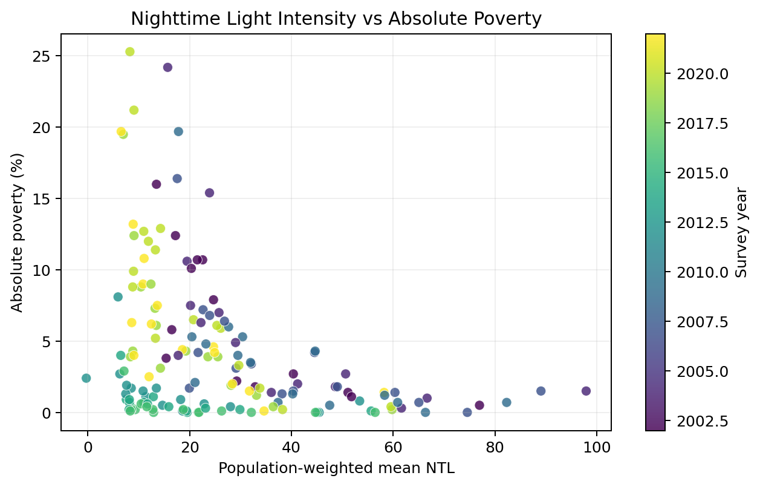
Figure 3 Nighttime Light Intensity vs Absolute Poverty Rate (Malaysian States, 2019 & 2022)
In the scatter plot shown, the cross-sectional relationship between the nighttime light intensity of each state (mean nighttime light intensity) and the absolute poverty rate of that same state for the last two survey periods is illustrated. The significant and strong negative regression line (r = -0.58, p < 0.001) supports the use of NTL as a structural poverty proxy at the state level. The low-NTL, high-poverty region contains many of the highest poverty states (Kelantan and Sabah); whereas the high-NTL, nearly zero-poverty region contains all of Malaysia's economically developed states (Kuala Lumpur and Selangor). This geographic pattern suggests that we should include NTL in our benchmark models at the state level. Satellite-derived nighttime lights (NTL) are used as the main economic activity proxy. Two different satellite-derived nighttime lights (NTL) data sources were used because they have provided continuous data coverage throughout the entire study period (1992 - 2022).
- Defense Meteorological Satellite Program - Operational Linescan System (DMSP-OLS):
i. Source: GEE Asset BNU/FGS/CCNL/v1
ii. Temporal Coverage: 1992 - 2013
iii. Spatial Resolution: ~ 1km
iv. Radiometric Calibration: Version-calibrated radiance normalized to the F182013 satellite
v. Processing: Composited annually based upon cloud-free pixels taken at nadir.
- Visible Infrared Imaging Radiometer Suite - Day/Night Band (VIIRS-DNB):
i. Source: GEE Asset NOAA/VIIRS/DNB/ANNUAL_V22
ii. Temporal Coverage: 2012 - present
iii. Spatial Resolution: ~ 500m
iv. Radiometric Processing: Composed monthly then aggregated to annual maxima; Stray Light and Cloud Masking applied.
v. Gap Period: 2011 (DMSP-OLS F182013 end) to 2012 (VIIRS-DNB begin) a & b.
Both datasets have been reduced to summary statistics by vector-based spatial reduction (GEE reduceRegion) to produce weighted mean and distribution statistics (Mean, Median, High-share Percentiles, Inter-quartile Range, Coefficient of Variation) to describe nighttime radiance intensity and spatial heterogeneity for each state-year.

Vegetation Indices
- MODIS Enhanced Vegetation Index (EVI):
i. Source: GEE Asset MODIS/061/MOD13Q1
ii. Temporal Coverage: 2000 - present
iii. Spatial Resolution: 250m
iv. Time Aggregation: 16-day composite data resampled into an annual mean and peak value
v. Calculation: A three-band formula using red, near-infrared, and blue channels to create an index that minimizes atmospheric and soil noise.
vi. Companion Measure: NDVI (Normalized Difference Vegetation Index), calculated to compare signal strength.
- MODIS Normalized Difference Vegetation Index (NDVI):
i. Same source and temporal window as EVI
ii. Additional Statistics: Annual Peak (Maximum Seasonal Value), Range (Seasonal Amplitude)
iii. Rationale: NDVI is easier to compare across studies, has fewer issues with atmospheric corrections than EVI, but uses more basic methods.
iv. Vegetation indices are produced at state-year granularity producing both mean-of-year and seasonal extreme (Peak, Range) measures to describe baseline vegetation levels and crop growth cycles.

Population and Topography
- WorldPop Global 100m Dataset:
i. Source: GEE Asset WorldPop/GP/100m/pop
ii. Temporal Coverage: 2000-2020
iii. Spatial Resolution: 100m
iv. Derivation: Census and Survey Data disaggregated to represent population numbers by rural or urban density
v. Aggregation: Total number of people per year by state, plus log base e transformed to address right skew in totals and distributions of people.
vi. Missing Years (2021-2022): Forward filled from Year 2020 before pre-processing for auditing purposes with forward fill flags to indicate the gap was replaced.
- SRTM Digital Elevation Model:
i. Source: GEE Asset USGS/SRTMGL1_003, created by NASA Shuttle Radar Topography Mission Global 1 arc second data (NASA Jet Propulsion Laboratory [NASA JPL] 2013)
ii. Temporal Coverage: Timeless (Shuttle radar topography from 2000 era)
iii. Spatial Resolution: 30m
iv. Derivation: Slope and elevation are created via local operations (Focal Operations Using an 8-Connected Neighborhood).
v. Aggregation: Weighted Mean per State, with population density as the weight when possible, else Un-weighted Mean.
vi. Justification: Topography does not change overtime and will be used to control for geographical restrictions on development

Data Preprocessing
There are three sequential stages of data preprocessing: Label Preparation, Feature Engineering and Inter-Sensor Calibration, and Final Panel Assembly and Auditing.

Phase I: Label Preprocessing
Raw DOSM poverty labels were standardised and transformed before being joined to the geospatial feature table.
State names were mapped to a single canonical state_key so that DOSM records could be joined consistently to GEE state geometries. The mapping covers Johor, Kedah, Kelantan, KualaLumpur, Labuan, Melaka, NegeriSembilan, Pahang, PulauPinang, Perak, Perlis, Putrajaya, Sabah, Sarawak, Selangor, and Trengganu.
The retained survey years are 2002, 2004, 2007, 2009, 2012, 2014, 2016, 2019, 2020, and 2022. These years reflect the official DOSM survey schedule and the availability of compatible remote-sensing features.
Poverty incidence rates were transformed using log1p(poverty_pct / 100) to reduce right skew and support models that assume smoother target distributions. The three targets remain separate: poverty_absolute, poverty_hardcore, and poverty_relative.
Labuan 2002 has no absolute or hardcore poverty value in the source DOSM file, but the relative poverty value is present. The absolute-poverty modelling therefore uses 157 observed state-year rows, while relative poverty uses all 158 rows.

Phase II: Feature Engineering and Sensor Transition Handling
Remote-sensing proxies were aggregated from pixel-level GEE exports into state-year summaries. The main sensor issue is the transition between DMSP-OLS and VIIRS-DNB nighttime-light products.
The workflow does not claim to create a fully harmonised raw radiance series from 1992 to 2022. Instead, it uses the CCNL product as a pre-calibrated nighttime-light input where applicable, records source-year and sensor provenance, and treats cross-sensor comparability as a methodological limitation.
For each state-year, the feature table stores summary statistics for nighttime lights, vegetation indices, land cover, population, and topography. These include means, medians, high-share percentiles, distribution moments, z-scores, and ranks where relevant.
WorldPop population data are available through 2020, so population counts for 2021 and 2022 are forward filled and flagged with pop_filled_2021_2022. This preserves population-weighted aggregates while making the imputation visible for review.

Phase III: Panel Assembly, VIF Diagnostics, and Export
The cleaned DOSM label table and the geospatial feature table were merged on state_key and year, producing a model-ready panel with 158 rows across 16 states and 10 survey years.
The panel contains identifier columns, target columns, audit/provenance columns, and satellite/geospatial proxy features. Audit fields record source years and sensor choices; proxy features describe nighttime lights, vegetation, land cover, population, elevation, slope, and derived yearly ranks or z-scores.
VIF diagnostics were calculated for numeric features to document multicollinearity. Population-related variables showed expected redundancy, but tree-based models such as Random Forest and XGBoost are less sensitive to this issue than linear regression. PCA was therefore not used, so feature interpretation could remain transparent.
The exported data layers are data/raw/dosm/hh_poverty_state.csv, data/interim/dosm_poverty_state_clean.csv, and data/state_year_panel_modelready_2002_2022.csv. The final model-ready panel combines cleaned DOSM labels with derived state-level satellite/geospatial features.

Data Understanding / Exploratory Data Analysis

Dataset Summary and Coverage
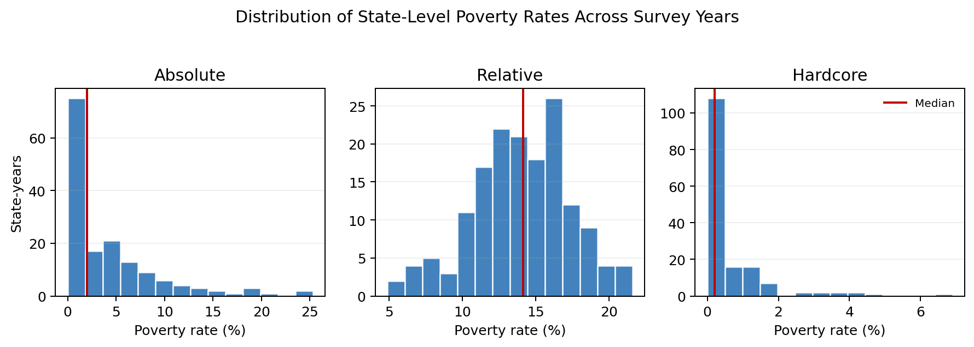
Figure 4 Distribution of State-Level Poverty Rates Across Survey Years
The boxplots below show the distributions of absolute and relative poverty rates across Malaysia's states for each of the ten survey years in the panel. The distribution of absolute poverty is skewed towards higher levels of poverty primarily due to the presence of high-poverty states (Sabah, Kelantan and Sarawak). The interquartile range decreases from 2002 to 2022 as indicated by DOSM's reported national decline and convergence of poverty rates. A subset of outlier values in the upper portion of the distributions illustrate persistent geographic inequality at the state-level which is a key motivation for developing an application of a state-level monitoring system. There are 158 unique combinations of state and year in the validated panel covering 16 different administrative regions over 10 survey years. There are no duplicate state-year keys. All 16 states have complete coverage over the period {2002, 2004, 2007, 2009, 2012, 2014, 2016, 2019, 2020, 2022}. Putrajaya has complete coverage over 8 years (all years except 2002 and 2004) while Labuan has complete coverage over all 10 years with only its absolute and hardcore poverty values missing in 2002. Only relative poverty values will be modeled. The full dimensionality of the panel is 158 rows x 70 columns representing identifiers, targets, meta/audit fields and approximately 50 geospatial proxy features. Descriptive statistics: Incidence rates of poverty prior to transformation ranged from almost zero in the urban Federal Territories to greater than twenty percent in some of the rural states. Transformed absolute poverty ranged from -infinity where poverty was absent/replaced with log(1+0.001)= -6.9 to approximately 2.4 (a twenty-one percent incidence rate). Transformed relative poverty rates remained relatively stable and spanned approximately -1.5 to 0.5 on a log scale. Radiance values from nighttime light imagery ranged from approximately zero to nearly eight hundred nanoWatts/cm^2/sr over time and sensors. Values of NDVI and EVI typically ranged between zero and one with average values ranging from approximately 0.3 to 0.5 indicative of tropical savannas. State populations ranged from approximately ten thousand (Labuan) to six million (Selangor). Elevations ranged from sea level to approximately four-thousand meters in Sabah's mountainous highlands. Due to the multi-order-of-magnitude differences within many of these ranges log transformations and normalization were applied during the preprocessing phase.
Feature | N | Mean | Std | Min | Median | Max
NTL Mean Intensity | 158 | 26.543 | 18.928 | -0.305 | 21.584 | 97.919
NTL Median Intensity | 158 | 26.269 | 18.983 | -0.307 | 21.475 | 97.919
NDVI Mean | 158 | 0.55 | 0.079 | 0.353 | 0.575 | 0.665
NDVI Peak | 158 | 0.664 | 0.089 | 0.424 | 0.697 | 0.791
NDVI Range | 158 | 0.35 | 0.074 | 0.199 | 0.353 | 0.54
EVI Mean | 158 | 0.356 | 0.059 | 0.209 | 0.37 | 0.438
Urban Land Fraction | 158 | 0.415 | 0.266 | 0.048 | 0.324 | 0.99
Cropland Fraction | 158 | 0.141 | 0.204 | 0.0 | 0.046 | 0.781
Forest Fraction | 158 | 0.098 | 0.1 | 0.0 | 0.059 | 0.368
Elevation (m) | 158 | 51.655 | 33.581 | 13.378 | 42.541 | 132.488
Slope (degrees) | 158 | 0.882 | 0.372 | 0.42 | 0.838 | 1.723
Population (grid sum) | 158 | 17088.094 | 13523.95 | 583.684 | 14913.733 | 66020.617
Poverty Absolute (%) | 157 | 4.28 | 5.178 | 0.0 | 2.0 | 25.3
Poverty Relative (%) | 158 | 14.027 | 3.341 | 4.9 | 14.15 | 21.6
Poverty Hardcore (%) | 157 | 0.583 | 1.025 | 0.0 | 0.2 | 6.9
Table 4 Summary Statistics of Continuous Variables (State-Year Panel, n=158)

Temporal and Spatial Signal Analysis
Temporally - The Pearson correlation between poverty and the primary indicators (proxies) is calculated for every year. Then an average value is taken. Throughout the entire 1992-2022 time series (available sensors), nighttime light correlates negatively with poverty (r ~ -0.58 to -0.62 throughout decades) and indicates areas with higher brightness tend to be wealthier. Both NDVI and EVI correlate very weakly with poverty (r ~ -0.20 to 0 through the years) and indicate that vegetation is a poor indicator of poverty. The correlation pattern is consistent throughout decades and indicates that the proxy has longitudinal validity. Spatially - At any one point in time (year), the correlation (between states) of nighttime light with poverty is high (r ~ -0.58). But temporally (the changes over time within a state), it is low (r ~ -0.23), and implies that many areas have long-term persistence of poverty regardless of the level changing. As such, we will use temporal-holdout evaluation: a model trained on data up to 2020 can take advantage of these persisting spatial patterns (as opposed to the temporal patterns) and therefore inflate its performance during validation. To avoid this, we used a state-based holdout (Section 4.5.2) to prevent spatial overfitting. Stability of Proxy Temporally: Each year from 2001 to 2022, we compute the Pearson correlation r(NTL,poverty_absolute). The correlation is strongly negative (r ~ -0.60) throughout all years indicating the presence of a strong signal. We confirm the stability by computing the standard deviation of r across years and find that it is approximately 0.10. The above is also true for each target variable (absolute, relative, hardcore), however the magnitude of correlations vary slightly, yet the directionality and ordering of the proxies remain constant.
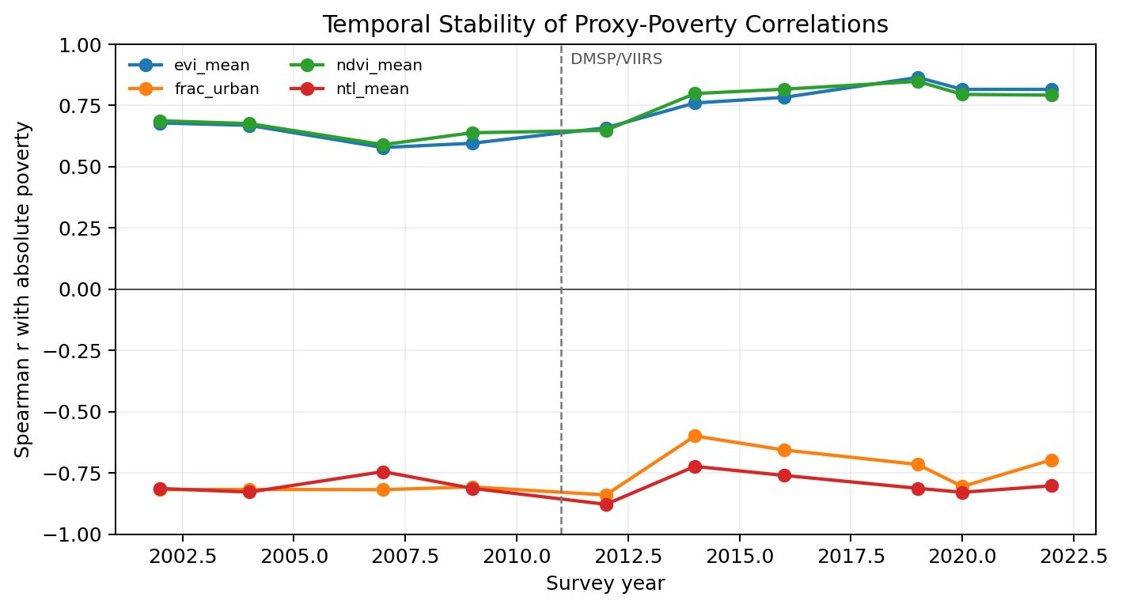
Figure 5 Temporal Stability of Proxy-Poverty Correlations: Spatial Signal (left) vs Temporal Signal (right)

Missing Data and Data Quality
Missing Feature Values: Population data (WorldPop) are provided through 2020 and have been forward filled for the years 2021-2022, and are clearly marked as being so. All remote sensing proxies (NTL, NDVI, EVI, landcover) have complete data for all state-years in the original datasets. Any pixel-level gaps larger than what would occur when aggregating to the state level do exist; none do in our case. There are no missing values anywhere else in the final dataset. Missing Target Values: Feature-Year Exception: The feature-panel typically uses the geospatial feature year most proximal to the current year for each feature without using any future poverty measures. In one documented instance, a feature-year exception exists for the 2012 survey year. Nighttime Light Variables used the 2013 VIIRS Annual Composite in lieu of the directly comparable 2012 VIIRS Annual Composite that existed in the original dataset. This resulted in loss of data for 16 out of 158 state-year observations. This is considered a limitation related to availability of data rather than inclusion of further label information regarding poverty. Labuan 2002 had missing values for both poverty_absolute and poverty_hardcore due to non-existence of those data points in the source DOSM file; however Labuan's poverty_relative did exist in the file. For certification purposes, the absolute-poverty baseline includes data from 157 total state-year observations (with Labuan 2002 removed); whereas, all three relative-poverty baselines include data from all 158 total state-year observations. Additionally, there were no data points in the source file for hardcore poverty for Labuan; however this was irrelevant as the evaluation covered only absolute and relative poverty metrics. Data Quality Flags: We exclude audit and metadata fields (mean_target_year, mean_ntl_year_used, mean_ntl_sensor_code, mean_pop_year_used, and their respective weighted means) from the "proxy-only" feature policy that restricts itself to remotely sensed and geospatial interpretable proxies. These fields are included only in the "augmented-policy", which provides temporal context but reduces interpretability. Panel Consistency Checks: We verify that our panel meets all of the following criteria:
- There are no duplicated (state_key, year) pairs
- The panel is fully populated in terms of state-year combinations (i.e., all 16 states x 10 years = 160 total possibilities; 158 total due to two missing entries)
- The panel is sorted by state_key followed by year
- Population counts are non-negative
- Poverty-rates fall in [0,100] prior to scaling
- All proxy-features have finite values after scaling All verification steps pass and confirm that our data is accurate

Feature Correlation and Leakage Prevention
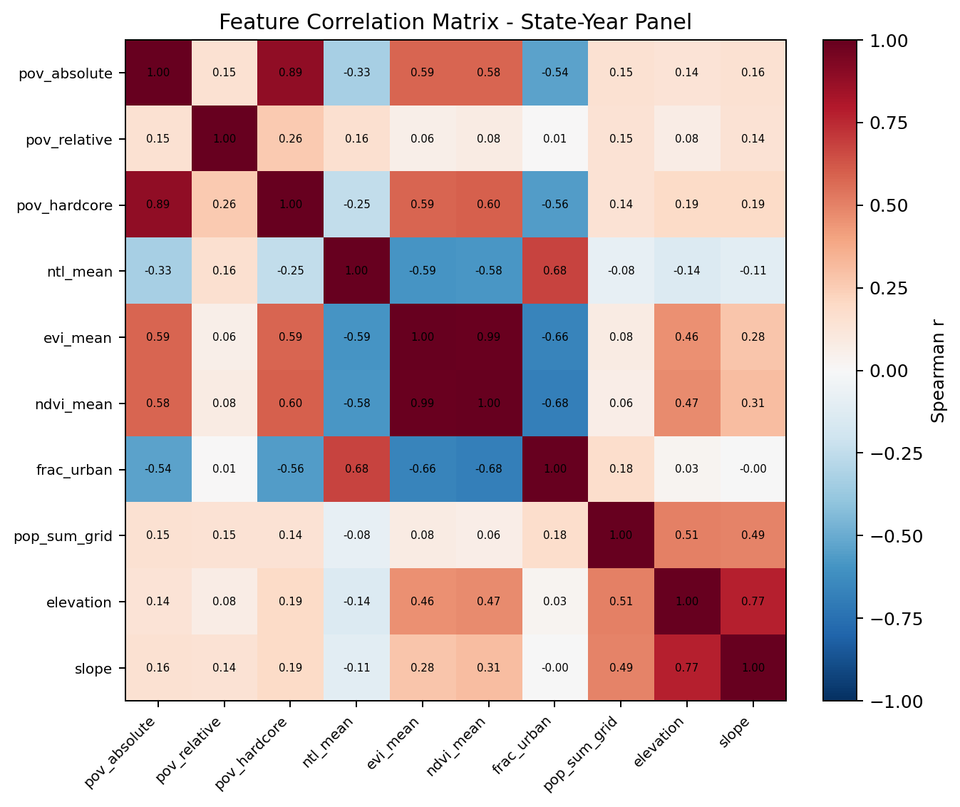
Figure 6 Feature Correlation Matrix - State-Year Panel (n=158)
The figure depicts the Pearson correlation matrix of primary satellite-derived features against poverty objectives. The strong, negative correlation between nighttime light levels and the rate of poverty indicates the spatial proxy's validity for NTL at the state level. Moderate positive correlations exist between poverty metrics and vegetation indices (ndvi, evi) and urban fraction. A high degree of inter-feature correlations (e.g., mean and median NTL, mean and median ndvi) support the necessity for multiple model comparisons, fold-level validations and cautious interpretations rather than reliance upon an individual proxy feature.
Proxy Inter-Correlation: Pearson correlations were calculated amongst the ~50 proxy features (appendix: correlation matrix). As anticipated, redundancy was found:
- mean and median NTL, along with other percentile values (p₁₀, p₂₅, p₇₅, p₉₀) showed a very high correlation value (>0.9).
- similar vegetation signals captured by ndvi and evi showed a very high correlation value (≈ 0.8).
- moderately high correlation values (≈ 0.6) existed between urban fraction and total population because total population and urbanization are related.
- nearly perfect correlation values (≈ 0.98) were observed between z-score and rank features due to both being monotonically transformed from one another. Although some redundancy exists, no feature selection is done prior to modeling; instead, automatic pruning of irrelevance features by tree-based models (Random Forest, XGBoost) are used. Tree-based models preserve all potential signal and minimize manual bias.
Prevention of information leaks using test set data for model training during cross-validation:
An important decision made when designing this model is to prevent the leakage of information (i.e., using test set data to train) in cross-validation.
Pre-split operations: dosm label standardization, poverty log-transformation, retained remote sensing aggregation output, and documented source year treatment are performed before model fitting. The Rationale for performing these operations on the entire dataset before it is split into different folds is to ensure that the operations are pre-split and thus do not require model specific parameters or test set statistics to be determined. Therefore, any calibration parameters that may have been fit based on either a pre-split operation or derived feature are now "frozen" throughout all subsequent model building steps.
Post-split operations: scaling of features (z-scoring standardization or log transformation of untransformed features), feature selection, and hyperparameter tuning of models are all performed in each fold. Only training data can be used during these operations to ensure that there will be no test data contamination.
In practice, since tree-based models (Random Forest, XGBoost) are scale invariant (i.e., the results of a model trained on scaled data are equivalent to those trained on unscaled data), post-split scaling does not occur (i.e., it is not necessary). Therefore, the distinction between pre-split and post-split operations becomes less relevant. However, if SHAP values are desired for explanation purposes, then post-split refit must occur so that only in-fold learned representations are used.

Model Building

Feature Policies and Target Variables
Feature Policies: Two policies regarding feature development were created to investigate how predictive accuracy could be traded off with interpretability:
Policy regarding proxy features only: Features included in this Policy include:
- Population (pop_sum_grid, pop_sum_grid_log1p)
- Elevation Slope Vegetation indices (mean, peak, range):
- NDVI/EVI Land cover fractions: cropland/forest/urban
- Night time light statistics (mean, median, percentiles/IQR/CV): NTL Yearly z-scores/ranks of NTL statistics: z-scores/rank
Features excluded from this Policy include:
- Audit/metadata fields: year; mean_target_year; mean_ntl_year_use; mean_ntl_sensor_code; mean_pop_year_use; weighted-mean variants
Rationale: geographic and economic proxies, directly interpretable as real world phenomena. Represent what a practitioner would expect to use in a deployment setting.
Policy regarding augmentation: This Policy includes all of the previously stated proxy-only features plus all audit/metadata fields listed above:
- Year Mean_target_year Mean_ntl_year_use mean_ntl_sensor_code Mean_pop_year_use Weighted-mean variants
Rationale: enrichment of input space allows model to capture temporal trends/sensor specific biases/data provenance effects. Increases predictive accuracy but complicates interpretability (a feature importance ranking for 'mean_ntl_year_use' is harder to explain to policymakers than 'nighttime lights intensity').
Target variables: Three poverty metrics are independently modeled:
- Poverty absolute: official poverty incidence (percent below official poverty line)
- Poverty Relative: bottom forty percent income threshold captures Relative deprivation
- Poverty hardcore: severe poverty incidence (percent below human poverty line) subset of poverty absolute
Log1+x transforms were applied to each of the Three targets to stabilize their variances and improve normalities. These transformations were completed in phase i preprocessing (Section 4.3.1) and persist through all subsequent modeling steps

Evaluation Protocols
Cross-validation is used to assess whether your model performs well when faced with new combinations of input variables. Leave-one-state-out (LOSO) cross-validation, also referred to as groupwise cross-validation, assesses model performance by leaving one state completely out at a time and then assessing model performance using the other states. In our study, we have 158 total observations of state/year. Our focus is on the ability of the model to predict poverty for new states or for current states in future years without having to retrain on their data. Thus, LOSO assesses exactly what we want from an operational standpoint. We compute three different measures of fit - Mean Absolute Error (MAE), Root Mean Squared Error (RMSE) and R-squared (macro-averaged). These fit statistics are computed separately for each of the 16 LOSO cross-validations and the standard error across these cross validations provides an assessment of the reliability of the average fit statistic for a given measure of fit. Temporal validation - i.e., assessing model performance over time - will be assessed through additional research post-submission using available DOSM survey data beyond 2022. Because our active submission uses only state-level LOSO cross-validation we are assessing only spatial generalization to unseen states.
LOSO provides us with robust estimates of overall spatial generalization performance. Specifically, LOSO is a 16-fold cross-validation approach that provides us with strong aggregate level metrics along with standard deviations across folds.
Why do we choose LOSO? LOSO directly addresses the key question: Can my model predict poverty in a state for which I have never collected data?
LOSO = "Can I accurately predict the amount of poverty in a state I've never seen before?" This is an important question if you plan to scale up your model to cover new areas (e.g. deploying your model in a region it has never been applied in).
We believe that LOSO is the best method for this project since it allows us to avoid problems associated with spatial leakages and directly address the questions most relevant to our users' needs.
Since our project's ultimate application is making predictions about the amount of poverty in regions we have not yet sampled; LOSO results are therefore used to make all selections related to choosing models for deployment.

Baseline Models
There are two non-machine learned baselines included:
1. FoldMeanBaseline:
a. Predictions: For each test fold, use the mean target value predicted in the training fold.
b. Rationale: A simple model that predicts based upon the "mean" without attempting to identify a proxy.
c. Expectations: Poor performance (high values for both MAE and RMSE); Negative R² (the model is worse than the global mean)
2. Year-only Baseline (for all evaluation protocols):
a. Predictions: Use a model trained solely on survey year as the input variable (i.e., no satellite inputs) to predict poverty for each test fold. This is the `year_only_xgb` row in the LOSO comparison table.
b. Rationale: If a model cannot perform better than a model trained solely on year alone, there is little point in including satellite inputs in a machine-learning model. Therefore, the year-only baseline represents a critical competitor for determining how much value satellites add to the model.
c. Expectations: For relative poverty, year-only will likely out-perform or match models that include satellite features due to the fact that relative poverty is largely determined by changes in national incomes rather than local economic conditions captured via satellite proxies.
d. Note: As stated above, all of the metrics evaluated in this paper use LOSO as the main method for evaluating model performance. The year-only comparisons are provided in the LOSO comparison tables for all of the evaluated targets for poverty.

Learnable Models
Two learnable ensemble models were created:
Random Forest Algorithm: An aggregation of decision trees that have been trained on bootstrapped samples to produce a single output. The outputs produced by each tree are aggregated to produce an average output.
- Hyperparameters:
  - n_estimators = 300: The number of decision trees; this was determined as a balance between reducing variance (the degree to which a sample will vary from the population) and minimizing the time required to train the model.
  - max_depth = 6: The maximum number of nodes allowed in the decision tree; this limits the expressive power of the model to minimize overfitting on the limited number of observations (n=158).
  - min_samples_leaf = 2: The minimum number of observations in a node before it can be split into child nodes; this prevents the creation of overly complex splits due to the limited number of observations available.
  - random_state = 42: A seed used for generating random numbers, ensuring that the results are reproducible.
  - n_jobs = 1: Indicates that the model should use a single processor to perform the training operation; since there are multiple processors available, but the amount of data is relatively small, we did not see a need to use multi-processing.
- Motivation: Random forests are non-parametric models that are resistant to outliers and high levels of multicollinearity and they can provide interpretations through the feature importance provided by the model. XGBoost:
Algorithm: A gradient boosted ensemble of decision trees where at each iteration, new decision trees are added to refine previous decisions based on residuals.
- Hyperparameters:
  - objective = "reg:squarederror": This indicates that we want to use mean squared error as our loss function; this is commonly used when performing regression modeling.
  - n_estimators = 200: The number of iterations performed by the boosting process; this was determined as a balance between allowing sufficient learning to occur while avoiding excessive computing costs.
  - max_depth = 3: Shallower than Random Forest's max_depth to account for the smaller sample sizes involved in this project and to reduce potential overfitting issues.
  - learning_rate = 0.05: Specifies how much each booster adds to the existing predictions; a lower learning rate tends to improve generalization performance but increases computation time. o subsample = 0.8: Specify what fraction of training examples should be used to fit each decision tree; this helps to reduce variability in decision making. o colsample_bytree = 0.8: Similar to subsampling, specifies what fraction of input features should be considered by each individual tree in order to encourage greater variety among features. Additional L1 regularization (reg_alpha = 0.1) is applied to help avoid overfitting on the relatively small panel of data. o reg_lambda = 1.0: L2 regularization parameter; specifies the penalty for complex models.
- Motivation: Gradient Boosted Ensembles generally tend to work well with many types of tabular data and XGBoost offers a modern implementation that can serve as a good baseline for comparative purposes against other models such as the Random Forest model selected and also serves as a suitable TreeSHAP model for providing feature importance explanations for the selected Random Forest model.
Both of these models are trained and tested similarly across all two feature sets and both testing protocols, thus enabling us to systematically compare them.

State-Level Model Evidence Chain
The final evidence chain is built around one state-level supervised panel. Official DOSM poverty labels and satellite/geospatial features are combined for 10 survey years across 16 Malaysian states or territories.
During feature construction, survey-year rules and source-year provenance are recorded so that satellite features are linked only to valid survey windows. Downstream evaluation uses LOSO cross-validation, which prevents the same state from appearing in both the training and held-out fold for a given validation round.
The notebook workflow then produces the model comparison tables, LOSO fold predictions, uncertainty intervals, RF SHAP feature rankings, dashboard contracts, and report QA artifacts used as the submission evidence chain.

Explainability and Feature Importance
TreeSHAP is used after model selection to explain the selected Random Forest absolute-poverty model and the XGBoost comparator. The selected model is refit on the available observed rows for descriptive feature-importance analysis.
These SHAP values are post-selection explanations, not held-out validation evidence. Model validity is assessed through the LOSO metrics and uncertainty analysis reported separately in the benchmark outputs.
The explainability artifacts include ranked feature-importance tables and SHAP beeswarm plots. Chapter 5 uses these outputs to interpret which features the trained models rely on, while keeping causal and policy claims separate from model explanation.

Implementation Details
This chapter documents the implementation baseline for the poverty monitoring framework.
Data collection combines official DOSM poverty labels, GEE remote-sensing imagery, GADM state boundaries, WorldPop population data, and static topography. Data preparation standardises state identifiers, filters records to valid survey years, transforms poverty targets, aggregates satellite features to the state-year level, and records source-year and sensor provenance.
The final panel contains 158 rows and is temporally consistent at the national survey-year level while remaining spatially diverse across states. Labuan 2002 is excluded from absolute-poverty modelling because poverty_absolute is unavailable, while relative poverty retains 158 rows.
Model development compares proxy-only and augmented feature policies, uses fixed hyperparameters for reproducibility, and evaluates Random Forest, XGBoost, Ridge, ElasticNet, and year-only baselines under LOSO validation. TreeSHAP is used only for post-selection explanation.

Feature List and Definitions
Feature Category | Features | Count | Data Source
Identifiers | state_key, state, year | 3 | Merged (DOSM + GEE)
Targets | poverty_absolute, poverty_hardcore, poverty_relative | 3 | DOSM Open Data Portal
Audit/Provenance | mean_target_year, mean_ntl_year_used, mean_ntl_sensor_code, mean_pop_year_used, wmean_* variants | 9 | GEE + DOSM processing logs
Population | pop_sum_grid, pop_sum_grid_log1p | 2 | WorldPop/GP/100m/pop
Nighttime Lights (NTL) | wmean_ntl_mean, wmean_ntl_median, wmean_ntl_highshare, dist_ntl_mean_mean, dist_ntl_mean_std, dist_ntl_mean_p10/p25/p75/p90, dist_ntl_mean_iqr, dist_ntl_mean_p90_p10, dist_ntl_mean_cv | 14 | BNU/FGS/CCNL/v1 (DMSP-OLS) + NOAA/VIIRS/DNB (VIIRS)
Vegetation (NDVI/EVI) | wmean_ndvi_mean, wmean_ndvi_peak, wmean_ndvi_range, wmean_evi_mean | 4 | MODIS/061/MOD13Q1
Landcover Fractions | wmean_frac_urban, wmean_frac_cropland, wmean_frac_forest | 3 | WorldPop + MODIS LC
Topography | wmean_elevation, wmean_slope | 2 | USGS/SRTMGL1_003
Distribution (Urban/Bright Pixels) | dist_urban_cell_share_thr02, dist_bright_cell_share_thr1, dist_urban_pop_share_thr02, dist_bright_pop_share_thr1 | 4 | Derived from NTL thresholds + WorldPop
Population Distribution | dist_pop_sum | 1 | WorldPop/GP/100m/pop
Z-Scores & Ranks (per feature per year) | wmean_*_z_by_year, wmean_*_rank_by_year | ~10 | Derived descriptive QA fields; excluded from final supervised LOSO feature sets
Table 5 Complete Feature Definitions and Data Sources
Inventory of columns in final supervised LOSO feature sets: 70 columns containing identifiers, target labels, fields identifying source-year/provenance, mean values by area/feature based on geographic location, distributions based on features/characteristics, and descriptive qa z/rank fields for year/same year. Selected current full model uses 21 features & sensor safe benchmark uses 10 features.

Model Hyperparameter Justification
Hyperparameters for Random Forest:
N_estimators=300: a common recommendation is 100 to 500 trees. 300 achieves a balance between bias (increasing number of trees decreases variance) and computational burden. Max_depth = 6: with only 158 observations, max_depth=6 limits the maximum depth of the decision tree to about 2^6 = 64 possible leaf nodes per tree. This represents sufficient capacity to fit finer grain relationships in the data without allowing trivial over-fitting. More complex trees (i.e. Max_depth=none) may result in significant over-fitting when working with small n data. Min_samples_leaf = 2: min_samples_leaf=2 permits leaf nodes with a minimum of 2 observations. Given the choice of max_depth=6, it prevents splitting of a node into too many branches. Hyperparameters for xgboost:
N_estimators=200: number of boosting iterations. Conservative limit established to prevent over-fitting. Early stopping not implemented (validation set not available), therefore establishing 200 as an upper limit. Max_depth = 3: shallower than rf to reflect constraints imposed by small n, as well as known instability of boosting on small datasets. Learning_rate = 0.05: learning_rate or shrinkage factor for step-size. A conservative setting. Smaller learning rate improves generality at the expense of requiring additional iterations. Subsample = 0.8, colsample_bytree = 0.8, reg_alpha = 0.1: Stochastic boosting combined with L1 regularization; randomization and slight leaf weight penalization help to reduce over-fitting in the 158-observation panel. Reg_lambda = 1.0: L2 penalty on leaf weights. Default value (1.0) provides a light base-line for regularization. Cross-validation could potentially tune reg_lambda if necessary; however, fixed hyperparameters have been employed here to maintain Reproducibility. In a larger project, nested cross-validation (evaluation loop outside of training loop, and hyperparameter-tuning loop inside) would generally be practiced; here, fixed hyperparameters can be justified by: Small n data context: potential risk of over-fitting the outer-loop during hyperparameter tuning leading to inflated performance estimates. Reproducibility: by employing fixed hyperparameters, identical results can be produced by users reproducing the exact notebook-first modeling workflow. Practicality: employing fixed hyperparameters (shallow trees, high regularization) is likely to provide acceptable estimates compared to what one might expect when evaluating typical tabular data.

Leakage Prevention Checklist
Step | Pre-Split (Full Data) | Post-Split (Per Fold) | Justification
Label standardization (state name mapping) | ✓ | - | Deterministic, no statistics fit
Poverty log-transformation | ✓ | - | Deterministic transformation
Remote sensing aggregation (GEE reduceRegion) | ✓ | - | Physics-based, no learning
Night-time-light sensor transition handling | Partial | - | Certified branch documents source-year caps and sensor change; no polynomial overlap calibration is claimed
Feature z-score standardization | - | ✓ | Must use training fold mean/std only
Feature log-transformation (where additional) | - | ✓ | Train fold statistics only
Feature selection / PCA | - | ✓ | Would learn from training fold if applied
Model hyperparameter tuning | - | ✓ | (Fixed here, but conceptually post-split)
Model training | - | ✓ | Training fold data only
Prediction on test fold | - | ✓ | Held-out test fold only
SHAP explanation (post-selection refit) | ✓ (full data) | - | Refit after model selection; descriptive only
Table 6 Leakage Prevention Checklist

Summary
Chapter 4 sets the implementation baseline for the project: the state-year panel, feature inventory, fixed hyperparameters, and leakage-prevention checks. These implementation details support the evaluation and deployment results discussed in Chapter 5.

Chapter 5: Results and Discussions

Introduction
Chapter 5 presents the empirical findings from the machine learning pipeline for Malaysia state-level poverty monitoring. It reports model evaluation results, explains the selected model, discusses limitations of interpretation, and describes the dashboard deployment.

Model Evaluations and Discussions

Leave-One-State-Out Cross-Validation Results
Leave-one-State-out (loos) cross validation represents an extremely rigorous testing method of spatial generalization. In each iteration of loos cross validation, one of the sixteen states is removed completely and the rest fifteen states are used as input to train the models. This closely approximates a real-world environment where predictions need to be produced for unseen new states.
Target | Model | MAE (pp) | RMSE | R² | Spearman
Absolute | RF sensor-safe (lowest MAE benchmark) | 2.362 | 4.243 | 0.324 | 0.806
Absolute | XGBoost full (rank comparator) | 2.414 | 4.489 | 0.244 | 0.823
Absolute | RF full (selected) | 2.524 | 4.564 | 0.218 | 0.787
Absolute | XGBoost sensor-safe | 2.716 | 4.965 | 0.075 | 0.765
Absolute | XGBoost year-only | 2.961 | 4.846 | 0.118 | 0.491
Relative | XGBoost year-only (selected) | 2.240 | 2.892 | 0.246 | 0.428
Relative | XGBoost sensor-safe | 2.475 | 3.311 | 0.011 | 0.468
Relative | RF sensor-safe | 2.545 | 3.335 | -0.003 | 0.390
Relative | XGBoost full | 2.547 | 3.293 | 0.022 | 0.426
Relative | RF full | 2.633 | 3.405 | -0.046 | 0.367
Table 7 State-Level LOSO Cross-Validation Results (Malaysia state-level benchmarks, n=157 absolute and n=158 relative state-year observations)
Findings: Absolute poverty: the selected primary point predictor is the full feature Random Forest (MAE = 2.524 pp., RMSE = 4.564, r² = 0.218, Spearman = 0.787). The sensor-safe Random Forest benchmark is the most accurate observed absolute poverty MAE for the regenerated run (MAE = 2.362 pp., r² = 0.324) and therefore is included as a robustness benchmark instead of replacing the full feature shap model. Current XGBoost is the top ranked comparator (MAE = 2.414 pp., r² = 0.244, Spearman = 0.823). Rf is identified as the selected interpretable point predictor as opposed to being the lowest error model. Relative poverty: the year only XGBoost baseline is the highest performing (MAE = 2.240 pp., r² = 0.246) which significantly surpasses both XGBoost with satellite / geospatial features and Random Forest indicating that national time trends have a much stronger influence than satellite observable spatial proxies to explain Relative poverty within the available State panel. Baseline benchmark: the year only baseline is not just an afterthought; it is the reality check for the project. When satellite / geospatial features are added to the year only baseline, absolute poverty improves while Relative poverty does not. Therefore, there is no over claiming of universal predictability by satellite. Conclusion: based on the state-level LOSO evidence alone, the selected state-level point predictor for absolute poverty is the full feature Random Forest model. Additionally, XGBoost remains a secondary comparator. Both rf and xgboos surpassed the year only baseline in terms of absolute poverty MAE, indicating that both satellite and geospatial features provide modest additional information at the state-level regarding absolute poverty. Equally importantly, another finding has been reported herein - some poverty definitions are better captured by policy / time trend indicators than by remote sensing proxies.

Cross-Target Comparison
The three poverty measures exhibit different difficulty profiles regarding prediction: Poverty absolute (% of population in absolute poverty): primary target. Both rf and XGBoost outperformed the year only baseline supporting a modest contribution of satellite / geospatial information at the state-level. Relative poverty: the year only baseline provides more stronger signal than satellite features to explain Relative poverty at the state-level; thus, the year only baseline remains the best predictor of Relative poverty in this available panel. Hardcore poverty (% severe poor): included in descriptive data where available for each State but not included within final state-level benchmark selection due to focusing on the validated notebook benchmark of absolute & Relative poverty.

ML Models vs Baselines Discussion
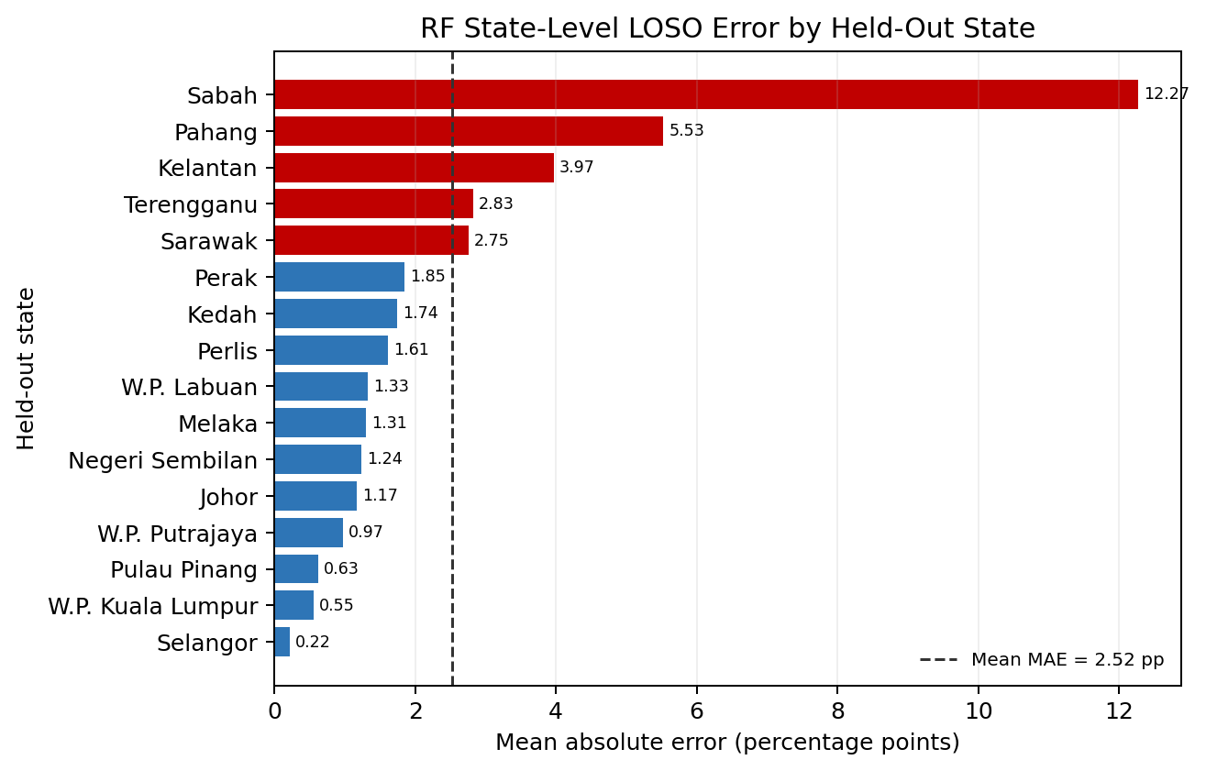
Figure 7 State-Level RF LOSO MAE by Held-Out State - Absolute Poverty
The bar plot reports the mean absolute error for each of the 16 held-out state/territory folds when predicting absolute-poverty levels with the selected Random Forest model. Sabah is the hardest state to predict, while most other states have an MAE below the overall LOSO MAE of about 2.52 percentage points.
The purpose of this plot is diagnostic. It shows where model error is concentrated; it does not show where poverty is highest.
Relative to the year-only baseline, satellite and geospatial features improve absolute-poverty prediction accuracy. The gain is modest, so it should be treated as empirical support for state-level monitoring rather than proof that satellite proxies will work equally well for every poverty definition.
The results are target-specific. For poverty_absolute, the full-feature Random Forest is selected as the primary SHAP explanation surface, while rf_sensor_safe is reported as the lower-error robustness benchmark and XGBoost remains a comparator. For poverty_relative, the year-only baseline performs best, indicating that relative poverty in this state panel is mainly trend-driven.

Model Use Boundary
The output produced by the validated model is a Malaysia state-level monitoring result. The model may be used for retrospectively analyzing poverty trends in each state during each survey period and comparing those trends between official survey periods, but the model cannot replace official releases of DOSM poverty statistics.

Comparison Against Similar Works
Regional comparisons include Hutasavi and Chen (2020), who used nighttime satellite imagery to estimate community-level socioeconomic status in Thailand, and Gonzales Martinez and Cooray (2025), who applied spatial machine learning to poverty targeting in Indonesia. These studies are relevant because they use satellite-based welfare estimation in Southeast Asian contexts, but they differ from this project in spatial unit, target definition, and validation design.
This project therefore does not claim to outperform previous studies. Its contribution is to establish a reproducible, leakage-aware, SHAP-explained Random Forest benchmark for Malaysia at the state level.
Jean et al. (2016), Yeh et al. (2020), Zhao et al. (2019), Chi et al. (2022), and Zheng et al. (2024) report stronger predictive performance in related poverty or welfare-mapping settings, often with finer spatial units, larger samples, or different validation strategies. Direct metric comparison is therefore not appropriate.
The selected RF LOSO R² of 0.218 should be read as a conservative state-level benchmark. The project partially responds to the temporal-panel, leakage-aware validation, and interpretability gaps identified in the literature, while remaining limited by the small state-level sample.

SHAP-Based Explainability and Feature Importance
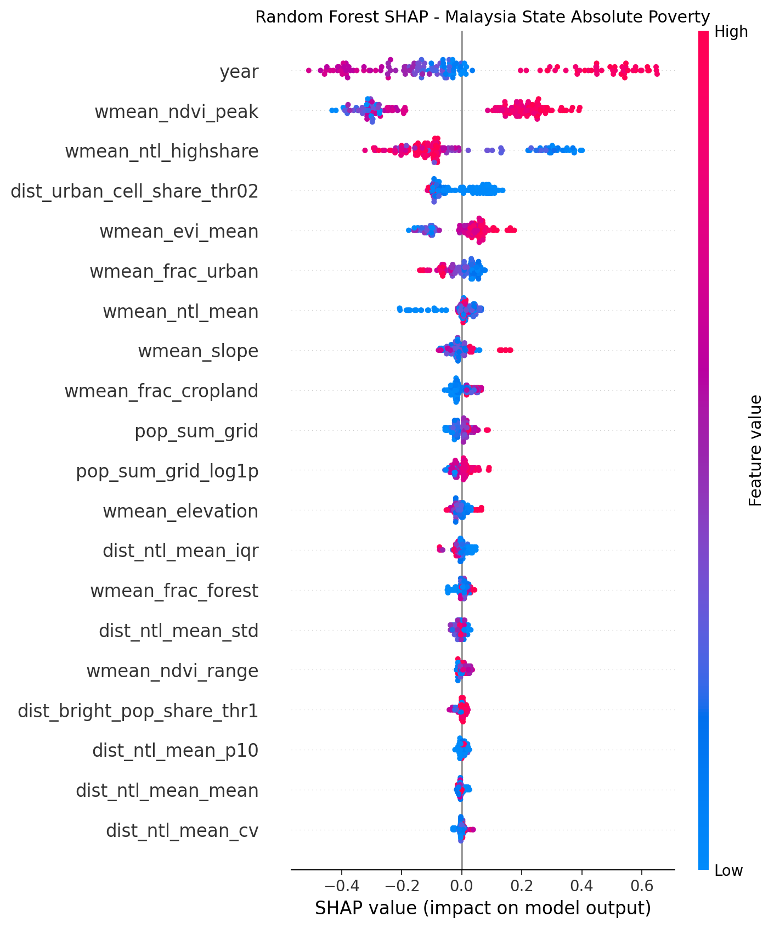
Figure 8 SHAP Feature Importance - Malaysia State-Level Random Forest, Poverty Absolute (n=157 evaluated state-years)
The RF SHAP summary for the selected Malaysia state-level absolute-poverty model was produced from the observed state-year panel used in the model selection workflow. It shows that year trend, vegetation indices, nighttime lights, and urbanisation features provide much of the model explanation. The ablation result shows that the selected RF model improves LOSO MAE for absolute poverty from 2.96 percentage points for the year-only baseline to 2.52 percentage points. The rf_sensor_safe model is reported separately as the lower-error robustness benchmark, so this figure should be read as an explanation of the selected model rather than proof that the selected RF has the lowest error.
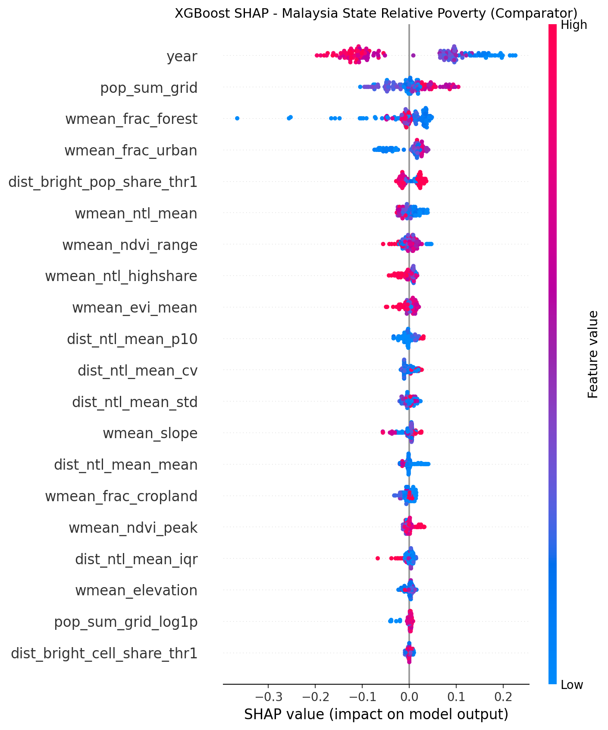
Figure 9 SHAP Feature Importance - Malaysia State-Level XGBoost, Poverty Relative (XGBoost comparator, n=158 state-years; descriptive post-selection only)
Although Year (national trend) is still the strongest predictor of poverty_relative; satellite signal is less strong than for poverty_absolute. The year-only XGBoost model is also the relative-poverty selected benchmark (MAE = 2.24%), whereas the current-full XGBoost comparator is less strong (MAE = 2.55%). This XGBoost SHAP plot is included only as a comparative diagnostic tool; it is not an explanation of the selected relative-poverty model.
SHAP describes each prediction as a function of all input features' contribution. Therefore, the values represent what the model has learned from training data, but do not necessarily imply causal effect, nor are they evidence of out-of-sample validation.
Rank | Feature | Feature Group | Importance Share
1 | year | year/time | 24.0%
2 | wmean_ndvi_peak | vegetation | 22.7%
3 | wmean_ntl_highshare | nighttime lights | 14.9%
4 | dist_urban_cell_share_thr02 | urbanisation | 6.7%
5 | wmean_evi_mean | vegetation | 6.4%
6 | wmean_frac_urban | urbanisation | 3.9%
7 | wmean_ntl_mean | nighttime lights | 3.2%
8 | wmean_slope | topography | 2.7%
Table 8 Top Features from RF SHAP (poverty_absolute, State-Level, n=157 evaluated state-year observations)
Key Interpretations: Year (national trend) is the strongest indicator at state level and represents Malaysia's long-term decline in poverty from 2002 to 2022. Nighttime-light features ranked high in the RF SHAP table, consistent with prior poverty-mapping work using luminosity as an economic proxy (Jean et al., 2016; Zhao et al., 2019). Population and settlement features capture density and infrastructure concentration, helping distinguish high-poverty rural states from more urbanised states. Vegetation and land-cover features complement these signals, but they remain descriptive correlates rather than causal explanations.
Important Caveat: As these rankings provide a description of what the model has learned from training data and not the causal relationships between them; they represent post-hoc descriptive analyses conducted after model selection and are not held-out validation results. The SHAP values represent the model's ability to identify patterns and thus may include spurious correlations or temporal artifacts.

Policy Implications of Feature Rankings
As a caveat, although these rankings do not provide evidence of causality, they reveal correlation patterns explaining how poverty relates to observable satellite-based features. In order to facilitate additional investigation, these are provided as interpretations guides for potential follow-up investigations, not as guidelines for policy:
- Temporal Trend is Dominant: Given that Malaysia has experienced sustained poverty reduction from 2002-2022, it is likely that the model has captured this trend, and therefore will need to be updated when additional survey data becomes available if one wants to avoid overstating continued reductions in poverty.
- Geographic Barriers: Consistent with geographic remoteness as a barrier to development, slope and elevation appear prominently in the SHAP rankings; therefore, further investigation into this relationship using causal methods prior to informing policy related to infrastructure development.
- Electrification Proxy: Consistent with previous studies in literature that demonstrated nighttime light intensity is positively correlated with electrification; given that electrification correlates negatively with poverty (although there is no causal relationship implied) there is no causal prioritizing for electrification-related investments based upon these findings alone.
- Agricultural Signal: A possible indication that agricultural productivity is an area of interest given that EVI is inversely correlated with poverty in some states; any agricultural-related interventions would require causal justification before implementation.
- Settlement Patterns: Populations concentrated in settlements appearing in SHAP rankings are consistent with agglomeration and lower poverty at state level; therefore whether urbanisation policy is effective requires econometric/experimental evidence.
Therefore, these associations aim to assist in supporting follow-up investigation and hypothesis generation. Any policy application would require causal justification via experimental/econometric evidence.

Model Deployment

Dashboard Architecture and Design
A local Dash stakeholder monitor was developed to support review of Malaysia state-level poverty trends and model evidence using official DOSM poverty rates.
The dashboard has three tabs: Overview, State Review, and Reliability Check. Overview summarises high-poverty states, survey trend fit, important model factors, and cautious stakeholder uses. State Review shows state-specific trends, supporting indicators, and comparison tables. Reliability Check compares benchmark models under LOSO validation and highlights uncertainty and larger prediction gaps.
The dashboard uses certified CSV and JSON artifacts produced by the notebook-first workflow. These include the state-year panel, benchmark metrics, LOSO fold predictions, SHAP artifacts, uncertainty summaries, dashboard-ready summaries, and the packaged state_model_predictions.csv selected-model prediction artifact.
The deployment is a local Dash application run from dashboard_stakeholder/app.py. It does not depend on serialized model files or retrain models at runtime.
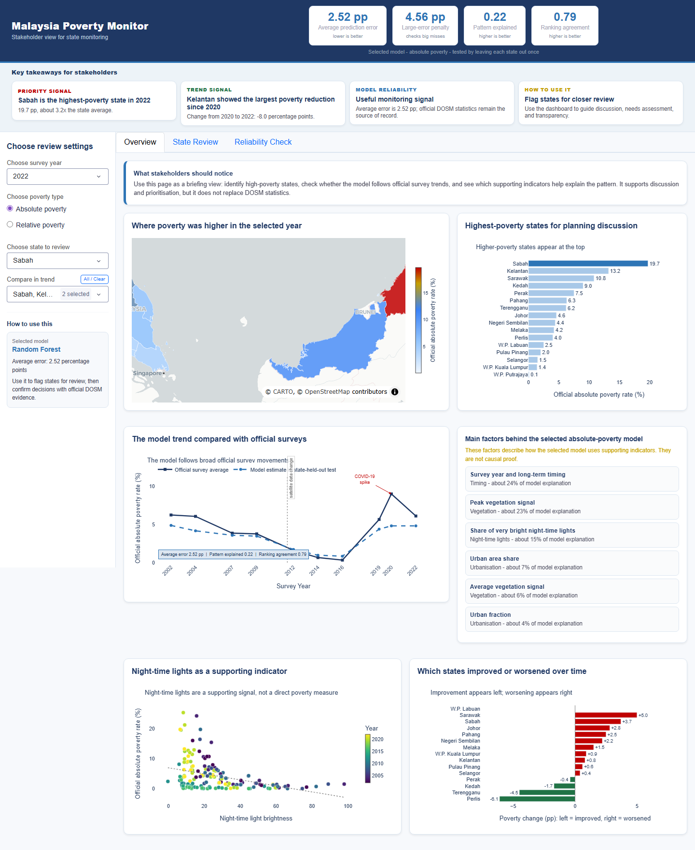
Figure 10 Dash Dashboard Overview Page
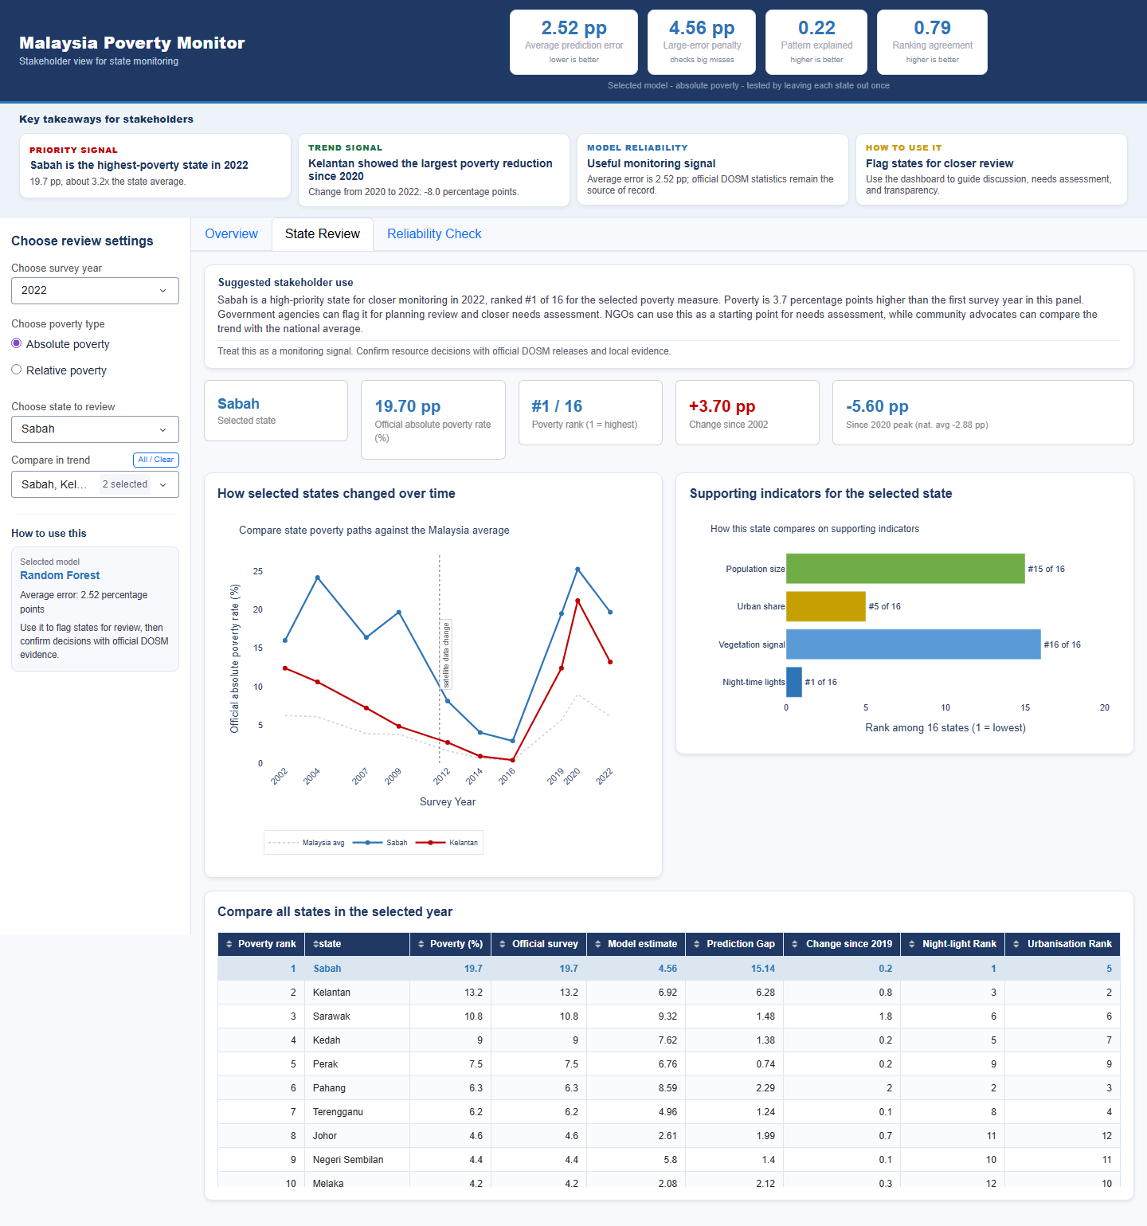
Figure 11 Dash Dashboard State Review Page
The official DOSM survey trend for the selected state and comparison states is shown as the foregrounded trend in The State Review view. This is preferred over reporting the small standalone map panel when reporting due to being more informative in print.
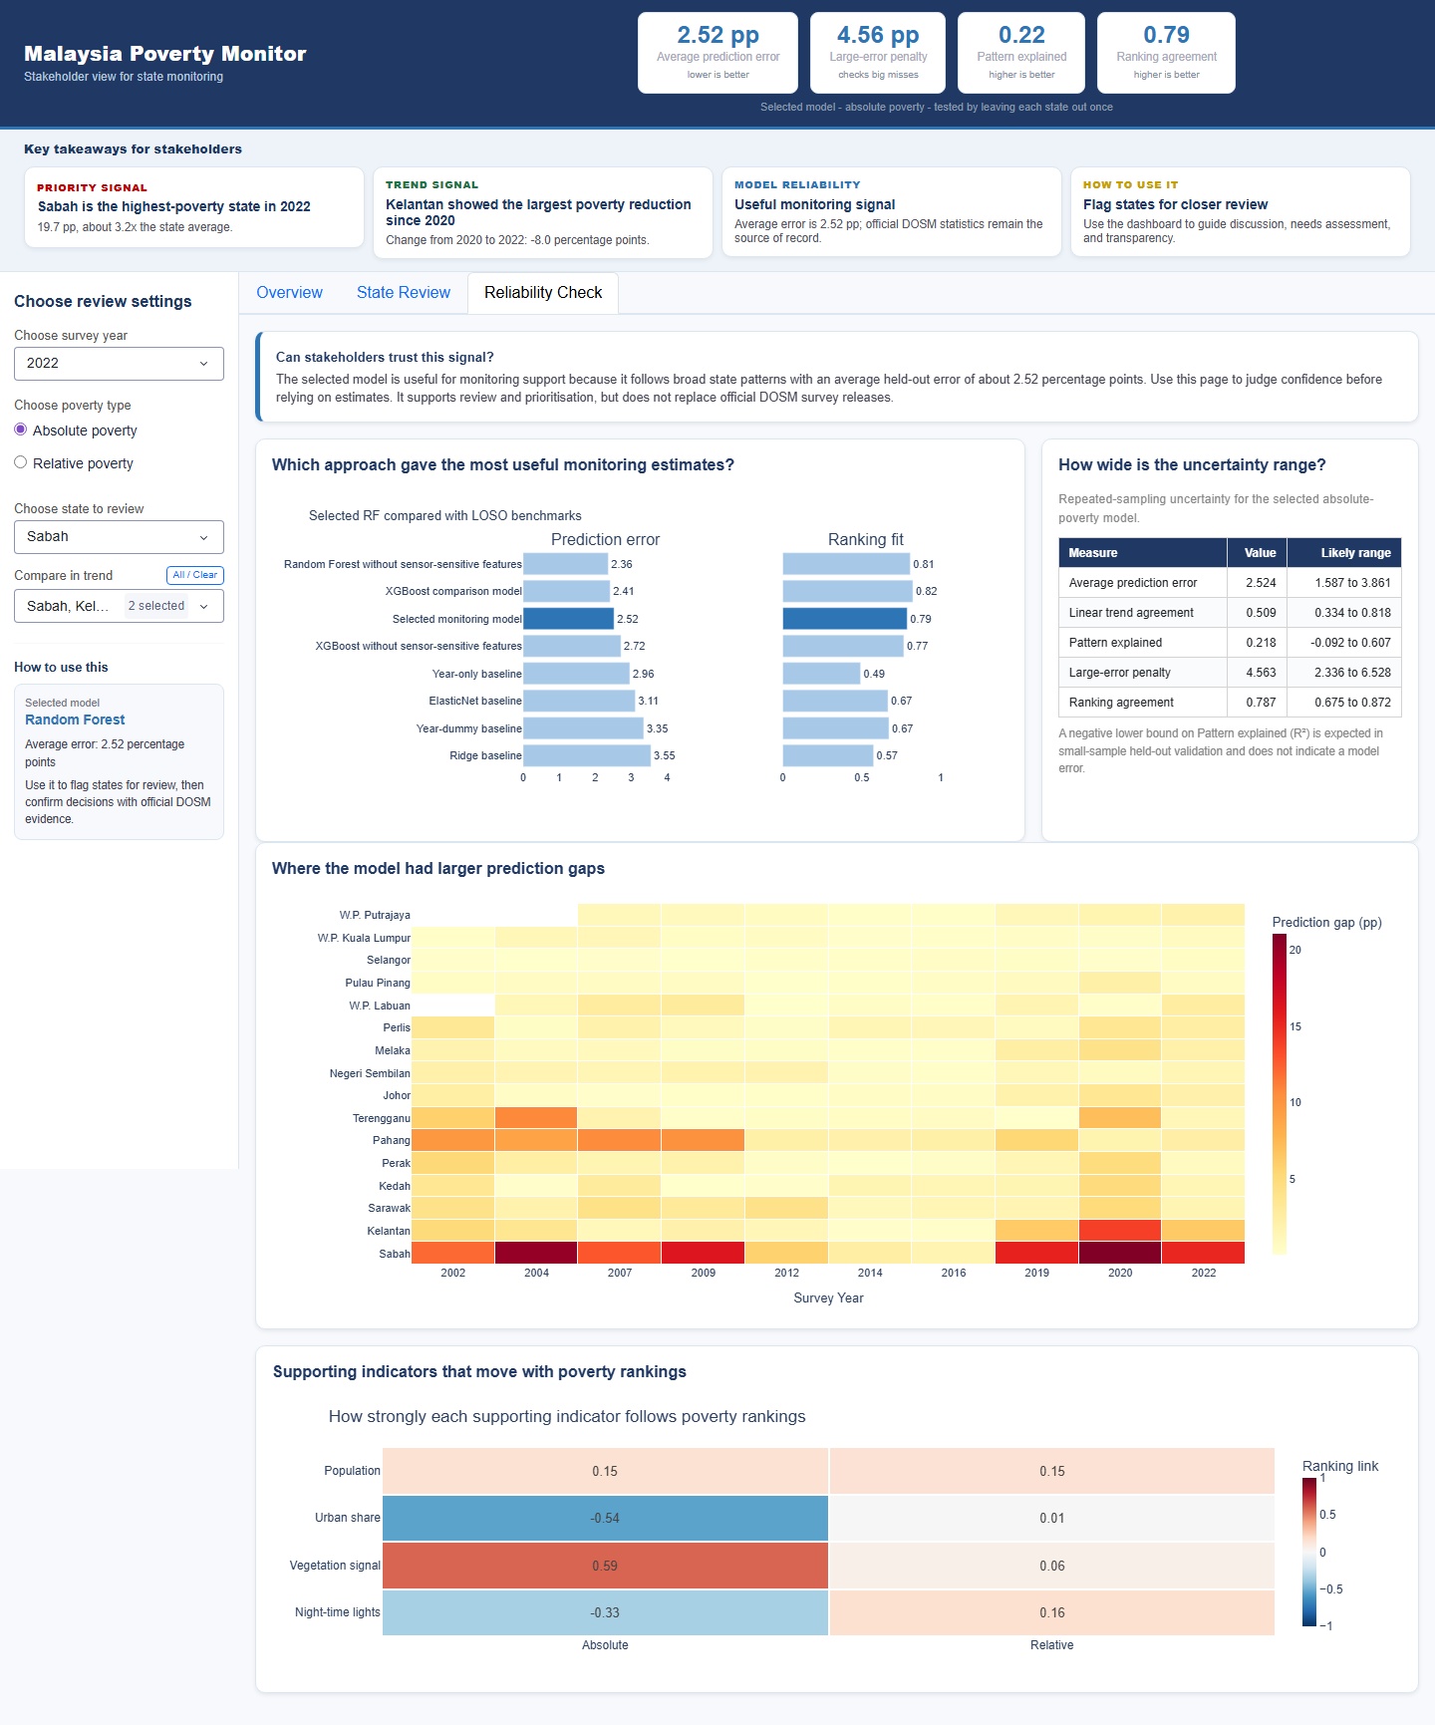
Figure 12 Dash Dashboard Reliability Check Page
The Reliability Check view is used to display model performance across all five benchmark approaches under leave-one-state-out validation. Each benchmark approach (Random Forest, XGBoost, year-only, Ridge, and ElasticNet) is represented by its LOSO MAE, RMSE, and R² values. An uncertainty interval table and a state-level error heatmap are also provided. A proxy correlation panel is used to provide additional supporting evidence that satellite features used in the model correlate with official poverty outcomes. These components are intended to assist stakeholders determine what level of confidence should be placed in their monitoring estimates prior to using those estimates to make informed decisions.

Key Features and Demonstration
The dashboard supports several user groups. Policymakers can use the map and trend views to identify states for review. Development practitioners can use the monitoring outputs and feature summaries to ask follow-up questions about infrastructure, terrain, and agricultural conditions. Researchers and data scientists can inspect the training data, model metrics, SHAP explanations, model comparisons, and uncertainty summaries. In a demonstration scenario, a user selects poverty_absolute for 2022, reviews Sabah and Kelantan as high-poverty states, compares official DOSM trends, and checks the selected RF model through descriptive SHAP rankings.

Summary
This chapter evaluated machine learning models for poverty prediction across Malaysian states. The selected Random Forest full-feature model achieved a positive LOSO R² for absolute poverty, while relative poverty was better explained by the year-only XGBoost baseline. The results support the dashboard as a transparent monitoring supplement, not as a replacement for official DOSM statistics.

Chapter 6: Conclusion

Critical Evaluation
The following section will provide a critical evaluation of the project's outputs compared to its four objective statements, discuss the major shortcomings of this study and outline possible directions for future work. The subsequent sub-sections will critically evaluate each of the four objectives that were specified at the beginning of the project. A fair and honest assessment of achievements and non-achievements follows:

Objective 1: Construct a Harmonized State-Year Panel Across 10 DOSM Survey Years (2002-2022)
Status: Achieved. A fully harmonized and combined panel dataset was developed using all available official poverty statistics from the Department of Statistics Malaysia (DOSM) across all sixteen Malaysian administrative areas. Night-time light data from both DMSP-OLS and VIIRS-DNB datasets have been included along with topography data (elevation and slope) from SRTM. Vegetation indices (EVI and NDVI) from MODIS and population density from WorldPop have also been integrated into the final dataset. The resulting panel dataset includes 158 state/year combinations representing all 16 Malaysian states/territories across 10 DOSM survey years (2002-2022). As there is no real temporal overlap in the data, LOSO-CV (leave one state out) was employed instead of temporal CV to validate the construction of the dataset. Forward fill was applied to missing population data for 2021 and 2022 due to forward filling assuming stable demographics. Establishment of a fully harmonized state/year panel across 10 DOSM survey years represents an established platform upon which future poverty prediction studies can be conducted in Malaysia. It is also representative of a methodology template upon which developing countries may use.

Objective 2: Evaluate Predictive Performance Under Leakage-Aware Protocols
Status: partially achieved, with clear limitations. The implementation used one leakage-aware validation protocol, Leave-One-State-Out (LOSO) cross-validation. The selected full-feature Random Forest model achieved MAE = 2.524 percentage points, R² = 0.218, and Spearman = 0.787 for absolute poverty. The rf_sensor_safe model is reported separately as a lower-error robustness benchmark, while XGBoost remains the strongest rank comparator. For relative poverty, year-only XGBoost performs best, showing that relative poverty is mainly time-trend driven in this state-level panel. Deployment against post-2022 data remains future work.

Objective 3: Implement SHAP-Based Explainability Analysis
Achieved status. With the appropriate cautions.
SHAP (SHapley Additive exPlanations) feature-importance rankings were computed for the Random Forest absolute-poverty model, with XGBoost retained as comparator evidence. These results are based on the Malaysia state-year panel and are used for interpretation only. SHAP values describe how the trained model uses features; they do not establish causal relationships or prove performance on unseen data.
Caveat: SHAP values are post-selection interpretive evidence. They show which features the model uses in prediction, but they cannot be used to make causal claims or replace LOSO validation.
As such policy implications can be proposed (i.e. Terrain difficulties are associated with higher levels of poverty, electrification may help lower levels of poverty), however those implications will need to be framed as hypotheses that require further research, rather than established causal relationships.

Objective 4: Deploy Interactive Dash Dashboard Supplement
A local Dash dashboard supplement was developed to support stakeholder review of the model outputs.
The dashboard includes an interactive state-level choropleth map, historical trend plots for observed DOSM survey values, model comparison evidence, a text-based summary of the main RF SHAP factors, and a clear reminder that DOSM statistics remain the official source of record. The dashboard supports monitoring review; it does not replace official DOSM survey releases.

Limitation
This study has several important limitations.

Data-Level Limitations
First, the sample size is small. The panel contains 158 state-year rows, and the certified absolute-poverty evaluation uses 157 observed target rows after excluding W.P. Labuan in 2002. This limits statistical power and makes spatial generalisation difficult under LOSO validation. Second, the analysis is state-aggregated, so it cannot identify rural-urban gaps or district-level poverty pockets within a state. Third, population density for 2021-2022 is carried forward from 2020 data, which may miss migration or urbanisation changes after the pandemic period.

Methodological Limitations
Relative poverty is also difficult to model from satellite features in this panel. The selected Random Forest full-feature model for absolute poverty achieved R² = 0.218, while the year-only XGBoost model performed best for relative poverty with R² = 0.246. This result suggests that relative poverty is mainly time-trend driven at the state level, while the defensible satellite contribution is found in the selected absolute-poverty monitoring model. The rf_sensor_safe benchmark is reported separately as a lower-error robustness comparison, not as the main selected model.

Model-Level Limitations
The project does not make causal claims. SHAP rankings describe how the trained model uses features; they do not prove that a feature causes poverty to rise or fall. The current modelling approach also treats each state-year observation independently, so future work could test panel-data methods that model state effects and temporal dependence more directly.

Interpretation Limitations
State-level aggregation can mask inequality within states. The analysis cannot measure Gini coefficients, district-level deprivation, or targeted poverty reduction in underserved communities.

Recommendation
The results provide a useful starting point for satellite-supported poverty monitoring in Malaysia. Future work can improve the framework in several directions.

Short-Term (1-2 Years)
First, future studies should test the method at sub-state level only when official poverty labels are available for enough districts or local areas across multiple years. This would allow local spatial variation to be studied without claiming more detail than the current state-level data can support.

Medium-Term (2-5 Years)
Second, future research can compare panel econometric methods, uncertainty models, and deep learning approaches using raw satellite imagery. These extensions should be tested against official poverty labels and should include careful validation to avoid overclaiming predictive performance.

Long-Term (5+ Years)
Third, monitoring dashboards could be improved with more frequent VIIRS nighttime-light features, additional administrative indicators, and clearer uncertainty displays. These additions should support review and prioritisation, not replace DOSM releases.
Fourth, the dashboard could be tested with policy users to see whether the monitoring outputs support follow-up analysis, resource discussion, and later evaluation against official poverty outcomes.
As new DOSM poverty data become available, the model and dashboard could be updated through the same reproducible notebook workflow.
This project created a harmonised Malaysia state-level poverty panel across 10 DOSM survey years from 2002-2022, built satellite and socioeconomic proxy features, compared state-level models under leakage-aware validation, selected Random Forest full features for absolute-poverty monitoring, and deployed the results through reproducible notebooks and a Dash dashboard.
The practical artifact is a dashboard supplement for policymakers, development practitioners, and researchers to review past state-level poverty monitoring estimates.
The limitations are also clear.
The work is limited by the small state-level sample, the difficulty of spatial generalisation, and the fact that Malaysia state-level results cannot be treated as district-level evidence. These are not failures of the project; they define the boundary of what this submission can claim.
Future direction is therefore straightforward.
Future work should add richer official labels, test panel econometric methods, compare deep learning methods on raw imagery, incorporate additional data sources, and evaluate the dashboard with real users. The largest benefit will come from closing the loop between monitoring estimates and later official poverty outcomes.

References
Aiken, E., Rolf, E., & Blumenstock, J. (2023). Fairness and representation in satellite-based poverty maps: Evidence of urban-rural disparities and their impacts on downstream policy. Proceedings of the 32nd International Joint Conference on Artificial Intelligence (IJCAI-23). arXiv. https://arxiv.org/abs/2305.01783
Alkire, S., & Santos, M. E. (2014). Measuring acute poverty in the developing world: Robustness and scope of the Multidimensional Poverty Index. World Development, 59, 251-274. https://doi.org/10.1016/j.worlddev.2014.01.026
Breiman, L. (2001). Random forests. Machine Learning, 45(1), 5-32. https://doi.org/10.1023/A:1010933404324
Browne, C., Matteson, D. S., McBride, L., Hu, L., Liu, Y., Sun, Y., Wen, J., & Barrett, C. B. (2021). Multivariate random forest prediction of poverty and malnutrition prevalence. PLOS ONE, 16(9), e0255519. https://doi.org/10.1371/journal.pone.0255519
Chapman, P., Clinton, J., Kerber, R., Khabaza, T., Reinartz, T., Shearer, C., & Wirth, R. (2000). CRISP-DM 1.0: Step-by-step data mining guide. SPSS Inc.
Chen, T., & Guestrin, C. (2016). XGBoost: A scalable tree boosting system. Proceedings of the 22nd ACM SIGKDD International Conference on Knowledge Discovery and Data Mining, 785-794. https://doi.org/10.1145/2939672.2939785
Chen, X., & Nordhaus, W. D. (2011). Using luminosity data as a proxy for economic statistics. Proceedings of the National Academy of Sciences, 108(21), 8589–8594. https://doi.org/10.1073/pnas.1017031108
Chi, G., Fang, H., Chatterjee, S., & Blumenstock, J. E. (2022). Microestimates of wealth for all low- and middle-income countries. Proceedings of the National Academy of Sciences, 119(3), e2113658119. https://doi.org/10.1073/pnas.2113658119
Dang, H.-A. H., & Lanjouw, P. (2023). Measuring poverty dynamics with synthetic panels based on repeated cross sections. Oxford Bulletin of Economics and Statistics, 85(3), 599–622. https://doi.org/10.1111/obes.12539
Department of Statistics Malaysia [DOSM]. (2022). Poverty in Malaysia 2022. Department of Statistics Malaysia. https://storage.dosm.gov.my/technotes/hies_poverty.pdf
Engstrom, R., Hersh, J., & Newhouse, D. (2017). Poverty from space: Using high-resolution satellite imagery for estimating economic well-being (Policy Research Working Paper No. 8284). World Bank. https://hdl.handle.net/10986/28988
Glewwe, P., & Grosh, M. (2000). Designing household survey questionnaires for developing countries: Lessons from 15 years of the Living Standards Measurement Study. World Bank.
Gonzales Martinez, R., & Cooray, M. (2025). Enhancing poverty targeting with spatial machine learning: An application to Indonesia. [Preprint]. arXiv. https://arxiv.org/abs/2503.04300
Gorelick, N., Hancher, M., Dixon, M., Ilyushchenko, S., Thau, D., & Moore, R. (2017). Google Earth Engine: Planetary-scale geospatial analysis for everyone. Remote Sensing of Environment, 202, 18-27. https://doi.org/10.1016/j.rse.2017.06.031
Hall, O., Dompae, F., Wahab, I., & Dzanku, F. M. (2023). A review of machine learning and satellite imagery for poverty prediction: Implications for development research and applications. Journal of International Development, 35(7), 1753-1768. https://doi.org/10.1002/jid.3751
Henderson, J. V., Storeygard, A., & Weil, D. N. (2012). Measuring economic growth from outer space. American Economic Review, 102(2), 994-1028. https://doi.org/10.1257/aer.102.2.994
Huete, A., Didan, K., Miura, T., Rodriguez, E. P., Gao, X., & Ferreira, L. G. (2002). Overview of the radiometric and biophysical performance of the MODIS vegetation indices. Remote Sensing of Environment, 83(1-2), 195-213. https://doi.org/10.1016/S0034-4257(02)00096-2
Hunter, J. D. (2007). Matplotlib: A 2D graphics environment. Computing in Science & Engineering, 9(3), 90–95. https://doi.org/10.1109/MCSE.2007.55
Hutasavi, S., & Chen, W. (2020). Socioeconomic status from space: Estimation of community-level poverty in Thailand using nighttime satellite imagery. The International Archives of the Photogrammetry, Remote Sensing and Spatial Information Sciences, XLIII-B4-2020, 109-115. https://doi.org/10.5194/isprs-archives-XLIII-B4-2020-109-2020
Jean, N., Burke, M., Xie, M., Davis, W. M., Lobell, D. B., & Ermon, S. (2016). Combining satellite imagery and machine learning to predict poverty. Science, 353(6301), 790-794. https://doi.org/10.1126/science.aaf7894
Khoun, T., Poortinga, A., Thwal, N. S., González de Alba, I., McMahon, A., & Mendez, C. (2025). Mapping the dimensions of poverty through big data, socioeconomic surveys and machine learning in Cambodia. Social Indicators Research, 180(3), 1593-1618. https://doi.org/10.1007/s11205-025-03718-3
Kluyver, T., Ragan-Kelley, B., Pérez, F., Granger, B., Bussonnier, M., Frederic, J., Kelley, K., Hamrick, J., Grout, J., Corlay, S., Ivanov, P., Avila, D., Abdalla, S., & Willing, C. (2016). Jupyter Notebooks - a publishing format for reproducible computational workflows. In F. Loizides & B. Schmidt (Eds.), Positioning and Power in Academic Publishing: Players, Agents and Agendas (pp. 87-90). IOS Press.
Kumar, L., & Mutanga, O. (2018). Google Earth Engine applications since inception: Usage, trends, and potential. Remote Sensing, 10(10), 1509. https://doi.org/10.3390/rs10101509
Li, X., & Zhou, Y. (2017). A stepwise calibration of global DMSP/OLS stable nighttime light data (1992-2013). Remote Sensing, 9(6), 637. https://doi.org/10.3390/rs9060637
Li, X., Zhou, Y., Zhao, M., & Zhao, X. (2020). A harmonized global nighttime light dataset 1992-2018. Scientific Data, 7, 168. https://doi.org/10.1038/s41597-020-0510-y
Lundberg, S. M., & Lee, S.-I. (2017). A unified approach to interpreting model predictions. Advances in Neural Information Processing Systems, 30, 4765-4774. https://doi.org/10.48550/arXiv.1705.07874
Lundberg, S. M., Erion, G. G., & Lee, S.-I. (2019). Consistent individualized feature attribution for tree ensembles. arXiv. https://arxiv.org/abs/1802.03888
Marty, R., & Duhaut, A. (2024). Global poverty estimation using private and public sector big data sources. Scientific Reports, 14, 3160. https://doi.org/10.1038/s41598-023-49564-6
Masaki, T., Newhouse, D., Silwal, A. R., Bedada, A., & Engstrom, R. (2022). Small area estimation of non-monetary poverty with geospatial data. Statistical Journal of the IAOS, 38(3), 1035-1051. https://doi.org/10.3233/SJI-210902
McCallum, I., Kyba, C., Laso Bayas, J. C., Moltchanova, E., Cooper, M., Crespo Cuaresma, J., Pachauri, S., See, L., Danylo, O., Moorthy, I., Lesiv, M., Baugh, K., Elvidge, C. D., Hofer, M., & Fritz, S. (2022). Estimating global economic well-being with unlit settlements. Nature Communications, 13, 3371. https://doi.org/10.1038/s41467-022-30099-9
Miller, S. D., Straka, W., Mills, S. P., Elvidge, C. D., Lee, T. F., Solbrig, J., Ziskin, D., & Hawkins, J. D. (2013). Illuminating the capabilities of the Suomi National Polar-Orbiting Partnership (NPP) Visible Infrared Imaging Radiometer Suite (VIIRS) day/night band. Remote Sensing, 5(12), 6717-6766. https://doi.org/10.3390/rs5126717
Molnar, C. (2022). Interpretable machine learning: A guide for making black box models explainable (2nd ed.). https://christophm.github.io/interpretable-ml-book/
NASA Jet Propulsion Laboratory. (2013). NASA Shuttle Radar Topography Mission Global 1 arc second [Data set]. NASA EOSDIS Land Processes Distributed Active Archive Center. https://doi.org/10.5067/MEaSUREs/SRTM/SRTMGL1.003
Newhouse, D. (2024). Small area estimation of poverty and wealth using geospatial data. Calcutta Statistical Association Bulletin, 76(1), 7–32. https://doi.org/10.1177/00080683231198591
Okwi, P. O., Ndeng'e, G., Kristjanson, P., Arunga, M., Notenbaert, A., Omolo, A., Henninger, N., Benson, T., Kariuki, P., & Owegi, J. (2007). Spatial determinants of poverty in rural Kenya. Proceedings of the National Academy of Sciences, 104(43), 16769-16774. https://doi.org/10.1073/pnas.0611107104
Pedregosa, F., Varoquaux, G., Gramfort, A., Michel, V., Thirion, B., Grisel, O., Blondel, M., Prettenhofer, P., Weiss, R., Dubourg, V., Vanderplas, J., Passos, A., Cournapeau, D., Brucher, M., Perrot, M., & Duchesnay, E. (2011). Scikit-learn: Machine learning in Python. Journal of Machine Learning Research, 12, 2825–2830. https://jmlr.org/papers/v12/pedregosa11a.html
Putri, S. R., Wijayanto, A. W., & Pramana, S. (2023). Multi-source satellite imagery and point of interest data for poverty mapping in East Java, Indonesia: Machine learning and deep learning approaches. Remote Sensing Applications: Society and Environment, 29, 100889. https://doi.org/10.1016/j.rsase.2022.100889
Ramadhan, R., Wijayanto, A. W., & Pramana, S. (2023). Geospatial big data approaches to estimate granular level poverty distribution in East Java, Indonesia using machine learning and deep learning regressions. Proceedings of The International Conference on Data Science and Official Statistics, 2023(1), 186-200. https://doi.org/10.34123/icdsos.v2023i1.359
Ribeiro, M. T., Singh, S., & Guestrin, C. (2016). “Why should I trust you?”: Explaining the predictions of any classifier. In Proceedings of the 22nd ACM SIGKDD International Conference on Knowledge Discovery and Data Mining (pp. 1135–1144). ACM. https://doi.org/10.1145/2939672.2939778
Seabold, S., & Perktold, J. (2010). Statsmodels: Econometric and statistical modeling with Python. Proceedings of the 9th Python in Science Conference (SciPy 2010), 57-61. https://doi.org/10.25080/Majora-92bf1922-011
Tatem, A. J. (2017). WorldPop, open data for spatial demography. Scientific Data, 4, 170004. https://doi.org/10.1038/sdata.2017.4
Tucker, C. J. (1979). Red and photographic infrared linear combinations for monitoring vegetation. Remote Sensing of Environment, 8(2), 127-150. https://doi.org/10.1016/0034-4257(79)90013-0
United Nations. (2015). Transforming our world: The 2030 agenda for sustainable development. (A/RES/70/1). United Nations. https://sdgs.un.org/2030agenda
Vrieling, A., de Leeuw, J., & Said, M. Y. (2013). Length of growing period over Africa: Variability and trends from 30 years of NDVI time series. Remote Sensing, 5(2), 982-1000. https://doi.org/10.3390/rs5020982
Waskom, M. L. (2021). seaborn: Statistical data visualization. Journal of Open Source Software, 6(60), 3021. https://doi.org/10.21105/joss.03021
Watmough, G. R., Marcinko, C. L. J., Sullivan, C., Tschirhart, K., Mutuo, P. K., Palm, C. A., & Svenning, J.-C. (2019). Socioecologically informed use of remote sensing data to predict rural household poverty. Proceedings of the National Academy of Sciences, 116(4), 1213-1218. https://doi.org/10.1073/pnas.1812969116
Yeh, C., Perez, A., Driscoll, A., Azzari, G., Tang, Z., Lobell, D., Polasky, S., & Burke, M. (2020). Using publicly available satellite imagery and deep learning to understand economic well-being in Africa. Nature Communications, 11, 2583. https://doi.org/10.1038/s41467-020-16185-w
Zhao, C., Cao, X., Chen, X., & Cui, X. (2022). A consistent and corrected nighttime light dataset (CCNL 1992-2013) from DMSP-OLS data. Scientific Data, 9, 424. https://doi.org/10.1038/s41597-022-01540-x
Zhao, X., Yu, B., Liu, Y., Chen, Z., Li, Q., Wang, C., & Wu, J. (2019). Estimation of poverty using random forest regression with multi-source data: A case study in Bangladesh. Remote Sensing, 11(4), 375. https://doi.org/10.3390/rs11040375
Zheng, X., Zhang, W., Deng, H., & Zhang, H. (2024). County-level poverty evaluation using machine learning, nighttime light, and geospatial data. Remote Sensing, 16(6), 962. https://doi.org/10.3390/rs16060962

Appendices

Appendix A: Project Proposal Form (PPF)

Figure 13 Project Proposal Form

Appendix B: Ethics Form (Fast Track)
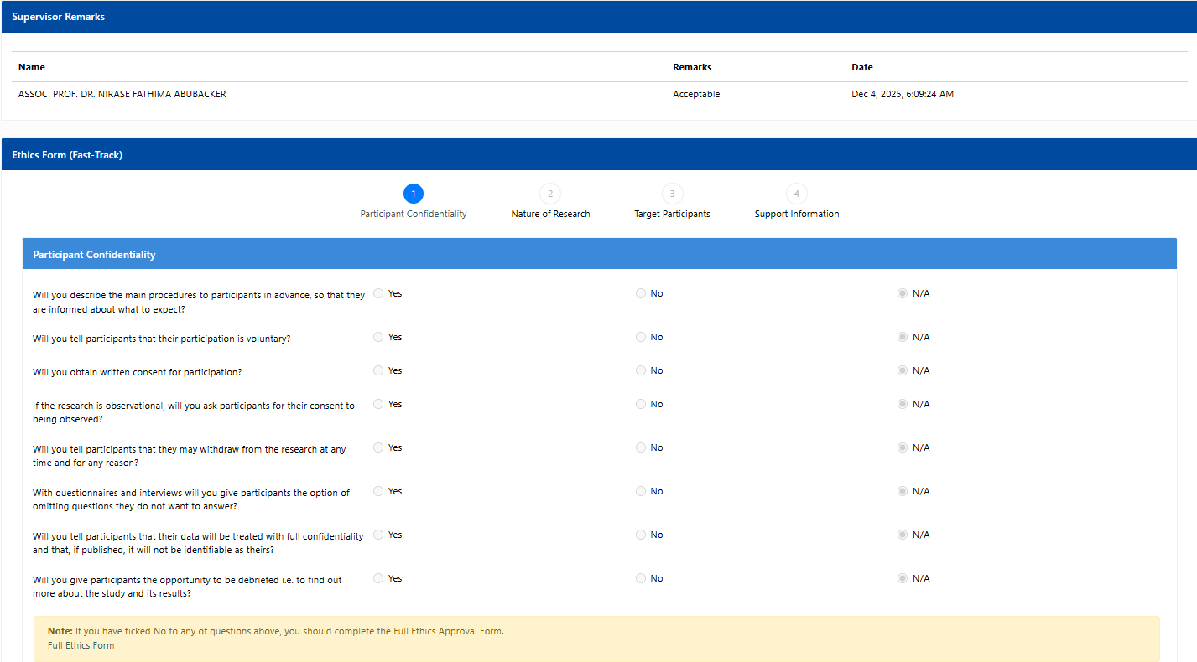
Figure 14 Ethics Form (Page 1)
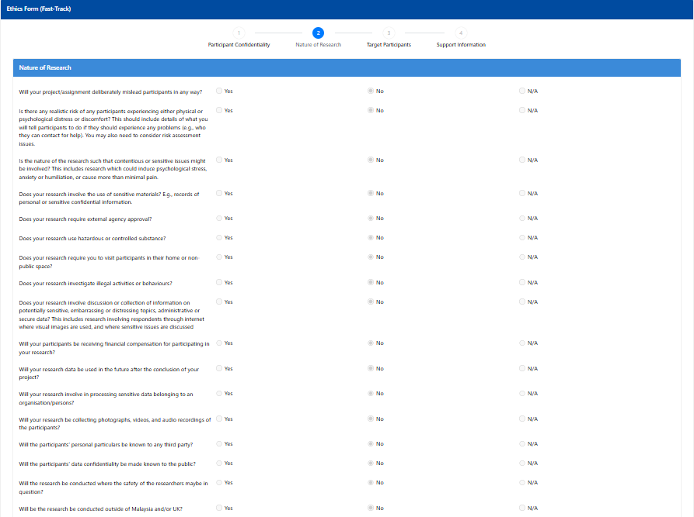
Figure 15 Ethics Form (Page 2)
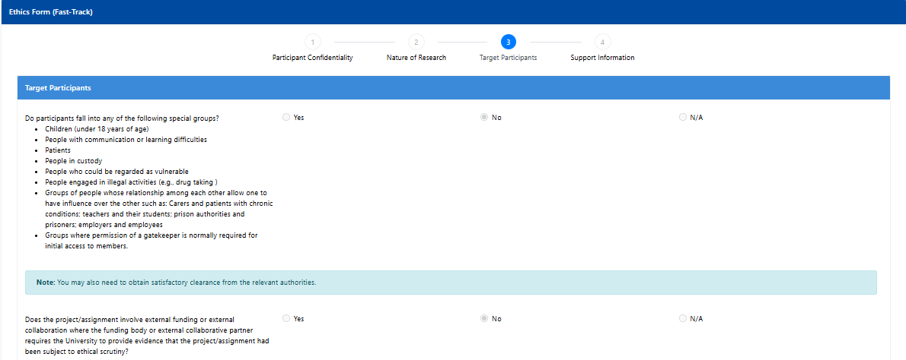
Figure 16 Ethics Form (Page 3)
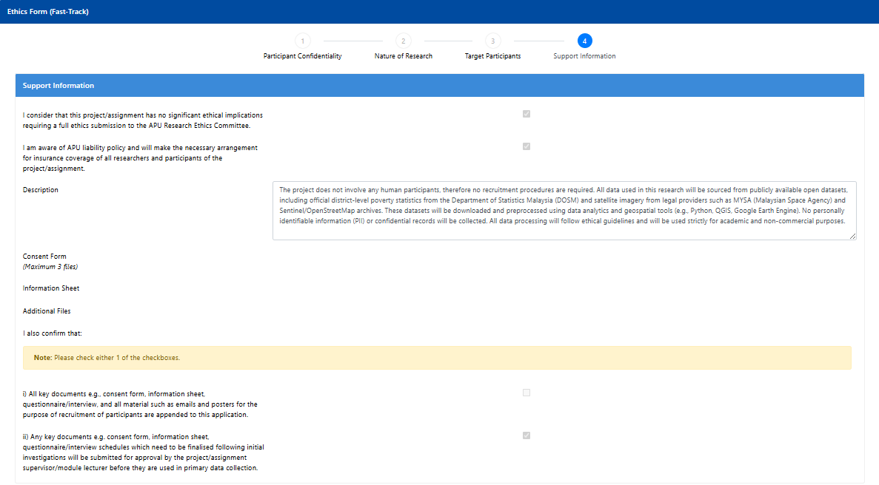
Figure 17 Ethics Form (Page 4)

Appendix C: Meeting Log Sheets
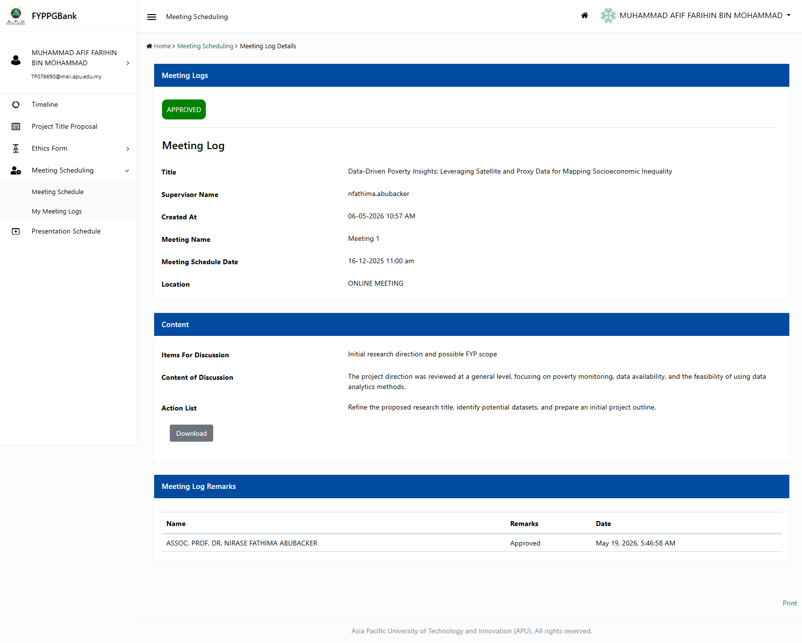
Figure 18 Meeting Log 1
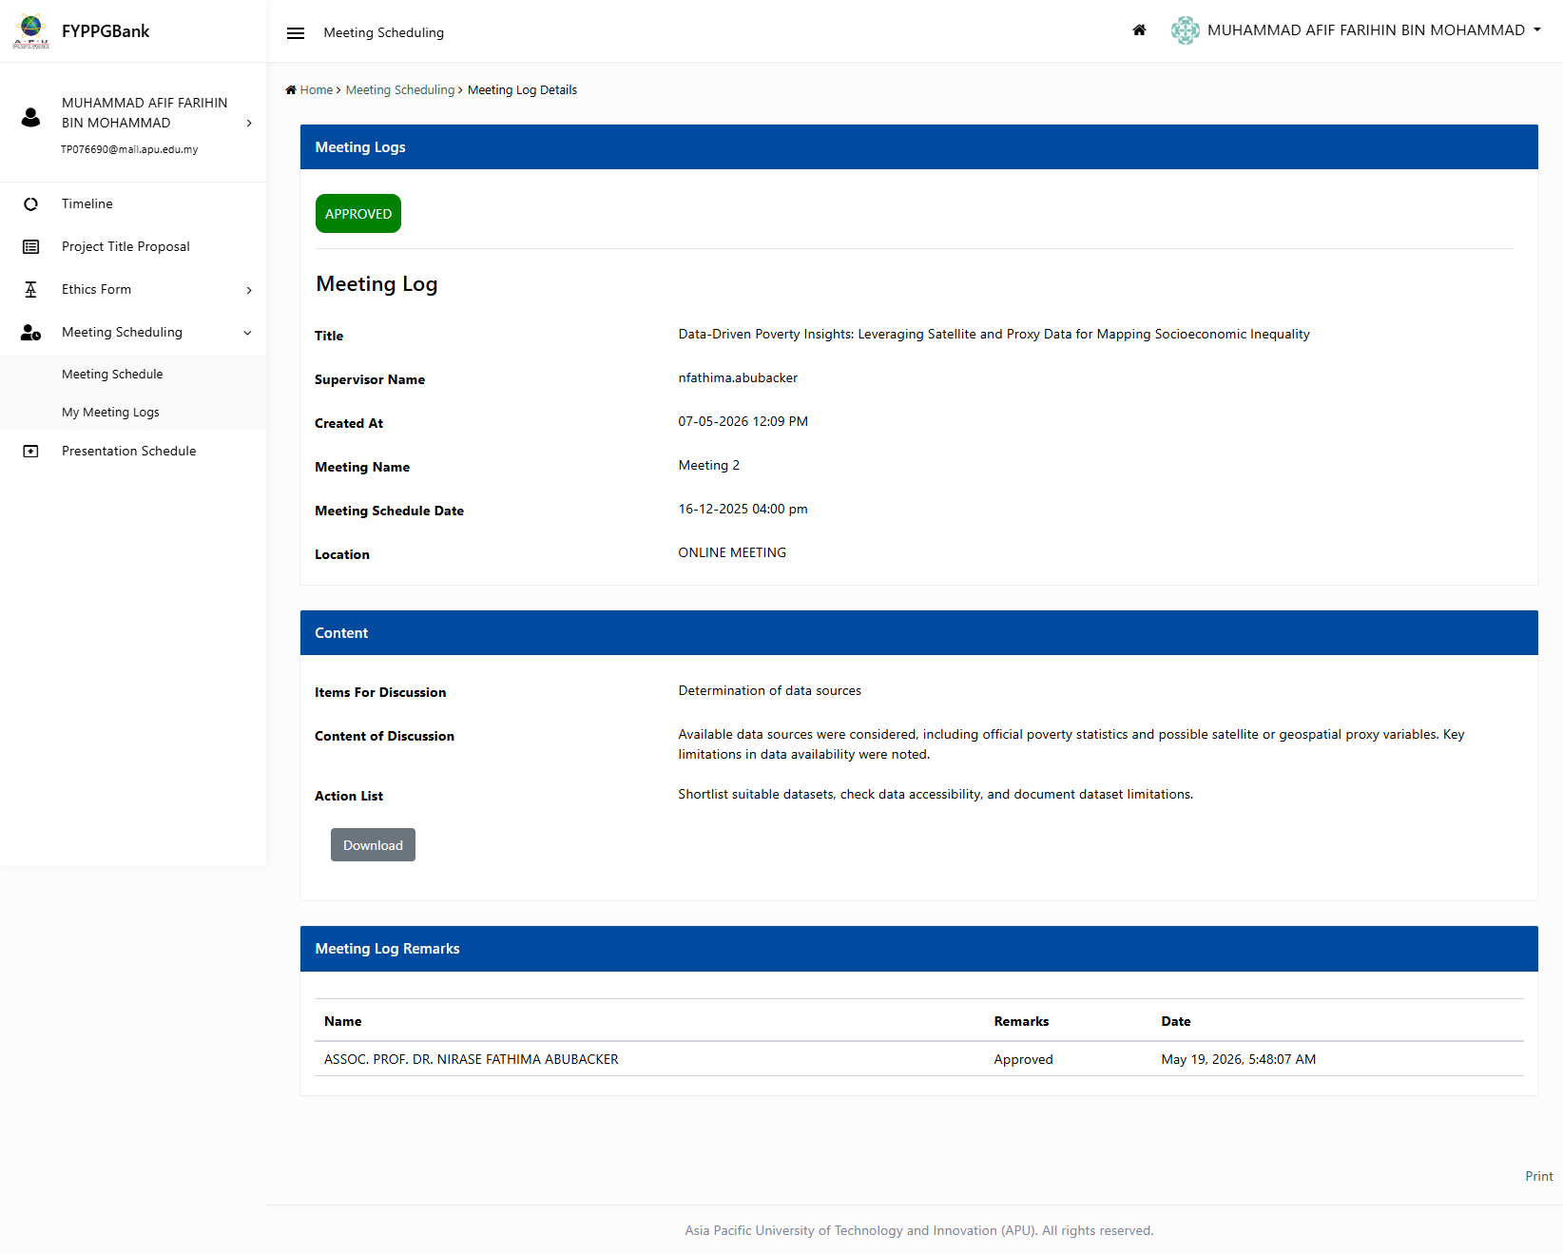
Figure 19 Meeting Log 2
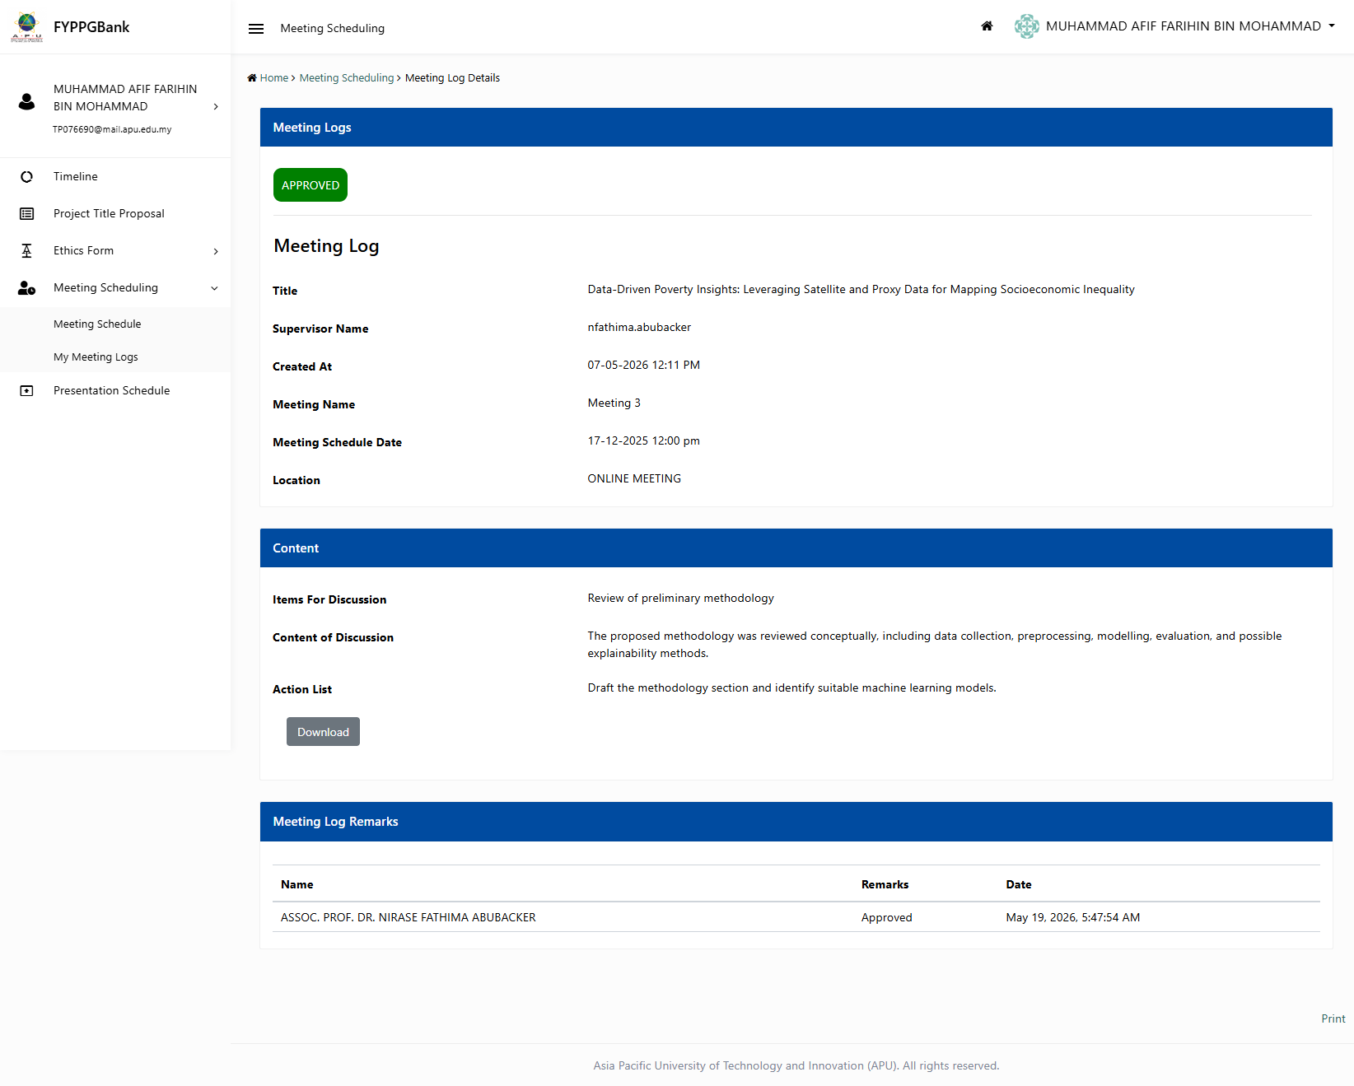
Figure 20 Meeting Log 3
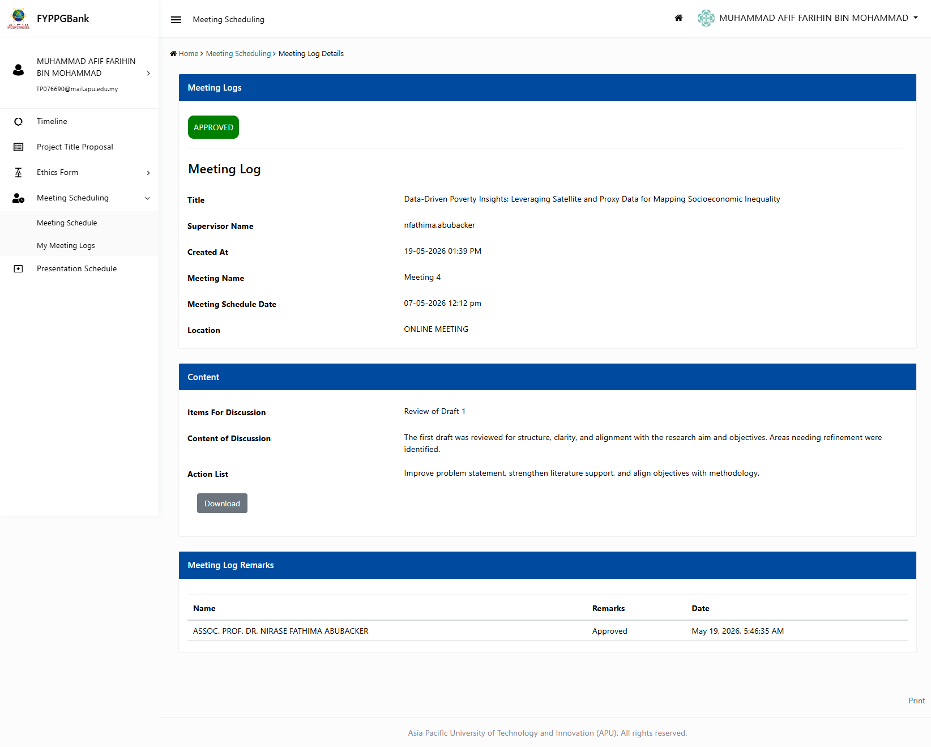
Figure 21 Meeting Log 4
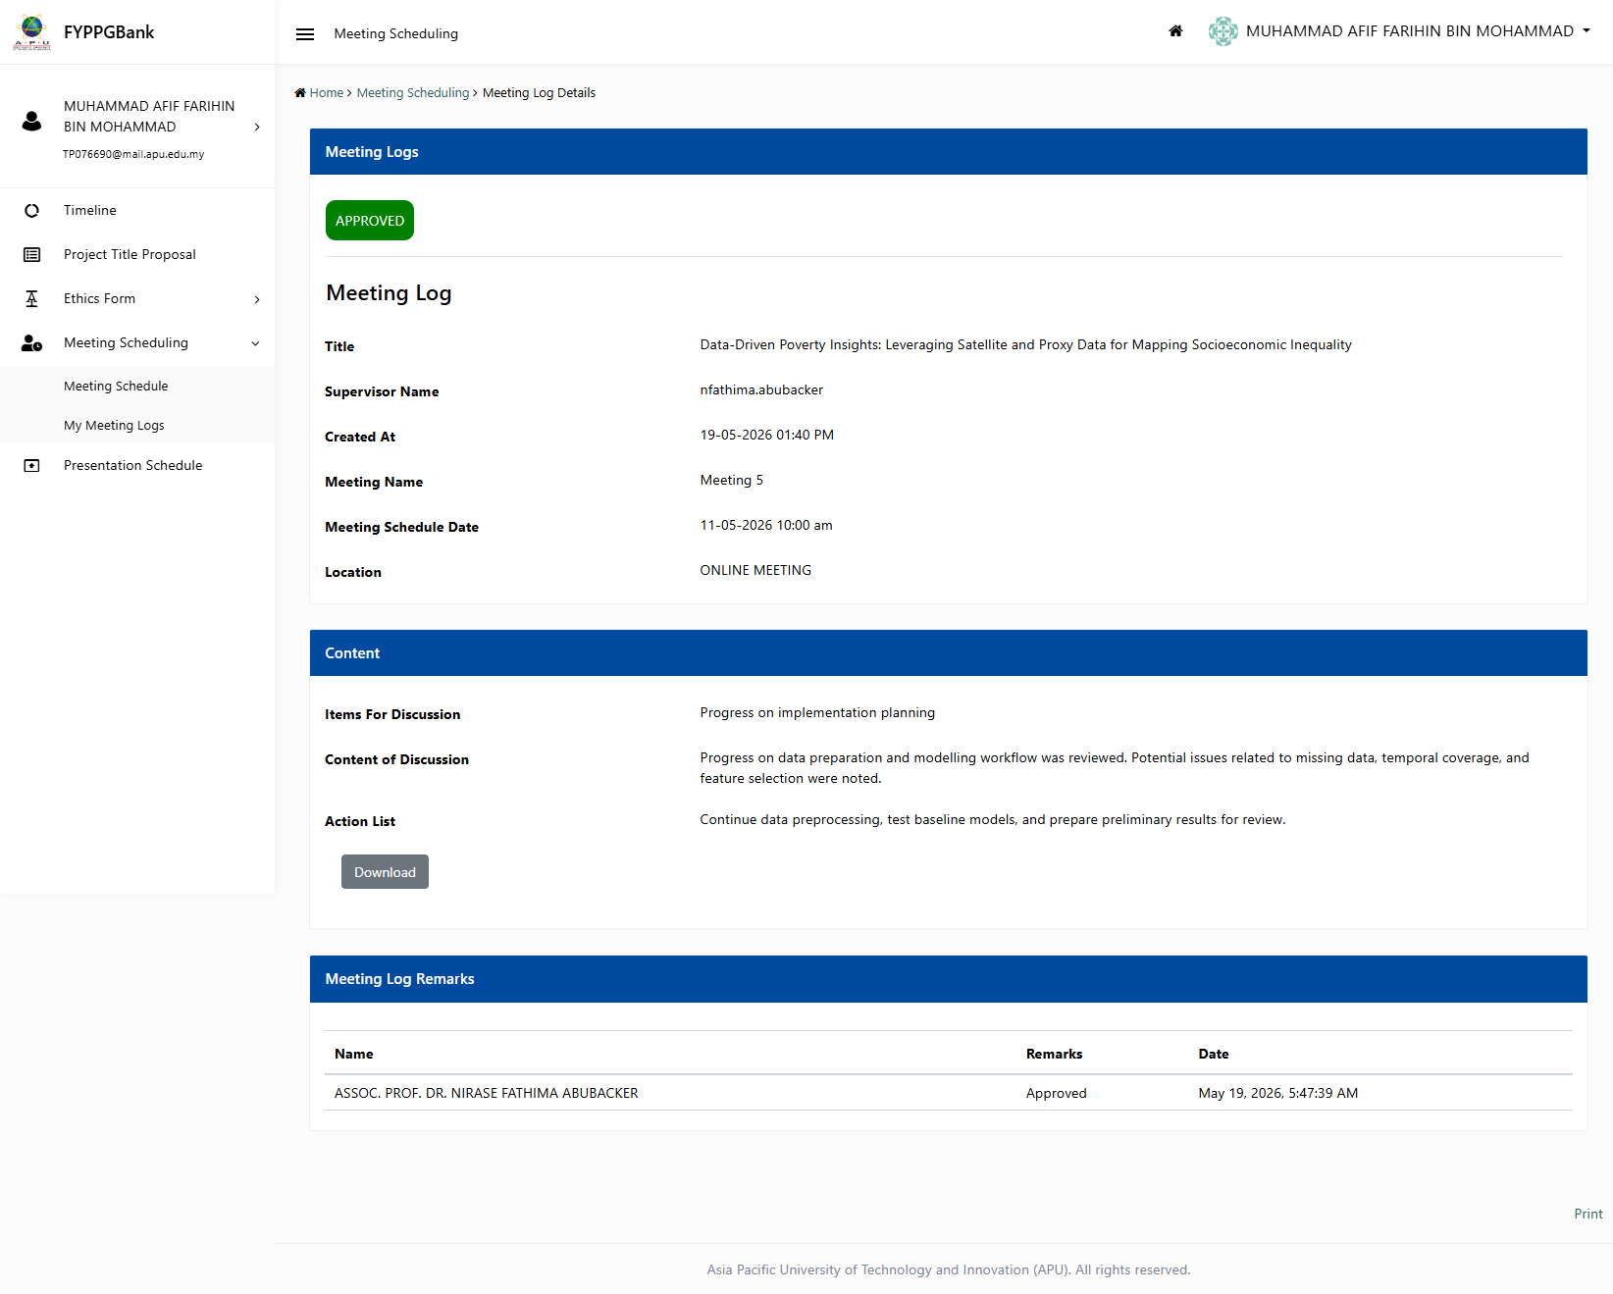
Figure 22 Meeting Log 5
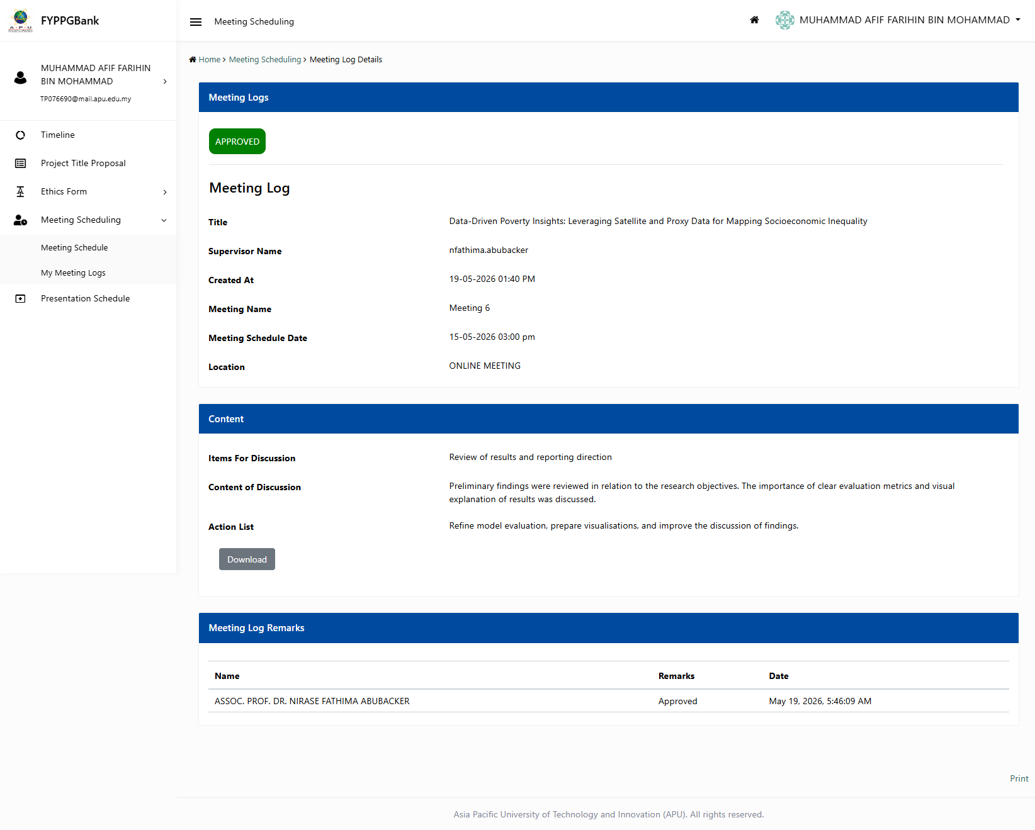
Figure 23 Meeting Log 6

Appendix D: FYP Poster
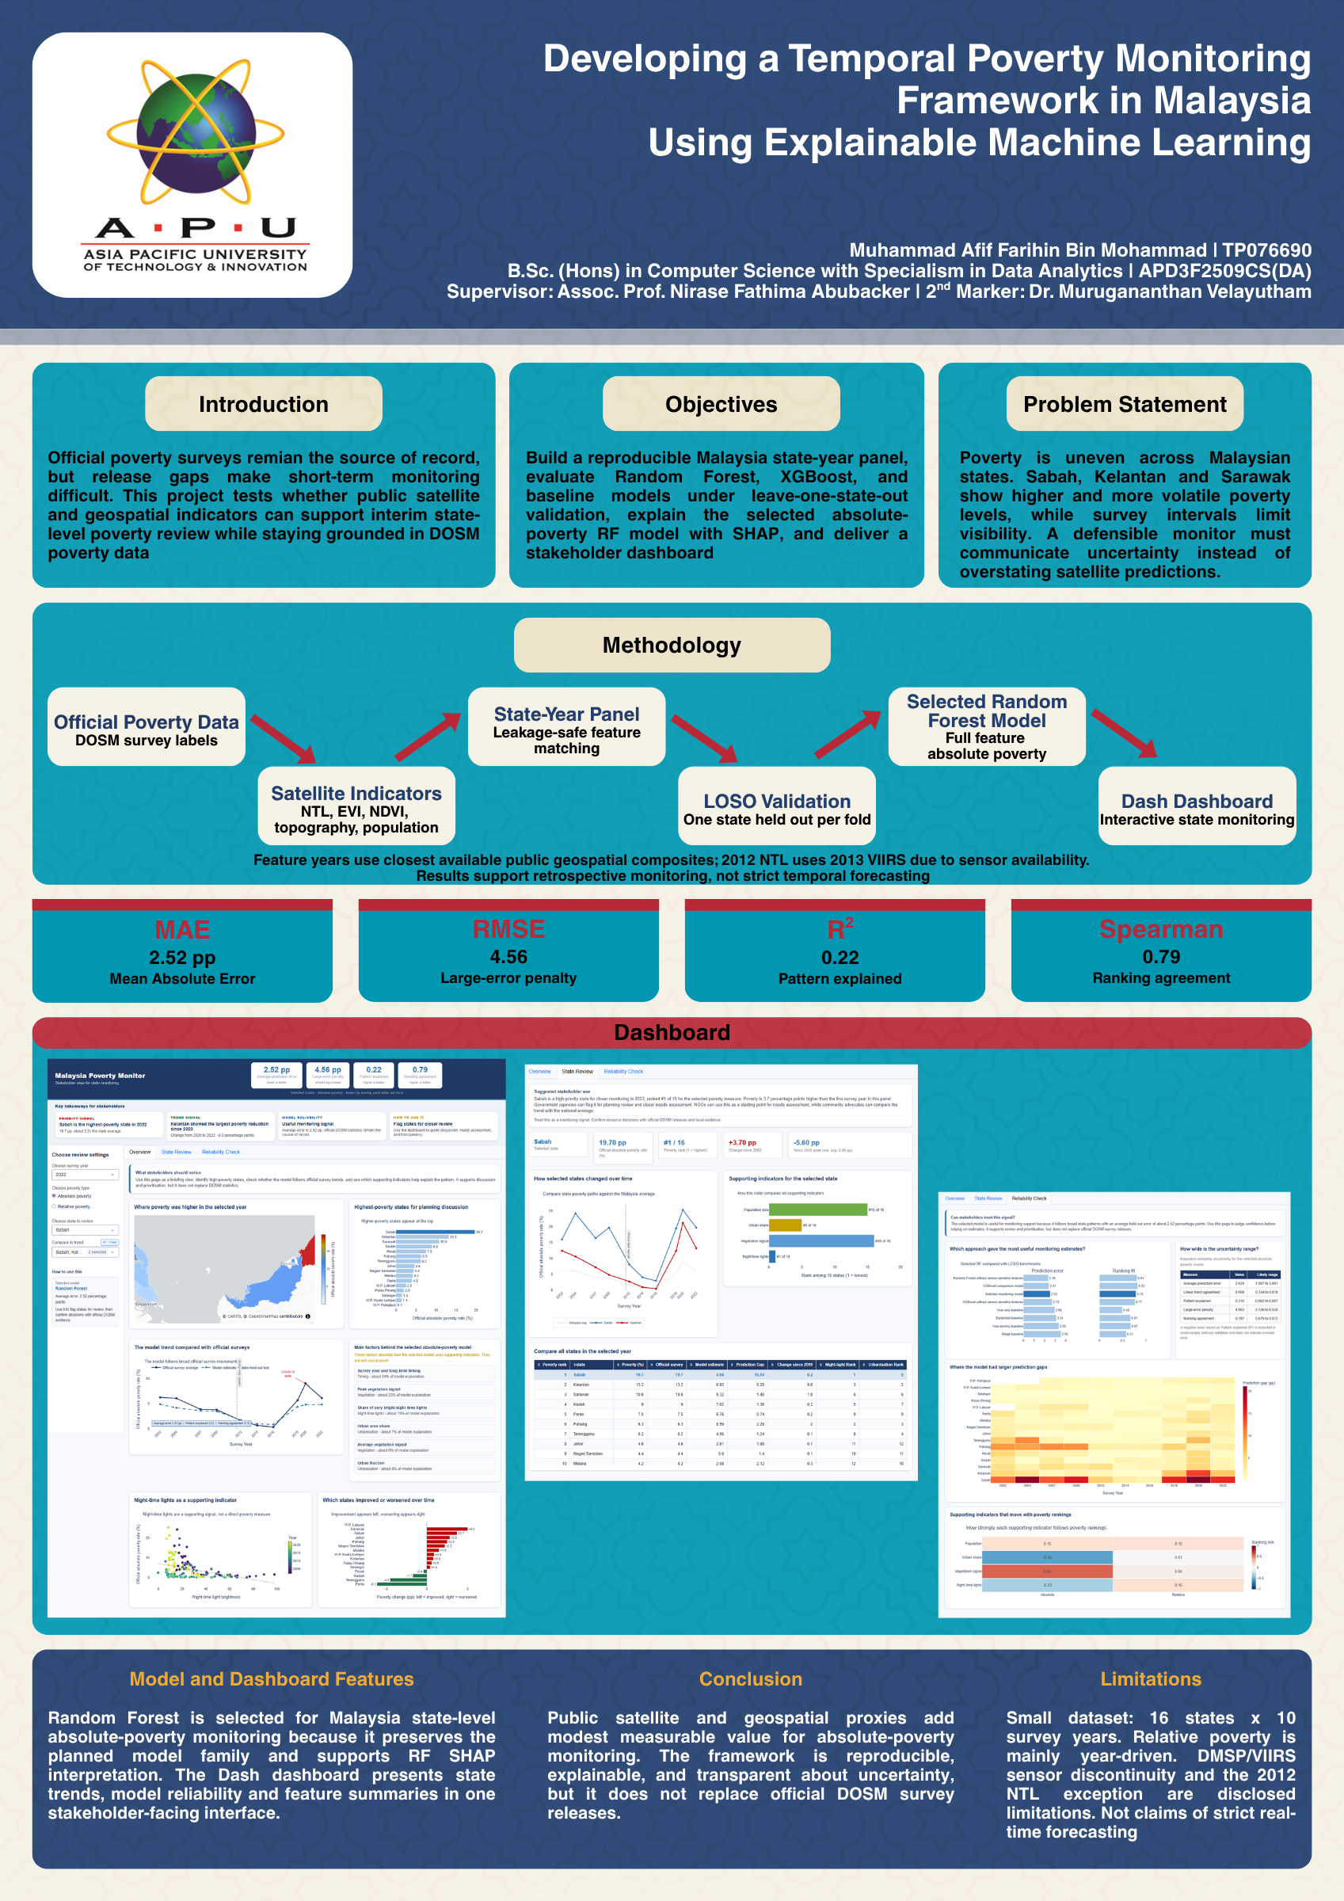
Figure 24 FYP Poster

Appendix E: Gantt Chart
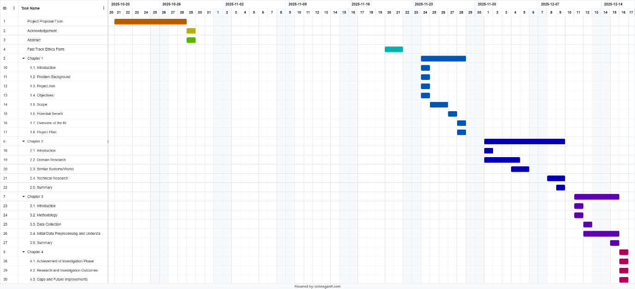
Figure 25 Semester 1 Gantt Chart
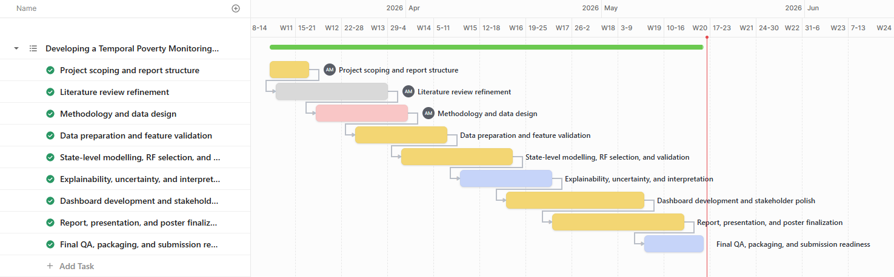
Figure 26 Semester 2 Gantt Chart

Appendix F: Sample Code Implementation
F1. Raw DOSM lineage and state-year panel validation
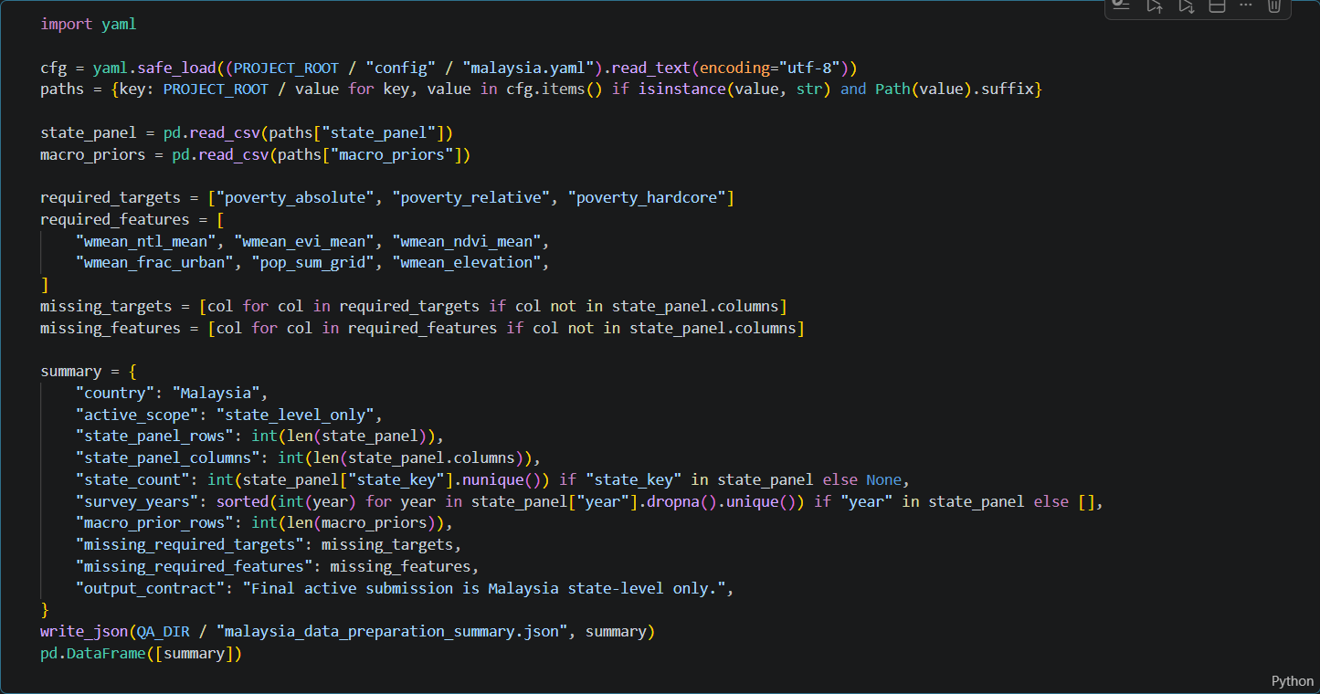
Figure 27 Notebook evidence for raw DOSM lineage and state-year panel validation. (notebooks/00_dosm_raw_to_labels.ipynb; notebooks/01_malaysia_data_preparation.ipynb)
F2. State-level LOSO benchmark, RF selection, and baseline metadata
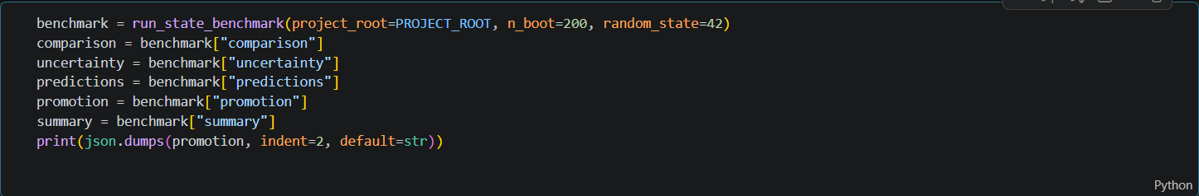
Figure 28 Executed notebook screenshot evidence for state-level LOSO benchmark, RF selection, and baseline metadata. (notebooks/03_model_training_evaluation.ipynb)

F3. DMSP-VIIRS sensor discontinuity rank-shift QA
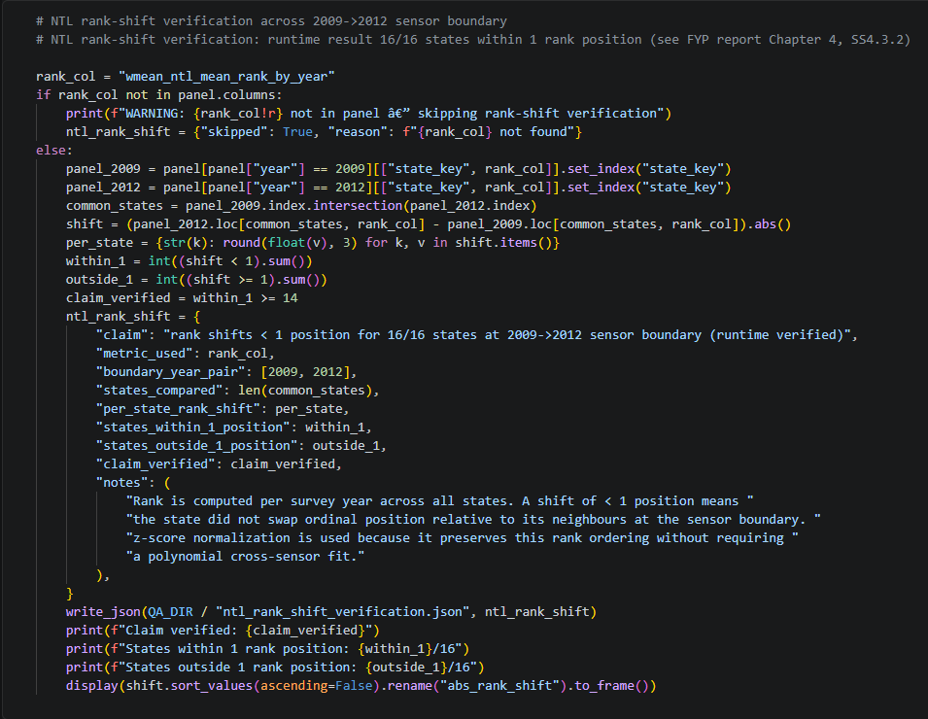
Figure 29 Executed notebook screenshot evidence for DMSP-VIIRS sensor discontinuity rank-shift QA. (notebooks/03_model_training_evaluation.ipynb)
F4. Dashboard artifact contract validation
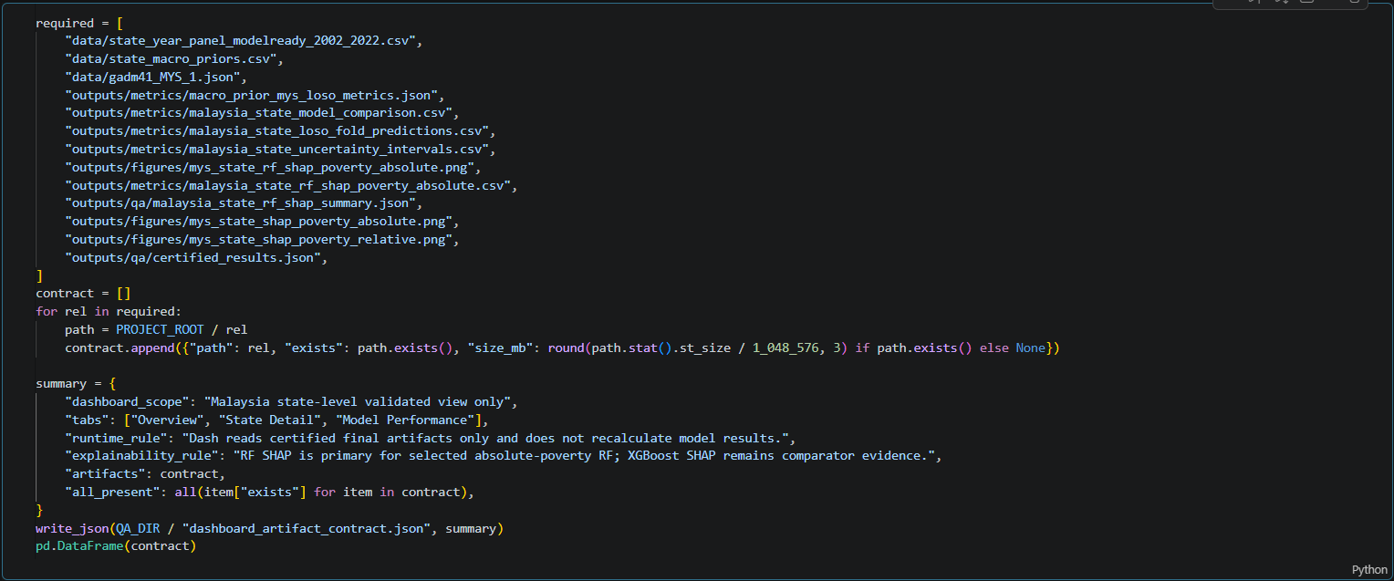
Figure 30 Executed notebook screenshot evidence for dashboard artifact contract validation. (notebooks/04_dashboard_artifacts.ipynb)

Appendix G: Turnitin Similarity Report
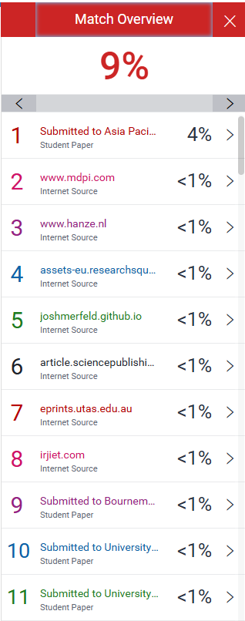
Figure 31 Turnitin Similarity Report Page 1
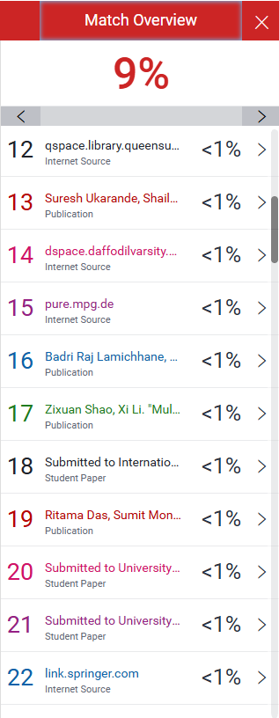
Figure 32 Turnitin Similarity Report Page 2

